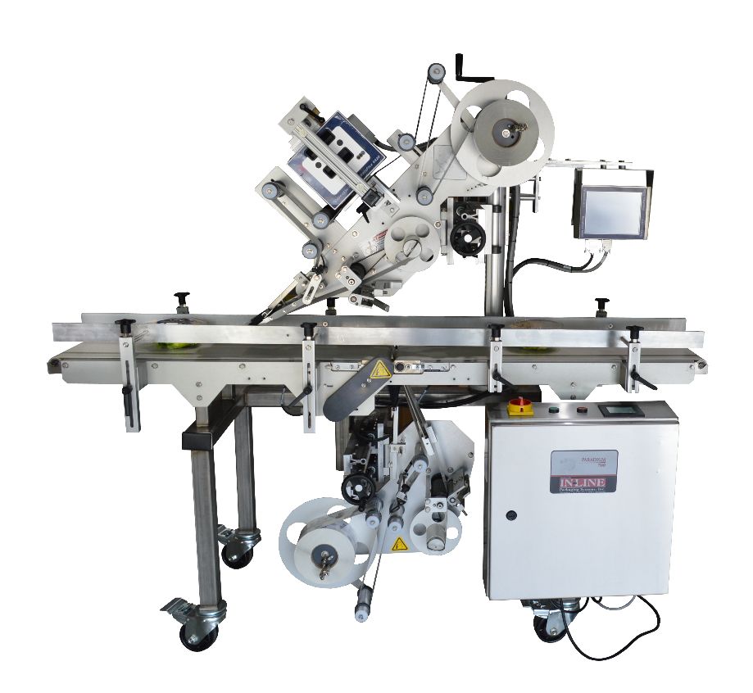

1

2

3

4

5

6

7

8

1000

9

1. Dancer Arm 6. Pinch Roll
2. Label Height Adjustment 7. Take Up Reel
3. Coder Control Panel 8. Peel Plate
4. Linear Adjustment 9. Pinch Roll
5. Touchscreen 10. Coder