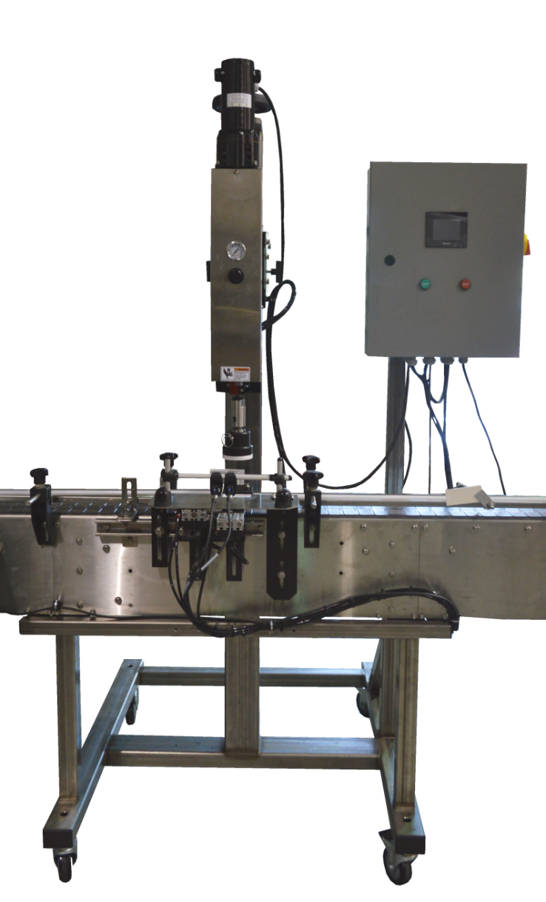**OPERATION MANUAL**

Chuck Screw Capper

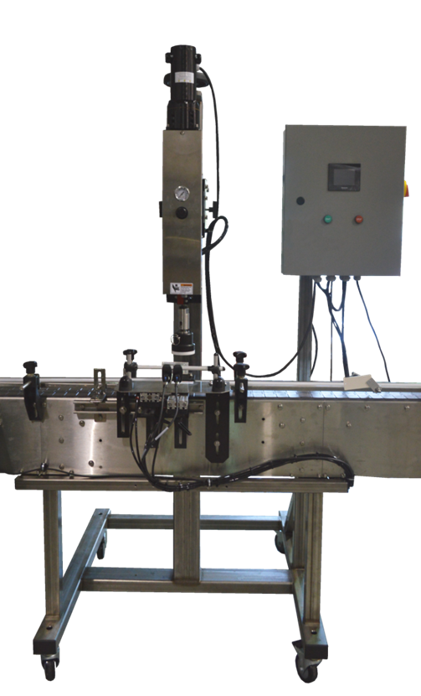****

7282 SPA ROAD | NORTH CHARLESTON, SC 29418

PHONE: 843-569-2530 | FAX: 843-576-0798

WWW.INLINEPACK.COM

**CAUTION!**

Persons operating this machinery are reminded to observe their own company safety policies. In addition, the following safety rules should be observed:

**DO NOT REACH INTO THE MACHINE WHILE IT IS IN OPERATION.**

**USE ONLY THE CORRECT TOOL FOR THE JOB BEING DONE.**

**STAY ALERT, REMEMBER LOCATION OF CONTROL SWITCHES.**

**MAINTENANCE**

The main electric switch supplying power to the machinery should be locked out or disconnected when repairs to work is performed on this equipment.

Machine should be cleaned and inspected regularly. All safety switches must be operable, attachments secure and machine free of broken glass and paper.

Do not hand lubricate when the machine is in operation.

Work area should be kept clean and as dry as is practical.

The repair or adjustment of this equipment should be performed only by persons qualified through technical training and ability, as assigned by your company.

**OPERATION**

All guards should be securely in place before operating the machine.

Company rules on eye protection should be followed.

Loose clothing or jewelry such as neckties, rolled sleeves, over blouses, bracelets, watches and rings should not be worn when operating the machine.

Report all malfunctions, unusual operation and defects immediately

Please exercise caution with any moving parts, including the conveyor and any pinch or drive rolls.

Stop the machine before placing hands or arms near or into any area where moving parts are located.

**TABLE OF CONTENTS**

**OPERATIONAL AND MAINTENANCE SAFETY RECOMMENDATIONS**

**SECTION ONE – GENERAL INFORMATION**

1.1 Terminology of Machine

1.2 Specifications and Requirements

1.3 Functional Description of Machine

1.4 Basic Machine Controls and Screen Settings

**SECTION TWO – UNCRATING AND INSTALLATION**

2.1 Power and Air Connections

2.2 Installing in Production Line

2.3 Leveling Base of Machine

2.4 Adjusting Components of Machine

**SECTION THREE – PREPARING FOR OPERATION**

3.1 Set Conveyor Rails

3.2 Adjust Machine Settings

3.3 Adjust Sensors

**SECTION FOUR – OPERATIONAL ADJUSTMENTS**

**SECTION FIVE – PERIODIC MAINTENANCE, CLEANING, AND LUBRICATION**

5.1 Maintenance

5.2 Cleaning the Machine

5.3 Lubrications

**SECTION SIX – TROUBLESHOOTING**

6.1 Nothing Works at All

6.2 Sensor Malfunctioning

6.3 Operational Inconsistencies

**SECTION SEVEN – OPTIONS AND/OR SPECIAL COMPONENTS SUPPLIED WITH MACHINE**

**SECTION EIGHT – PARTS LIST AND DIAGRAMS**

**SECTION ONE – GENERAL INFORMATION**

**1.1 TERMINOLOGY OF MACHINE**

1. Spindle/clutch Assembly 4. Entry Gate Eye, Gripper Eye

2. Entry Gate 5. Cap Chuck

3. Gripper/Exit Gate 6. Control Box

(not pictured is the vertical adjustment handwheel located behind the spindle motor)

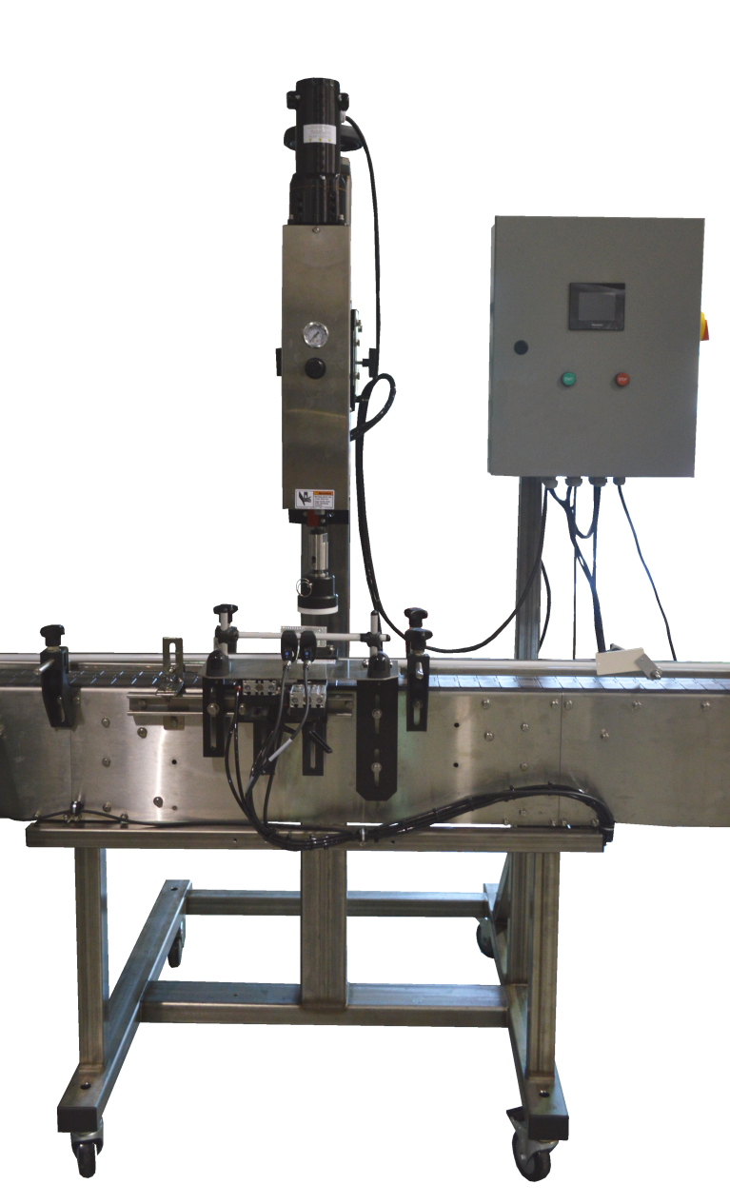

1

6

2

3

4

5

**1.2 SPECIFICATIONS – STANDARD MACHINE**

|  |  |
| --- | --- |
| ITEM | SPECIFICATION |
| Conveyor width | 4 1/2 inches standard |
| Machine speed | variable |
| Machine weight | 600 lbs |
| Overall dimensions | Variable, standard is 72”x48” |
| Electric requirements | 120VAC @ 6 amps |
| Air requirements | 60psi @ 3-4 cfm |

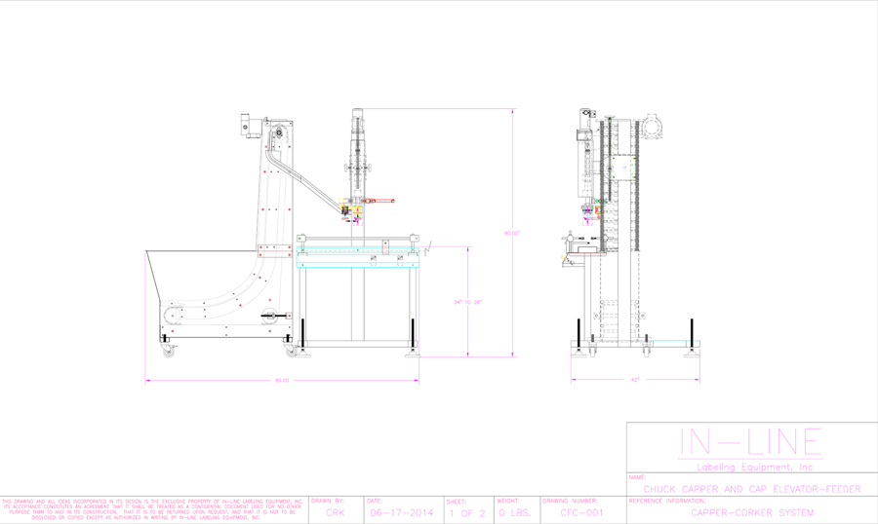

**1.3 FUNCTIONAL DESCRIPTION OF MACHINE**

The In-Line Chuck Capper is a semi or fully automatic (as ordered) Capper capable of placing a variety of caps on containers of various shapes and sizes. If the automatic sorter or bulk hopper are purchased, the machine will automatically sort and feed caps from a bulk hopper and deliver them to the escapement and cap applicator. The applicator will transfer the cap from the chute escapement on to the container and insert the cap in to the cap retainer, pressing the cap to its position on the neck of the container. The containers will be automatically indexed and centered under the application station for container to cap alignment and released after the cap has been applied.

**1.4 BASIC MACHINE CONTROLS**

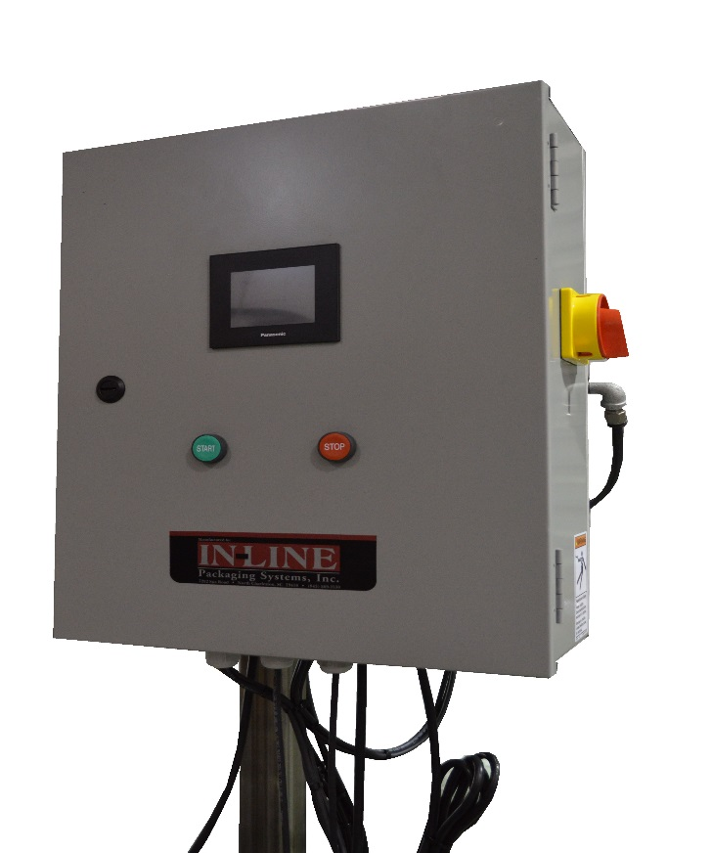

1

2

3

4

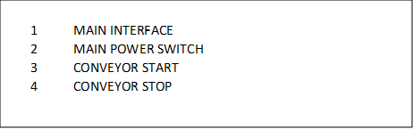

**SCREEN SETTINGS**

|  |  |
| --- | --- |
|  | **Main Screen:**  **Main Speed:** Enter speed of machine conveyor (ipm)  **Batch Count:** Displays current batch count  **Batch Reset:** Press to reset count to 0  **Timers:** Access screen for Timers  **Jog Functions:** Access screen for Jogging Devices  **Sorter:** Access screen to adjust Sorter settings  **System Settings:** Change system settings |
|  | **Capper Timers Screen:**  **Cap Start Delay:** This number affects the timing in which the capping cycle starts after the Gripper closes.  **Cap Dwell:** This number affects the time in which the chuck will remain down when applying a cap or cap  **Plunger Delay:** This number affects the time in which the plunger will engage.  **Plunger Dwell:** This number affects the time in which the plunger remains engaged  **Shuttle Delay:** This number affects the time in which the Shuttle moves a cap to the Plunger  **Shuttle Return Delay:** This number affects the time in which the Shuttle returns to the Chute.  **Inserter Delay:** This number affects the time in which the cap Inserter inserts the cap into the plunger.  **Inserter Dwell:** This number affects the time in which the Inserter remains engaged  **Entry Gate In Delay:** This number affects the timing in which the gate closes to hold bottles back.  **Entry Gate Out Delay:** This number affects the timing in which the gate retracts after the cycle.  **Exit Gate/Gripper Delay:** This number affects the timing in which the Gripper closes to start cycle after a container is detected.  **Exit Gate/Gripper Dwell:** This number affects the time in which the Gripper remains engaged. |
|  | **System Settings Screen:**  **Capping On/Off:** Push to Toggle On or Off  **Spindle On/Off:** Push to Toggle On or Off  **Backup Delay:** Set to control when Exit Gate and Entry Gate will open to control discharge flow of bottles.  **Spindle Speed:** Controls the speed of the Spindle Speed (Only Applicable to Capper) |
|  | **Sorter Screen:**  **Chain Stop Delay:** Set to control stopping delay of Sorter  **Air Jet Length:** Set to control the length of time the Air Jet blows  **Sorter Run Speed:** Set to control the Speed of the Sorter |
|  | **Jog Functions Screen:**  **Jog Spindle:** Jog Spindle Motor (Only applicable to Capper)  **Jog Plunger:** Jog Plunger (Only applicable to Corker)  **Cap Press:**  **Jog Shuttle:** Jog Cap Shuttle  **Jog Inserter:** Jog Cap Inserter  **Jog Exit:** Jog Exit Gate  **Jog Entry:** Jog Entry Gate  **Tamp Eye:** Monitors the Tamping Mechanism Photoeye  **Gripper Eye:** Monitors the Gripper Mechanism Photoeye  **Backup Eye:** Monitors the Backup Photoeye  **Chute Eye:** Monitors the Cap Chute detection Photoeye |
|  |  |

**SECTION TWO – UNCRATING AND INSTALLATION**

**2.1 POWER AND AIR CONNECTIONS**

A grounded electrical male plug is provided with the machine, and is connected to the main electrical enclosure on the side of the machine. Plug this into any grounded receptacle. On machines with coders or that require air, an air filter/reservoir with a ¼” male quick disconnect fitting attached, is provided underneath the main electrical enclosure on machines that require compressed air. You can supply compressed air to the machine by either a mating quick disconnect on the end of an air hose, or you can permanently pipe air to the machine using standard pipe and connecting directly into the air filter using threaded pipe connections. If you permanently pipe air into the system we recommend a cut-off valve be mounted at the machine. Some changeover adjustments are easier if the operator is able to temporarily turn off the air pressure.

**2.2 INSTALLING IN PRODUCTION LINE**

Move the machine into its permanent location. Adjust the conveyor height of the machine to match the heights of the adjoining machines as required. Leveling Pads are provided with the Labeler that allow some vertical adjustment. If necessary, make spacing blocks to raise the height. Approximately 12 inches of lineal space (as a standard, extensions are available) is provided on each end of the machine to allow a crossover from or to the next machine. Butt the conveyor ends as close to each other as possible and then use conveyor rails to guide the bottles across narrow dead plates onto the conveyor.

**2.3 LEVELING BASE MACHINE**

Once the machine is installed, level the main conveyor through the machine by using a bubble level. Place the bubble level along the length of the machine and also perpendicular to the conveyor at the label station. Leveling the machine is important to the quality of labeling since this will affect the web path and container path. Verification that the machine is square and level will ensure proper operation.

**SECTION THREE – PREPARING FOR OPERATION**

**3.1 LOADING CAPS OR**

The machine can be ordered with a bulk hopper and cap chute, cap chute only, or capper only. If the hopper is ordered then level of the hopper should be set to allow only properly oriented caps to remain on the elevator chain, if caps are feeding backwards then the elevator/hopper should be adjusted to be more vertical to cause backwards caps to fall off. The hopper should be loaded with several hundred caps but not loaded completely full.

**3.2 SET CONVEYOR RAILS TO CONTAINER SIZE**

The guide rails are adjusted in from the front and rear adjustments so the bottles are centered under the cap chuck on the conveyor chain.

**3.3 ADJUST HEIGHT OF TORQUEING HEAD TO CONTAINER**

The vertical height of the cap chuck is adjusted using the handwheel located behind the spindle motor. This height is based on the cap being placed fully into or torqued on the container so that the internal spring on the chuck is fully compressed when the cap is fully seated. The vertical stroke length of the spindle is adjustable by removing the cover and adjusting the spindle travel screw and nut. The chuck must be high enough to allow bottles to move under it on the conveyor, and the stroke set long enough for caps to fully seat.

**3.4 ADJUST GRIPPERS BASED ON ACTUAL SIZE**

Round bottles require grippers made to the size of the bottle and may be changed from bottle to bottle. The gripper, rear bottle stop, and stripper plate are adjusted in so that the bottle when gripped is centered under the chuck and has enough pressure to keep the bottle from spinning while cap insertion is occurring.

**SECTION FOUR – OPERATIONAL ADJUSTMENTS**

**4.1 ADJUSTING TIGHTNESS OF CAP OR PRESSURE ON CAP**

Cap tightness is adjusted by increasing or decreasing the pressure on the torqueing clutch. The pressure should be set so the chuck stalls when the cap is tight, if the pressure is set too high and the cap is over-tightened premature wear to the torqueing pad in the chuck will occur.

The cap insertion depth is adjusted by increasing the stroke or height of the chuck mechanism.

**4.2 ADJUSTMENTS**

The vertical height of the capping head is raised by loosening the locking handles and raising the threaded rod.

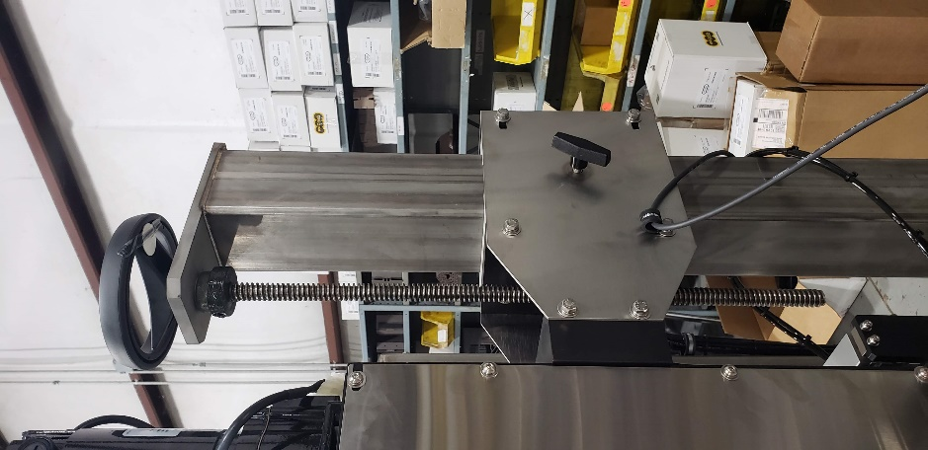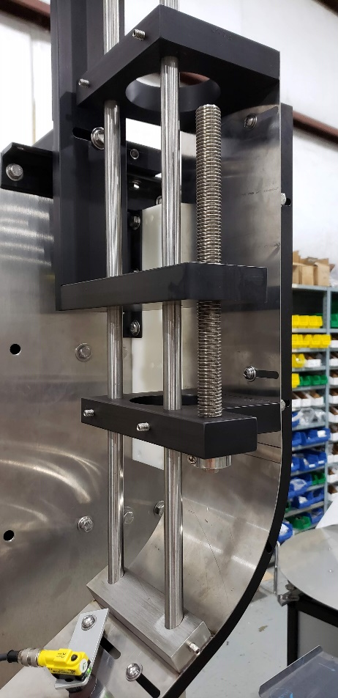

The Width and height of the chute are adjustable using basic hand tools.

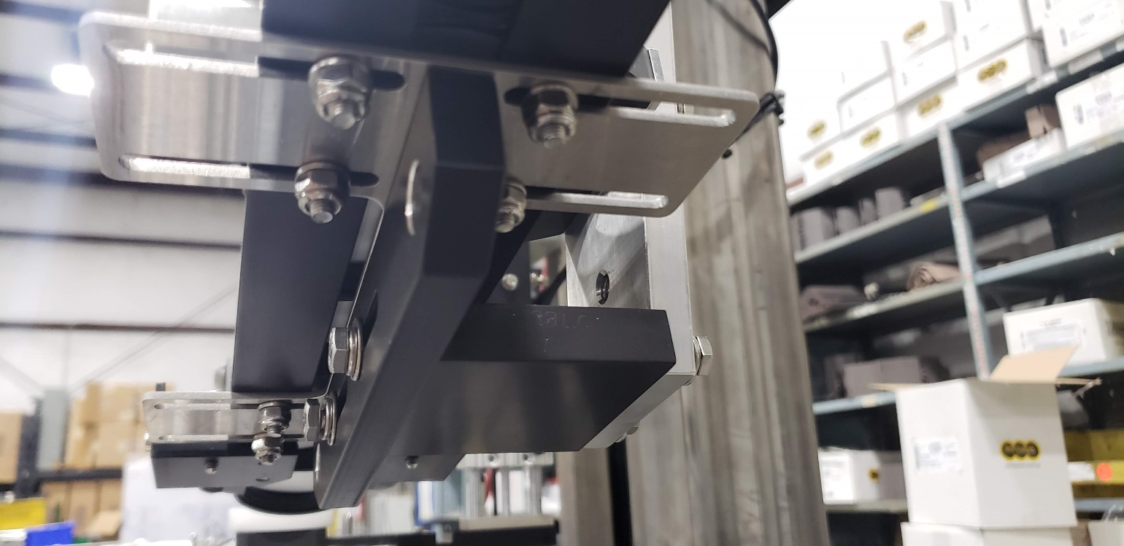

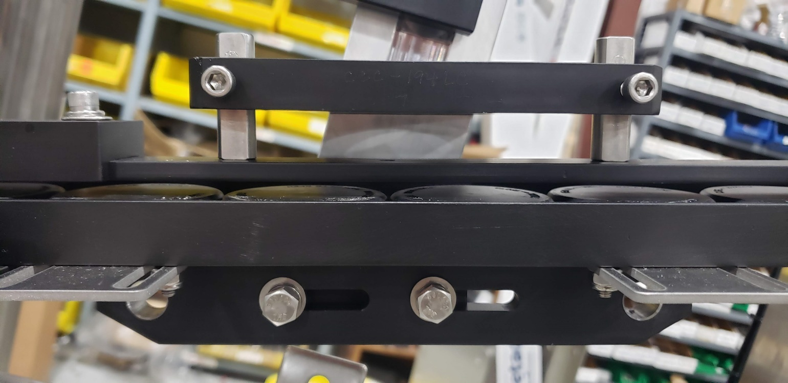

The top cap guide has a lateral adjustments for cap placement relative to the transfer button and retainer fingers.

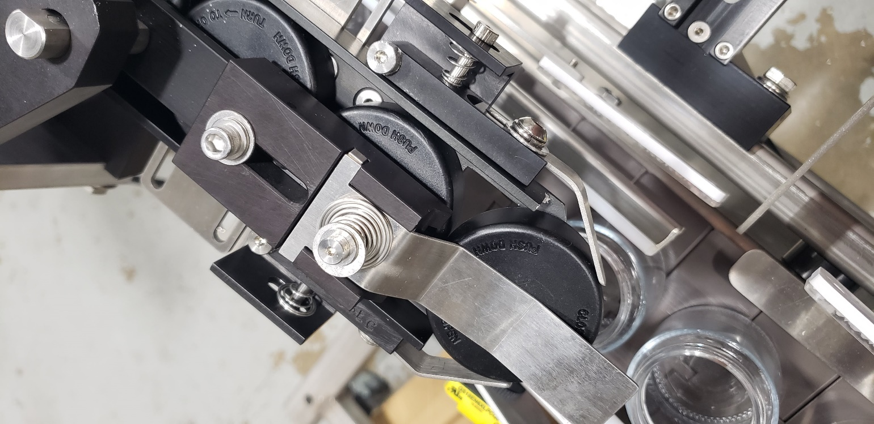

The Gripper and Entry gates should be set so that a bottle passes the Photo eye as it travels into the capping area. The adjustments are vertical and horizontal.

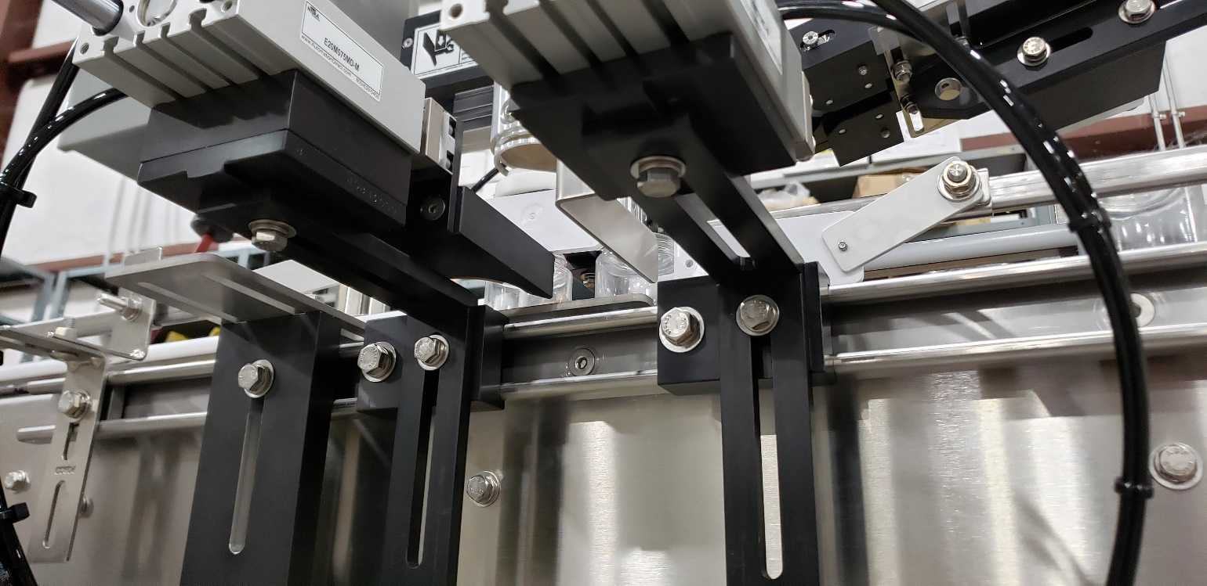

**SECTION FIVE – PERIODIC MAINTENANCE, CLEANING, AND LUBRICATION**

**5.1 MAINTENANCE**

Ensure that you perform a monthly visual inspection for wear. The torqueing chuck life will vary depending on cap design, characteristics, and desired cap tightness.

**5.2 CLEANING THE MACHINE**

The Capper comes in stainless and aluminum construction. Cleaning the machine regularly is recommended using soap and water.

**5.3 LUBRICATION**

The lubrication points on the machine are:

1. The conveyor idler sprockets inside the frame of the machine may need some grease once/year. The conveyor idler sprockets are located under the conveyor chain.
2. Any threaded rod for linear motion should have light oil applied to it periodically to keep the mechanism moving freely.
3. The spindle cylinder has grease fittings and should be lubricated bi-monthly.

**SECTION SIX – TROUBLESHOOTING**

**6.1 NOTHING WORKS AT ALL**

1. Check main power. Is machine plugged in? Is main power switch turned on?
2. Check fuses inside control panel.
3. Are speed controls turned up above zero?

**6.2 NO CAP HAS BEEN PLACED OR HAS BEEN PLACED INCORRECTLY**

1. Ensure that the photo-eye sensor is properly connected. A test for this is to identify if the green light located on the sensor is on and that when an object running past it causes the orange light to blink. This indicates a count. Ensure that the reflector is properly positioned directly across from the sensor.
2. If repetitive chuck actuation occurs ensure that the gripper eye is centered on the bottle and the sensor is adjusted to turn on and remain on from the time the bottle is detected until the bottle exits the gripper area. If the gripper eye flashes on/off after the capping has occurred the chuck will fire a second time.

**SECTION SEVEN – PARTS DIAGRAM**

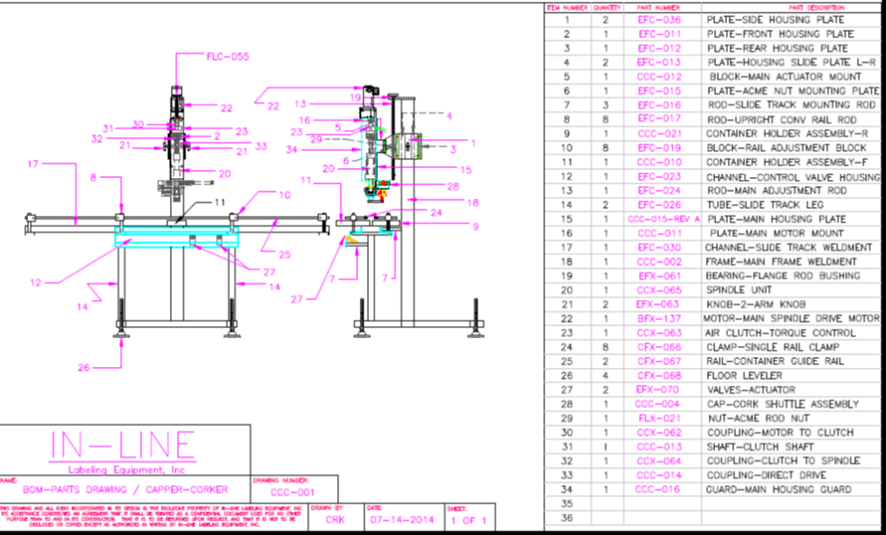

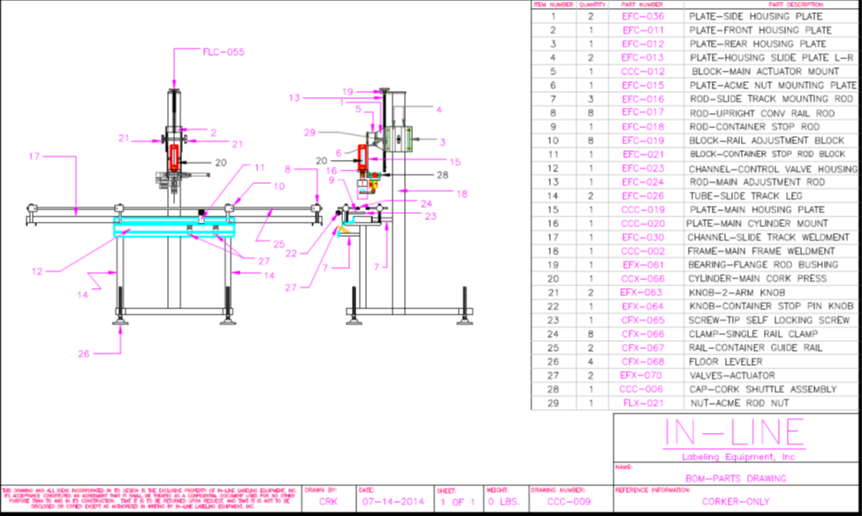

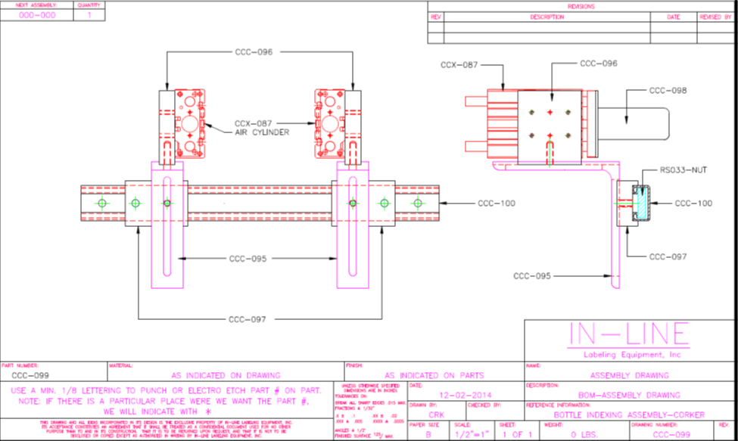

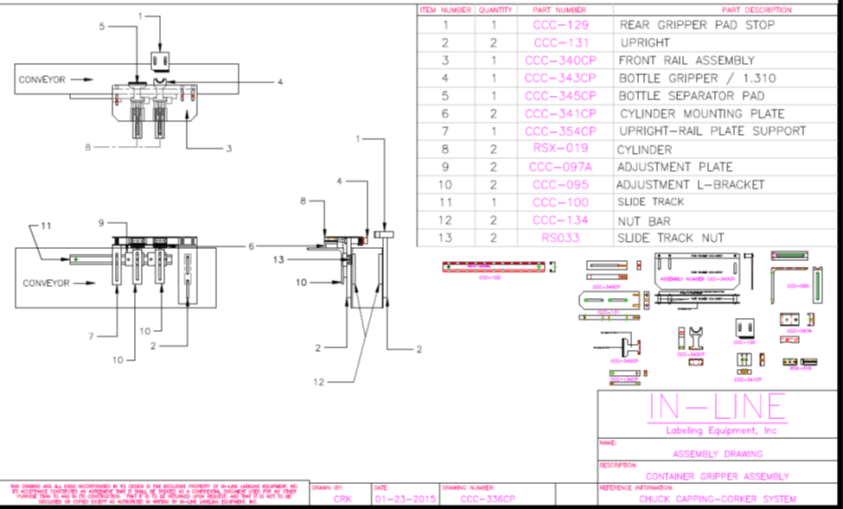

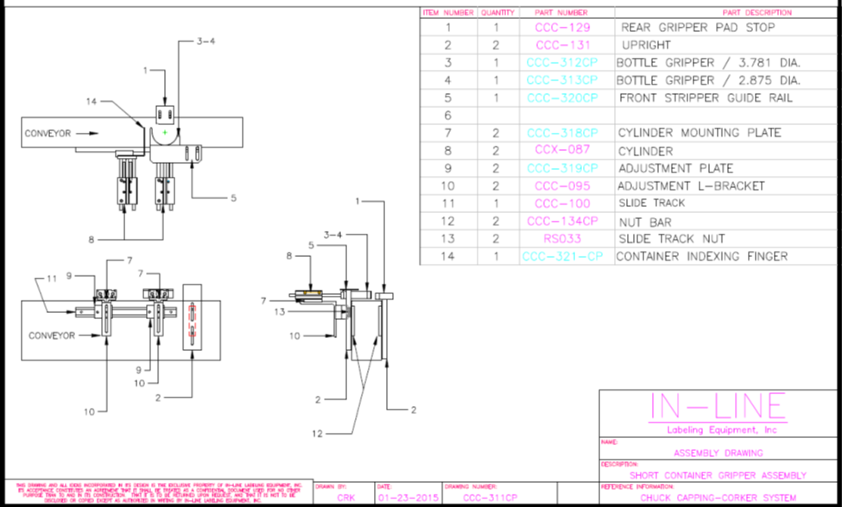

**SECTION EIGHT – RECOMMENDED SPARE PARTS**

PSX411LR-M12QD PHOTOEYE (gripper, entry gate, backup) -1

PSX915 AIR SOLENOID -2

PSX634-RELAY -2

PSX125 CONVEYOR CHAIN -2 FEET

RSX019 GRIPPER/HOLDBACK/SHUTTLE -1

BFX137 SPINDLE MOTOR -1

CCX063 CLUTCH -1

TORQUING PAD (CHANGE PART) -4