  - CORKER – Operation Manual

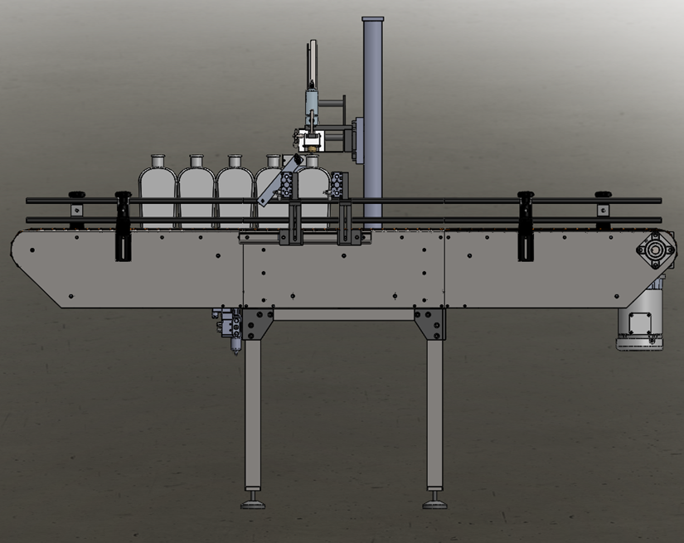

For helpful how-to videos visit our
YouTube channel - Inlinelabeling1

Follow us on:
Instagram @inlinepackaging
Facebook @inlinepack

CAUTION!

Persons operating this machinery are reminded to observe their own company safety policies. In addition, the following safety rules should be observed:

- DO NOT REACH INTO THE MACHINE WHILE IT IS IN OPERATION.
- USE ONLY THE CORRECT TOOL FOR THE JOB BEING DONE.
- STAY ALERT, REMEMBER LOCATION OF CONTROL SWITCHES.

MAINTENANCE
The main electric switch supplying power to the machinery should be locked out or disconnected when repairs are performed on this equipment.

Machine should be cleaned and inspected regularly. All safety switches must be operable, attachments secure and machine free of broken glass and paper.

Do not hand lubricate when the machine is in operation.
Work area should be kept clean and as dry as is practical.

The repair or adjustment of this equipment should be performed only by persons qualified through technical training and ability, as assigned by your company.

OPERATION
All guards should be securely in place before operating the machine. Close all doors when operating machine.

Company rules on eye protection should be followed.

Loose clothing or jewelry such as neckties, rolled sleeves, over blouses, bracelets, watches and rings should not be worn when operating the machine.

Report all malfunctions, unusual operation, and defects immediately.

Please exercise caution with any moving parts, including the conveyor and any pinch or drive rolls.

Stop the machine before placing hand or arms near or into any area where moving parts are located.

TABLE OF CONTENTS

SECTION ONE – GENERAL INFORMATION

1.1 | Terminology of Machine | pg. 4
1.2 | Specifications and Requirements | pg. 5
1.3 | Functional Description of Machine | pg. 6

SECTION TWO – UNCRATING AND INSTALLATION

2.1 | Electrical | pg. 16
2.2 | Communication Cables | pg. 16
2.3 | Pneumatic | pg. 17
2.4 | Installing in Production Line | pg. 18
2.5 | Leveling Base of Machine | pg. 18

SECTION THREE – OPERATIONAL ADJUSTMENTS

3.1 | Adjusting Fill Levels | pg. 19
3.2 | Foam Issues | pg. 19

SECTION FOUR – PERIODIC MAINTENANCE, CLEANING, AND LUBRICATION

4.1 | Maintenance | pg. 20
4.2 | Cleaning the Machine | pg. 20
4.3 | Lubrication | pg. 20

SECTION FIVE – TROUBLESHOOTING

5.1 | Nothing Works at All | pg. 21
5.2 | Operational Inconsistencies | pg. 21

SECTION SIX – SCREENS

6.1 | Main Screen | pg. 22
6.2 | Bottler Screens | pg. 23
6.3 | Rinser Settings | pg. 28
6.4 | Labeler Settings | pg. 30
6.5 | System Settings | pg. 32

SECTION SEVEN – CLEANING CYCLE
REFERENCES
WIRING BLOCK DIAGRAMS

SECTION ONE – GENERAL INFORMATION

TERMINOLOGY OF MACHINE

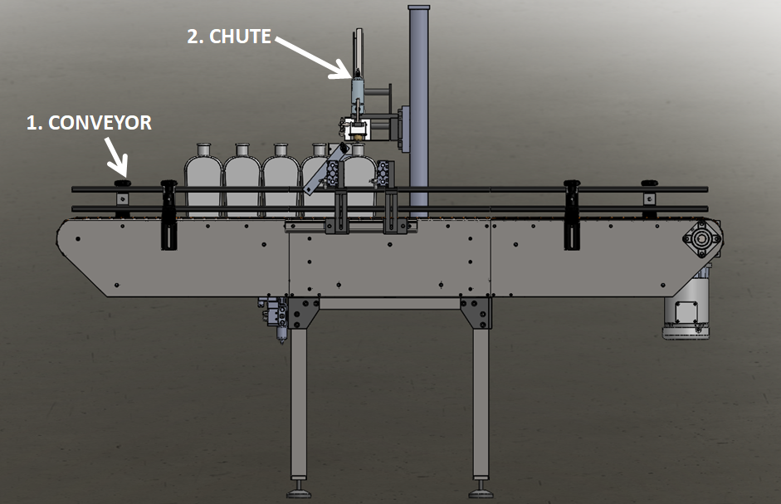
Positive Displacement Filler
Item No. | Assembly Name | Description
1 | Conveyor | Moves bottles through system
2 | Chute | Places corks into tops of bottles

SPECIFICATIONS – STANDARD MACHINE

ITEM | SPECIFICATION
CONVEYOR WIDTH | 4.5 INCHES STANDARD
MACHINE SPEED | VARIABLE UP TO 32 Bottles per Minute (BPM)
OVERALL DIMENSIONS | h: 68”; L: 86” (varies); w: 39 1/2”
ELECTRIC REQUIREMENTS | 110VAC 6 AMPS
AIR REQUIREMENTS | 90 PSI @ 2 CFM

FUNCTIONAL DESCRIPTION OF MACHINE

The In-line Micro Filler is a fully automatic in-line carbonated filling machine that can fill various bottle sizes with minimal amounts of waste. This means less product down the drain and more bottles filled.
The machine can be configured as a 4-, 6-, or 8-head machine.
The machine indexes the set target of bottles into position under the fill tubes. The straightener closes on the bottles, further aligning them to the fill tubes, and the filling manifold lowers down onto the bottles. The fill cycle consists of the following: pulling vacuum, charging bottles with CO₂, filling bottles to a consistent fill level, removing pressure from the bottle, and releasing the bottles to move down the line. The next group then indexes in and the cycle is repeated.
After filling, the bottles move into the Crowner section of the machine. A crown is placed onto the top of the bottle and then formed over the bottle to provide a sufficient seal. The bottles index one at a time to have the crowns formed.

Conveyor

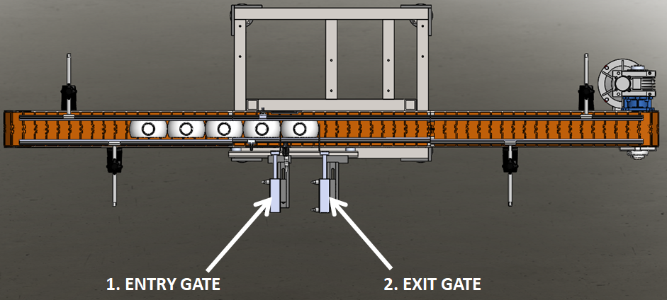
The Conveyor for the Corker controls the indexing of bottles for corking.
- Entry Gate – creates spacing between cycles
- Exit Gate – positions bottles under corker

Adjustments
Place multiple bottles on the conveyor in different locations and adjust all railing accordingly. Center bottles under corker and adjust entry gate and exit gate accordingly.

Chute Lower

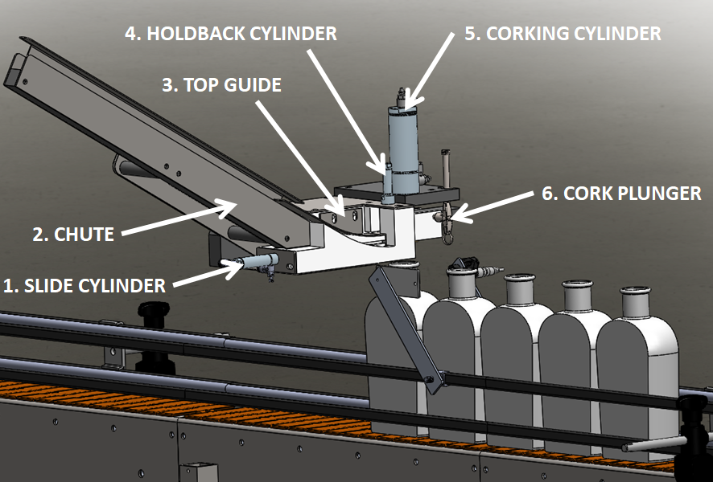 | The Chute Lower puts the cork into the top of the bottle.  - Slide Cylinder – holds cork up until time to be put into bottle  - Chute –puts corks in place one at a time  - Top Guide – adjustable for different thickness corks  - Holdback Cylinder – keeps the next few corks from moving forward while corking is in progress  - Corking Cylinder – cylinder that pushes the cork into the bottle  - Cork Plunger – change part for each cork size

Adjustments

Adjust the Lower Chute and Top Guide as needed when switching from one cork size to the next.

SCREEN SETTINGS

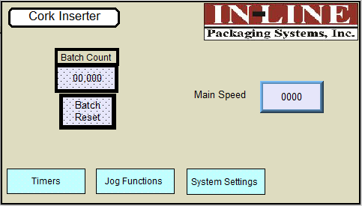 | Main Screen:  Main Speed: Enter speed of machine conveyor (ipm)  Batch Count: Displays current batch count  Batch Reset: Press to reset count to 0  Timers: Access screen for Timers  Jog Functions: Access screen for Jogging Devices  System Settings: Change system settings
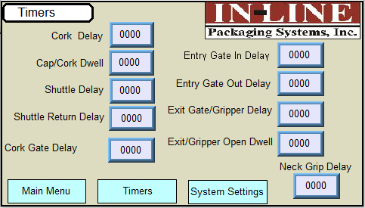 | Corker Timers Screen:  Cork Delay: This number affects the timing in which the capping cycle starts after the Gripper closes.  Cap/Cork Dwell: This number affects the time in which the chuck will remain down when applying a cork or cap  Shuttle Delay: This number affects the time in which the Shuttle moves a cap/cork to the Plunger  Shuttle Return Delay: This number affects the time in which the Shuttle returns to the Chute.  Entry Gate In Delay: This number affects the timing in which the gate closes to hold bottles back.  Entry Gate Out Delay: This number affects the timing in which the gate retracts after the cycle.  Exit Gate/Gripper Delay: This number affects the timing in which the Gripper closes to start cycle after a container is detected.  Exit Gate/Gripper Dwell: This number affects the time in which the Gripper remains engaged.  Neck Grip Delay: This number affects the time in which the Neck Gripper Mechanism engages.
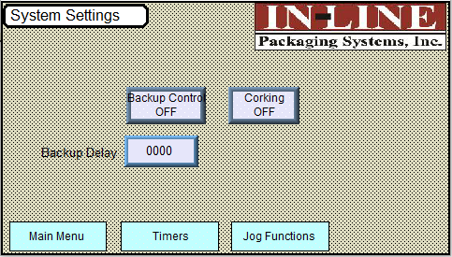 | System Settings Screen:  Corking On/Off: Push to Toggle On or Off  Backup Control On/Off: Push to Toggle On or Off  Backup Delay: Set to control when Exit Gate and Entry Gate will open to control discharge flow of bottles.
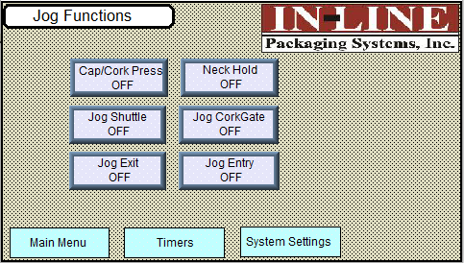 | Jog Functions Screen:  Cap/Cork Press:  Jog Shuttle: Press to Jog Cork/Cap Shuttle  Jog Exit: Press to Jog Exit Gate  Jog Neck Hold: Press to Jog Neck Hold  Jog Cork Gate: Press to Jog Cork Gate  Jog Entry: Press to Jog Entry Gate

SECTION TWO – UNCRATING AND INSTALLATION

2.1 POWER AND AIR CONNECTIONS

A grounded electrical male plug is provided with the machine, and is connected to the main electrical enclosure on the side of the machine. Plug this into any grounded receptacle. On machines with coders or that require air, an air filter/reservoir with a ¼” male quick disconnect fitting attached, is provided underneath the main electrical enclosure on machines that require compressed air. You can supply compressed air to the machine by either a mating quick disconnect on the end of an air hose, or you can permanently pipe air to the machine using standard pipe and connecting directly into the air filter using threaded pipe connections. If you permanently pipe air into the system we recommend a cut-off valve be mounted at the machine. Some changeover adjustments are easier if the operator is able to temporarily turn off the air pressure.

2.2 INSTALLING IN PRODUCTION LINE

Move the machine into its permanent location. Adjust the conveyor height of the machine to match the heights of the adjoining machines as required. Leveling Pads are provided with the Labeler that allow some vertical adjustment. If necessary, make spacing blocks to raise the height. Approximately 12 inches of lineal space (as a standard, extensions are available) is provided on each end of the machine to allow a crossover from or to the next machine. Butt the conveyor ends as close to each other as possible and then use conveyor rails to guide the bottles across narrow dead plates onto the conveyor.

2.3 LEVELING BASE MACHINE

Once the machine is installed, level the main conveyor through the machine by using a bubble level. Place the bubble level along the length of the machine and also perpendicular to the conveyor at the label station. Leveling the machine is important to the quality of labeling since this will affect the web path and container path. Verification that the machine is square and level will ensure proper operation.

SECTION THREE – PREPARING FOR OPERATION

3.1 LOADING CAPS OR CORKS

The machine can be ordered with a bulk hopper and cork chute, cork chute only, or corker only. If the hopper is ordered then level of the hopper should be set to allow only properly oriented corks to remain on the elevator chain, if corks are feeding backwards then the elevator/hopper should be adjusted to be more vertical to cause backwards corks to fall off. The hopper should be loaded with several hundred corks but not loaded completely full.

3.2 SET CONVEYOR RAILS TO CONTAINER SIZE

The guide rails are adjusted in from the front and rear adjustments so the bottles are centered under the cork chuck on the conveyor chain.

3.3 ADJUST HEIGHT OF TORQUEING HEAD TO CONTAINER

The vertical height of the cork chuck is adjusted using the handwheel located behind the spindle motor. This height is based on the cork being placed fully into or torqued on the container so that the internal spring on the chuck is fully compressed when the cork is fully seated. The vertical stroke length of the spindle is adjustable by removing the cover and adjusting the spindle travel screw and nut. The chuck must be high enough to allow bottles to move under it on the conveyor, and the stroke set long enough for corks to fully seat.

3.4 ADJUST GRIPPERS BASED ON ACTUAL SIZE

Round bottles require grippers made to the size of the bottle and may be changed from bottle to bottle. The gripper, rear bottle stop, and stripper plate are adjusted in so that the bottle when gripped is centered under the chuck and has enough pressure to keep the bottle from spinning while cork insertion is occurring.

SECTION FOUR – OPERATIONAL ADJUSTMENTS

4.1 ADJUSTING TIGHTNESS OF CAP OR PRESSURE ON CORK

Cork tightness is adjusted by increasing or decreasing the pressure on the torqueing clutch. The pressure should be set so the chuck stalls when the cork is tight, if the pressure is set too high and the cork is over-tightened premature wear to the torqueing pad in the chuck will occur.

The cork insertion depth is adjusted by increasing the stroke or height of the chuck mechanism.

4.2 CHUTE ADJUSTMENT
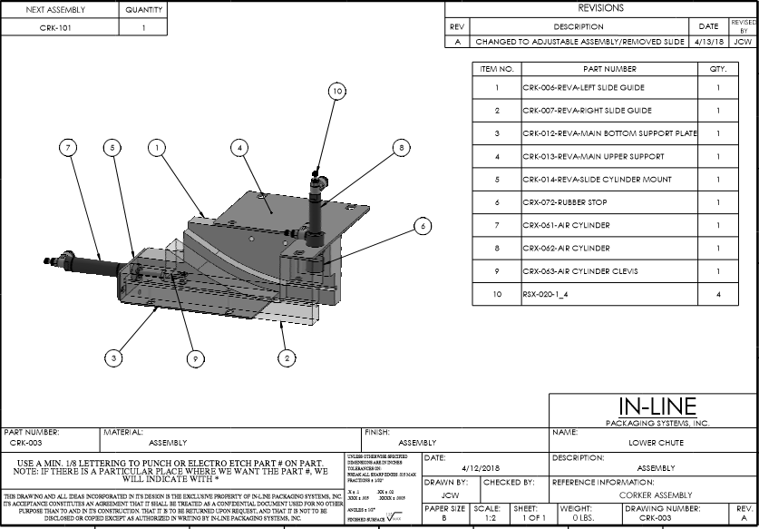

SECTION FIVE – PERIODIC MAINTENANCE, CLEANING, AND LUBRICATION

5.1 MAINTENANCE

Ensure that you perform a monthly visual inspection for wear. The torqueing chuck life will vary depending on cap design, characteristics, and desired cap tightness.
5.2 CLEANING THE MACHINE

The Corker comes in stainless and aluminum construction. Cleaning the machine regularly is recommended using soap and water.

5.3 LUBRICATION

The lubrication points on the machine are:

- The conveyor idler sprockets inside the frame of the machine may need some grease once/year. The conveyor idler sprockets are located under the conveyor chain.
- Any threaded rod for linear motion should have light oil applied to it periodically to keep the mechanism moving freely.
- The spindle cylinder has grease fittings and should be lubricated bi-monthly.

SECTION SIX – TROUBLESHOOTING

6.1 NOTHING WORKS AT ALL

- Check main power. Is machine plugged in? Is main power switch turned on?
- Check fuses inside control panel.
- Are speed controls turned up above zero?

6.2 NO CAP OR CORK HAS BEEN PLACED OR HAS BEEN PLACED INCORRECTLY

- Ensure that the photo-eye sensor is properly connected. A test for this is to identify if the green light located on the sensor is on and that when an object running past it causes the orange light to blink. This indicates a count. Ensure that the reflector is properly positioned directly across from the sensor.
- If repetitive chuck actuation occurs ensure that the gripper eye is centered on the bottle and the sensor is adjusted to turn on and remain on from the time the bottle is detected until the bottle exits the gripper area. If the gripper eye flashes on/off after the capping has occurred the chuck will fire a second time.

SECTION SEVEN – PARTS DIAGRAM

CRK-003
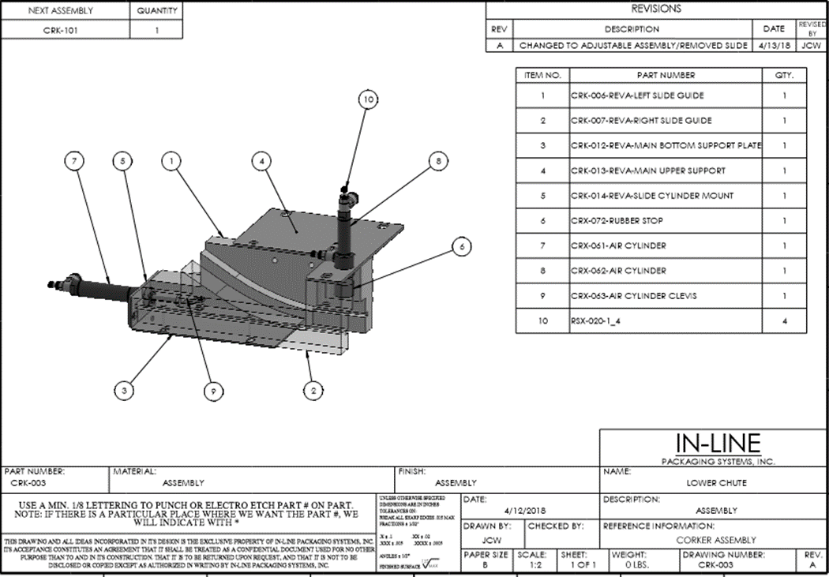

*Some parts may be specific to your machine.

CRK-101

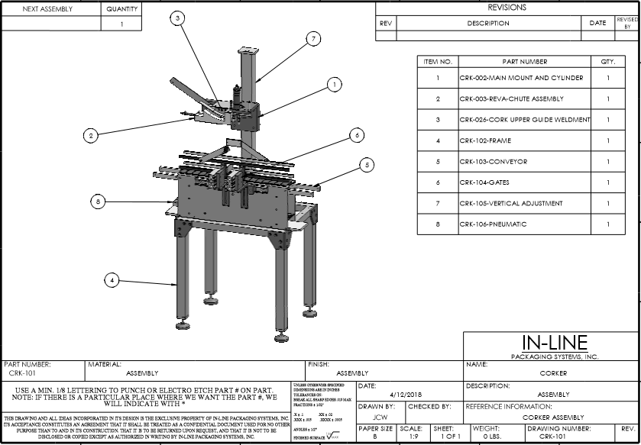

*Some parts may be specific to your machine.

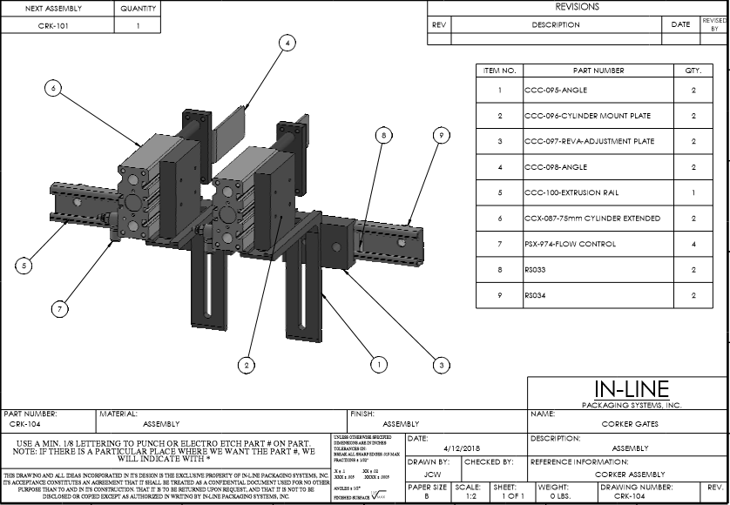
CRK-104

*Some parts may be specific to your machine.

SECTION EIGHT – RECOMMENDED SPARE PARTS

PSX411LR-M12QD PHOTOEYE (gripper, entry gate, backup) -1
PSX915 AIR SOLENOID -2
PSX634-RELAY -2
PSX125 CONVEYOR CHAIN -2 FEET
RSX019 GRIPPER/HOLDBACK/SHUTTLE -1
BFX137 SPINDLE MOTOR -1
CCX063 CLUTCH -1
TORQUING PAD (CHANGE PART) -4

