**OPERATION MANUAL**

ECONO FILLER

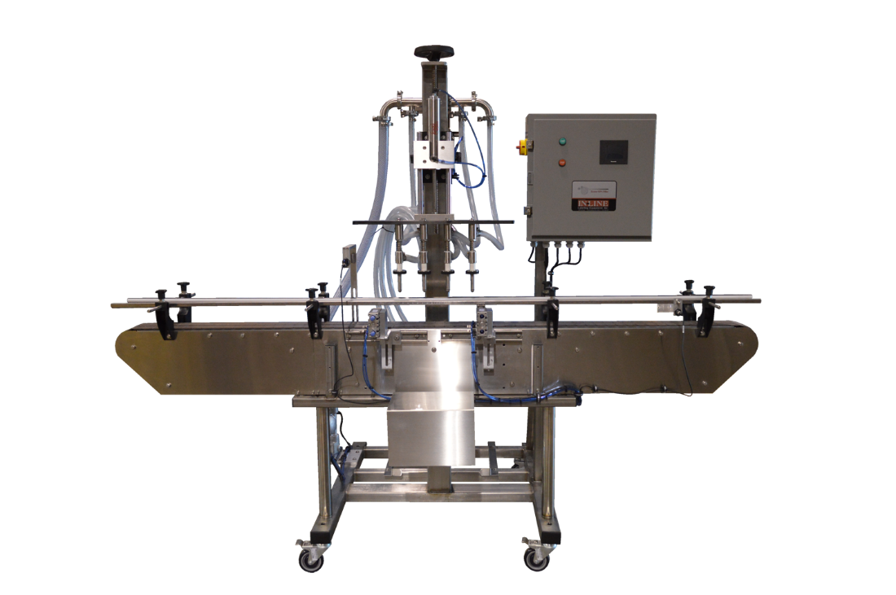



7282 SPA ROAD | NORTH CHARLESTON, SC 29418

PHONE: 843-569-2530 | FAX: 843-576-0798

WWW.INLINEPACK.COM

CAUTION!

Persons operating this machinery are reminded to observe their own company safety policies. In addition, the following safety rules should be observed:

# DO NOT REACH INTO THE MACHINE WHILE IT IS IN OPERATION.

# USE ONLY THE CORRECT TOOL FOR THE JOB BEING DONE.

**STAY ALERT, REMEMBER LOCATION OF CONTROL SWITCHES.**

**MAINTENANCE**

The main electric switch supplying power to the machinery should be locked out or disconnected when repairs are performed on this equipment.

Machine should be cleaned and inspected regularly. All safety switches must be operable, attachments secure and machine free of broken glass and paper.

Do not hand lubricate when the machine is in operation.

Work area should be kept clean and as dry as is practical.

The repair or adjustment of this equipment should be performed only by persons qualified through technical training and ability, as assigned by your company.

**OPERATION**

All guards should be securely in place before operating the machine.

Company rules on eye protection should be followed.

Loose clothing or jewelry such as neckties, rolled sleeves, over blouses, bracelets, watches and rings should not be worn when operating the machine.

Report all malfunctions, unusual operation and defects immediately.

Please exercise caution with any moving parts, including the conveyor and any pinch or drive rolls.

Stop the machine before placing hand or arms near or into any area where moving parts are located.

**TABLE OF CONTENTS**

**OPERATIONAL AND MAINTENANCE SAFETY RECOMMENDATIONS**

**SECTION ONE – GENERAL INFORMATION**

1.1 Terminology of Machine

1.2 Specifications and Requirements

1.3 Functional Description of Machine

1.4 Basic Machine Controls and Screen Settings

**SECTION TWO – UNCRATING AND INSTALLATION**

2.1 Power and Air Connections

2.2 Installing in Production Line

2.3 Leveling Base of Machine

2.4 Adjusting Components of Machine

**SECTION THREE – PREPARING FOR OPERATION**

3.1 Set Conveyor Rails

3.2 Adjust Machine Settings

3.3 Adjust Sensors

**SECTION FOUR – OPERATIONAL ADJUSTMENTS**

**SECTION FIVE – PERIODIC MAINTENANCE, CLEANING, AND LUBRICATION**

5.1 Maintenance

5.2 Cleaning the Machine

5.3 Lubrications

**SECTION SIX – TROUBLESHOOTING**

6.1 Nothing Works at All

6.2 Operational Inconsistencies

**SECTION SEVEN – OPTIONS AND/OR SPECIAL COMPONENTS SUPPLIED WITH MACHINE**

**SECTION EIGHT – PARTS LIST AND DIAGRAMS**

## **SECTION ONE – GENERAL INFORMATION**

**1.1 TERMINOLOGY OF MACHINE**

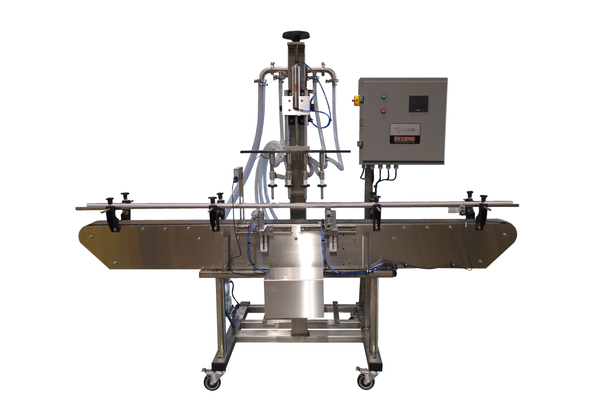

4

1

6

5

2

3

**Econo Filler**

1. Control Box 4. Manifold

2. Entry Gate 5. Diaphragm Pump (not pictured)

3. Exit Gate 6. Fill Nozzles

**1.2 SPECIFICATIONS – STANDARD MACHINE**

|  |  |
| --- | --- |
| ITEM | SPECIFICATION |
| CONVEYOR WIDTH | 4.5 INCHES STANDARD |
| MACHINE SPEED | VARIABLE UP TO 40 BPM |
| MACHINE WEIGHT | 600 LBS |
| OVERALL DIMENSIONS | 72 INCHES STANDARD |
| ELECTRIC REQUIREMENTS | 110VAC 6 AMPS |
| AIR REQUIREMENTS | 90 PSI @ 4-6 CFM |

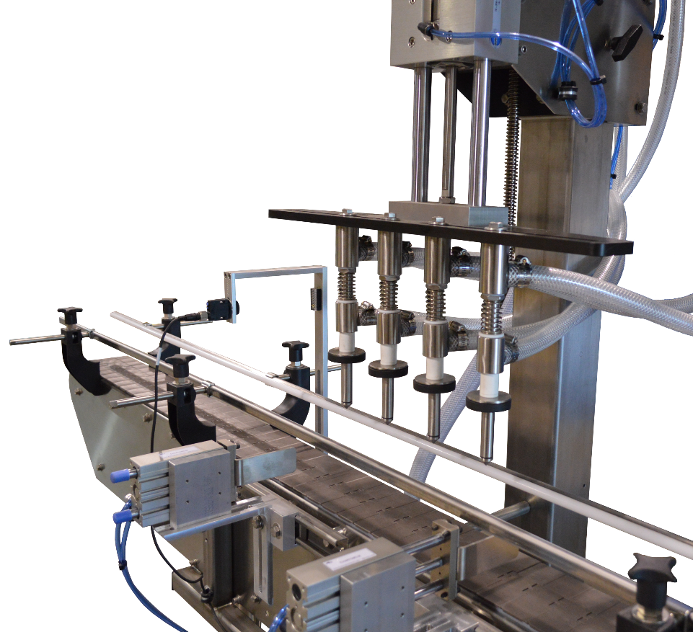

**1.3 FUNCTIONAL DESCRIPTION OF MACHINE**

The Inline Econo Filler is a fully automatic inline overflow filling machine that can fill various sizes of containers with medium to low viscosity.

The machine can be configured as a 4 or 6 head machine.

The filler indexes the target number of sets under the filling heads. The diaphragm pump is started and the fill heads lower into the bottle for filling. Once the filling cycle is complete the heads lift, and bottles are released to the exit conveyor. A new set of bottles is indexed into position and the cycle continues until the batch target is met (if batch function is enabled).

**Features:**

* 304-stainless steel frame construction
* Aluminum and plastic parts throughout the mechanism
* Stainless steel filling nozzles
* Easy change over and minimum change over parts
* Rear mounted supply/overflow tank with diaphragm supply pump
* Positive container indexing and centering
* Hand crank adjustment for different height containers

**1.4 BASIC MACHINE CONTROLS**

1. Main Power Switch
2. Start Push Button
3. Stop Push Button

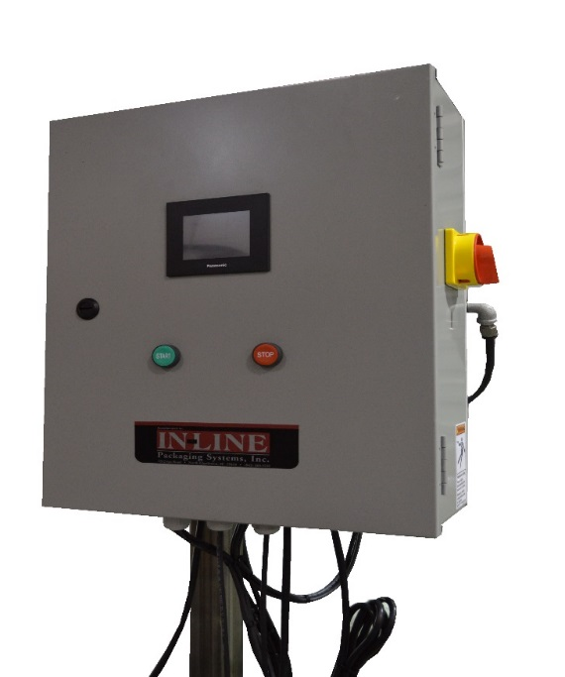

1

2

3

**SCREEN SETTINGS**

|  |  |
| --- | --- |
|  | **Main Screen**  **Main Speed:** Enter speed of machine (ipm)  **Batch Count:** displays current batch count  **Batch Reset:** Press to reset count to 0  **Filling Settings:** access screen for Filling  **Gate Settings:** access screen for Gate control  **Device Settings:** change device speeds & ratios  **Recipe Functions:** save/recall previous settings  **System Settings:** change settings/devices |
|  | **Filler Settings Screen**  **Filler On/Off:** Push to Toggle On or Off  **Filler Start Delay:** Push Number to enter new delay. This number affects the timing in which the capping cycle starts after the count is complete.  **Filling Cycle time:** Push Number to enter the total length of the fill cycle.  **Pump Dwell time:** Push to enter the length of time for the pump to run. This should be set shorter than the fill cycle time.  **Bottles per cycle:** Push to enter the number of bottles for each fill cycle. |
|  | **System Settings Screen:**  **Backup CTRL On/Off:** Push to Toggle On or Off |
|  | **Gate Settings Screen:**  **Entry Gate In Delay:** Push Number to enter new delay. This number affects the timing in which the gate extends.  **Entry Gate Out Delay:** Push Number to enter new delay. This number affects the timing in which the gate retracts after the cycle. |
|  | **Device Jog Settings Screen:**  Gates, the pump and devices can be manually jogged from this screen. |
|  | **Recipe Function Screen:**  The recipe function allows you to enter a new recipe or load up a previously saved one. This is used for different configurations based on multiple container sizes. |

**SECTION TWO – UNCRATING AND INSTALLATION**

**2.1 POWER AND AIR CONNECTIONS**

A grounded electrical male plug is provided with the machine, and is connected to the main electrical enclosure on the rear side of the machine. Plug this into any grounded receptacle. For compressed air, behind the electrical enclosure is an air filter/reservoir with a 1/4” male quick disconnect attached. You can supply compressed air to the machine by either a mating quick disconnect on the end of an air hose, or you can permanently pipe air to the machine using standard pipe and connecting directly into the air filter using threaded pipe connections. If you permanently pipe into the system we recommend a cut-off valve be mounted at the machine. Some changeover adjustments are easier if the operator is able to temporarily turn off the air pressure.

**2.2 INSTALLING IN PRODUCTION LINE**

Move the machine into its permanent location. Adjust the conveyor height of the machine to match the heights of the adjoining machines as required. Leveling pads are provided with the Econo-Filler that allow you some vertical adjustment. If necessary, make spacing blocks to raise the height. Additional lineal space is provided on each end of the machine to allow a crossover from or to the next machine. Position the conveyor ends as close to each other as possible and then use conveyor rails to guide the containers across narrow dead plates onto the conveyor.

**2.3 LEVELING THE BASE MACHINE**

Once the machine is installed, level the main conveyor through the machine by using a bubble level. Place the bubble level along the length of the machine. Leveling the machine is important to the flow of the line as it allows for more seamless transitions between machines. The squaring and straightness of the base machine will ensure the machine operates correctly.

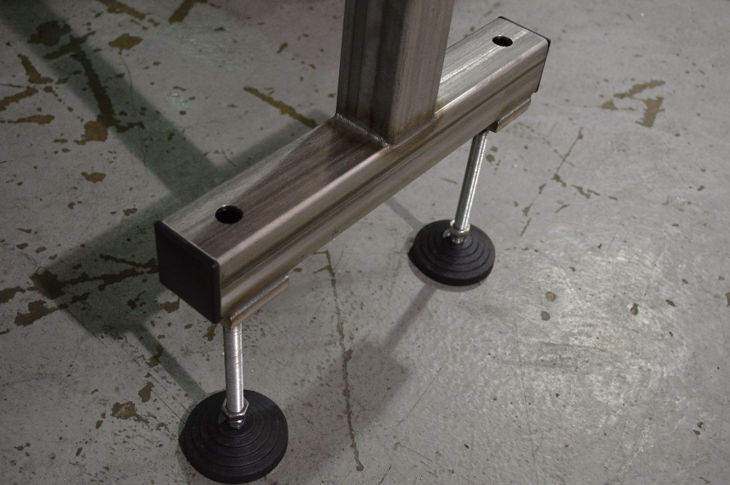

# SECTION THREE – PREPARING TO FILL

**3.1 LOADING PRODUCT INTO THE TANK**

Fill the supply tank 2/3 full of product. Visually monitor tank level throughout bottling run and refill when desired

**3.2 SET CONVEYOR RAILS TO CONTAINER SIZE**

Adjust the guide rails in from the front and back until the bottles are centered under the filling nozzles from front to back.

**3.3 ADJUST HEIGHT AND SPACING OF NOZZLES**

The height of the nozzles is adjusted using the handwheel at the top of the nozzle support stantion. The locking screws on the side will be loosened before adjusting height. The nozzle spacing will be adjusted so the fill tubes are centered in the neck of the bottles when lowered for filling.

**3.4 ADJUST ENTRY/EXIT GATES BASED ON ACTUAL SIZE**

The entry and exits gates should be adjusted to center the set of bottles to be filled under the nozzles from left to right.

**SECTION FOUR – OPERATIONAL ADJUSTMENTS**

**4.1 ADJUSTING FILL LEVELS**

Add or remove spacer washers above the sealing washer to raise or lower the fill level in the bottle. The fewer the spacers the lower the fill level, and vice versa.

**SECTION FIVE – PERIODIC MAINTENANCE, CLEANING, AND LUBRICATION**

**MAINTENANCE**

Ensure that you perform a monthly visual inspection for wear on the fill heads, conveyor chain, and pump leaks.

**CLEANING THE MACHINE**

The Econo-Filler comes in stainless and aluminum construction. Cleaning the machine regularly is recommended using soap and water.

**LUBRICATION**

The only lubrication points on the machine are:

1. The conveyor idler sprockets inside the frame of the machine may need some grease once/year. The conveyor idler sprockets are located under the conveyor chain.
2. Any threaded rod for linear motion should have light oil applied to it periodically to prevent rust and to keep the mechanism moving freely.

**SECTION SIX - TROUBLESHOOTING**

The list below represents a few scenarios in which troubleshooting may need to occur.

**6.1 NOTHING WORKS AT ALL/POWER IS ON BUT NOTHING WORKS**

1. Check main power. Is machine plugged in? Is main power switch turned on?
2. Check fuses inside control panel.
3. Are speed controls turned up above zero?

**6.2 OPERATIONAL INCONSISTENCIES (NOTHING IS BEING FILLED)**

1. Confirm that filling is on and that the counting eye is changing states between bottles.
2. Confirm that air supply is on.
3. Confirm bottles per cycle is not set to zero.