Operation Manual
OF-8 Filler

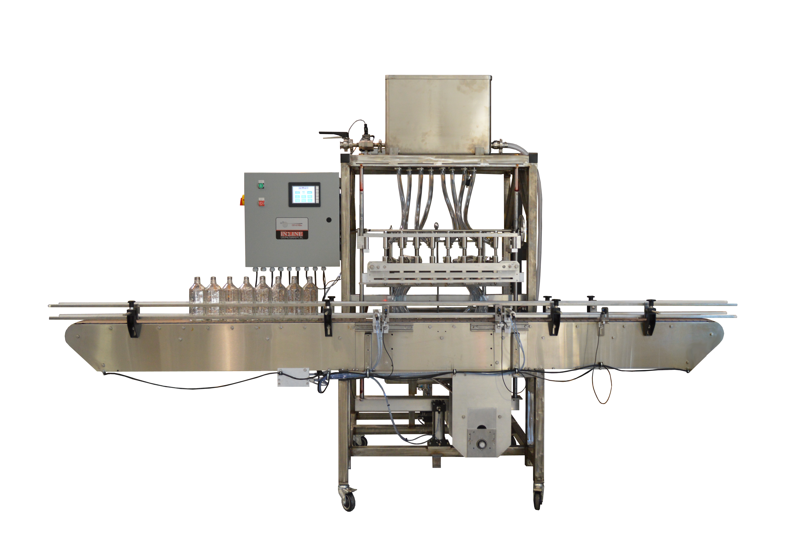
Operation Manual
Pressure Sensitive Labeler

In-Line Labeling Equipment, Inc.
7282 Spa Road, North Charleston, SC 29418
Phone: 843.569.2530 Fax: 843.569.2531
www.labeling.net

OF-8 Filler

CAUTION!
Pressure Sensitive Labeler

In-Line Labeling Equipment, Inc.
7282 Spa Road, North Charleston, SC 29418
Phone: 843.569.2530 Fax: 843.569.2531
www.labeling.net

Persons operating this machinery are reminded to observe their own company safety policies. In addition, the following safety rules should be observed:

DO NOT REACH INTO THE MACHINE WHILE IT IS IN OPERATION.

USE ONLY THE CORRECT TOOL FOR THE JOB BEING DONE.

STAY ALERT, REMEMBER LOCATION OF CONTROL SWITCHES.

MAINTENANCE

The main electric switch supplying power to the machinery should be locked out or disconnected when repairs are performed on this equipment.

Machine should be cleaned and inspected regularly. All safety switches must be operable, attachments secure and machine free of broken glass and paper.

Do not hand lubricate when the machine is in operation.
Work area should be kept clean and as dry as is practical.

The repair or adjustment of this equipment should be performed only by persons qualified through technical training and ability, as assigned by your company.

OPERATION

All guards should be securely in place before operating the machine.

Company rules on eye protection should be followed.

Loose clothing or jewelry such as neckties, rolled sleeves, over blouses, bracelets, watches and rings should not be worn when operating the machine.

Report all malfunctions, unusual operation and defects immediately.

Please exercise caution with any moving parts, including the conveyor and any pinch or drive rolls.

Stop the machine before placing hand or arms near or into any area where moving parts are located.

Table of Contents

Section One - General Information
1.1 Terminology of Machine
1.2 Specifications and Requirements
1.3 Functional Description of Machine
1.4 Basic Machine Controls
1.5 PLC Screens

Section Two - Uncrating and Installation
2.1 Power and Air Connections
2.2 Installing in Production Line
2.3 Leveling Base Machine
2.4 Leveling Label Heads
2.5 Adjusting Web Path and Height

Section Three - Preparing to Label
3.1 Loading Label Reels
3.2 Set Conveyor Rails to Container Size
3.3 Adjust Aligning/Spacing Belt to Align Containers
3.4 Adjust Top Belt to Container Height
3.5 Adjust Height of Label on Container
3.6 Adjust Web Guides
3.7 Adjust Label Gap Sensor for Height of Label
3.8 Adjust Timing of Label
3.9 Adjust Angle of Peel Plate, Taper or Labeling Head
3.10 Adjust Skew of Label
3.11 Adjust Spacing of Containers
3.12 Adjust Brushes for Wiping of Label
3.13 Set Wrap Station for Container Size

Section Four - Operational Adjustments
4.1 Adjusting Label Gap Sensor for Gap Detection
4.2 Adjusting Label Tracking and Presentation to the Container
4.3 Operator Interface and Machine Settings

Section Five - Periodic Maintenance, Cleaning and Lubrication

Table of Contents (continued)

Section Seven - Parts Diagrams

Section Eight - Options and/or Specials supplied with machine

Section Nine - Recommended Spare Parts (if Supplied)

Section One - General Information

The Paradigm 700NR is a fully automatic front/back labeling machine consisting of two Labeling applicators, an integrated conveyor, a Top Belt mechanism to hold containers, a spacing/orienting belt for centering containers, and an optional Wrap Station for applying wraparound labels on round containers.

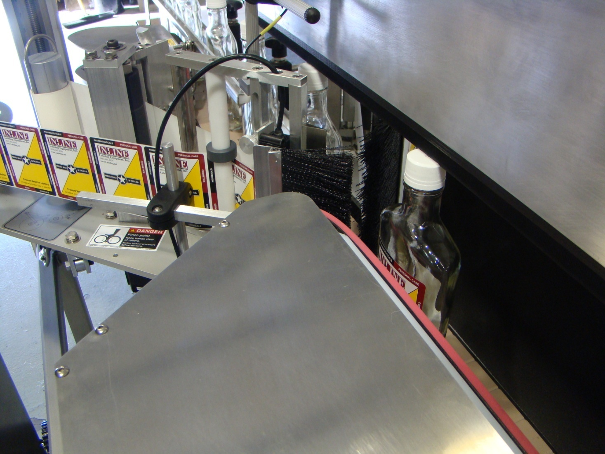

1.1 Terminology of a Labeling Machine
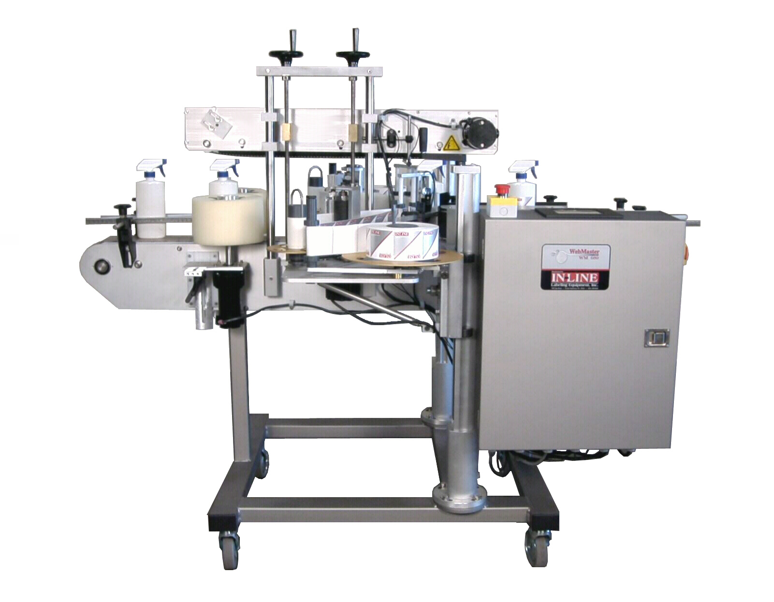
1
2
3
4
5
6
7
8
9
10
11
12

Typical Front/Back Pressure Sensitive Labeler

1. Guide Rails 7. Wrap Station (Optional)

2. Bottle Orienter 8. Operational Interface

3. Web Station 9. Main Power Switch

4. Top Belt Adjustment Wheels 10. Electrical Box

5. Top Belt Mechanism 11. Linear Motion Adjustment Assembly

6. Label Station Height Adjustment 12. Locking Casters (Optional)

Typical Labeling Applicator
5
6
7
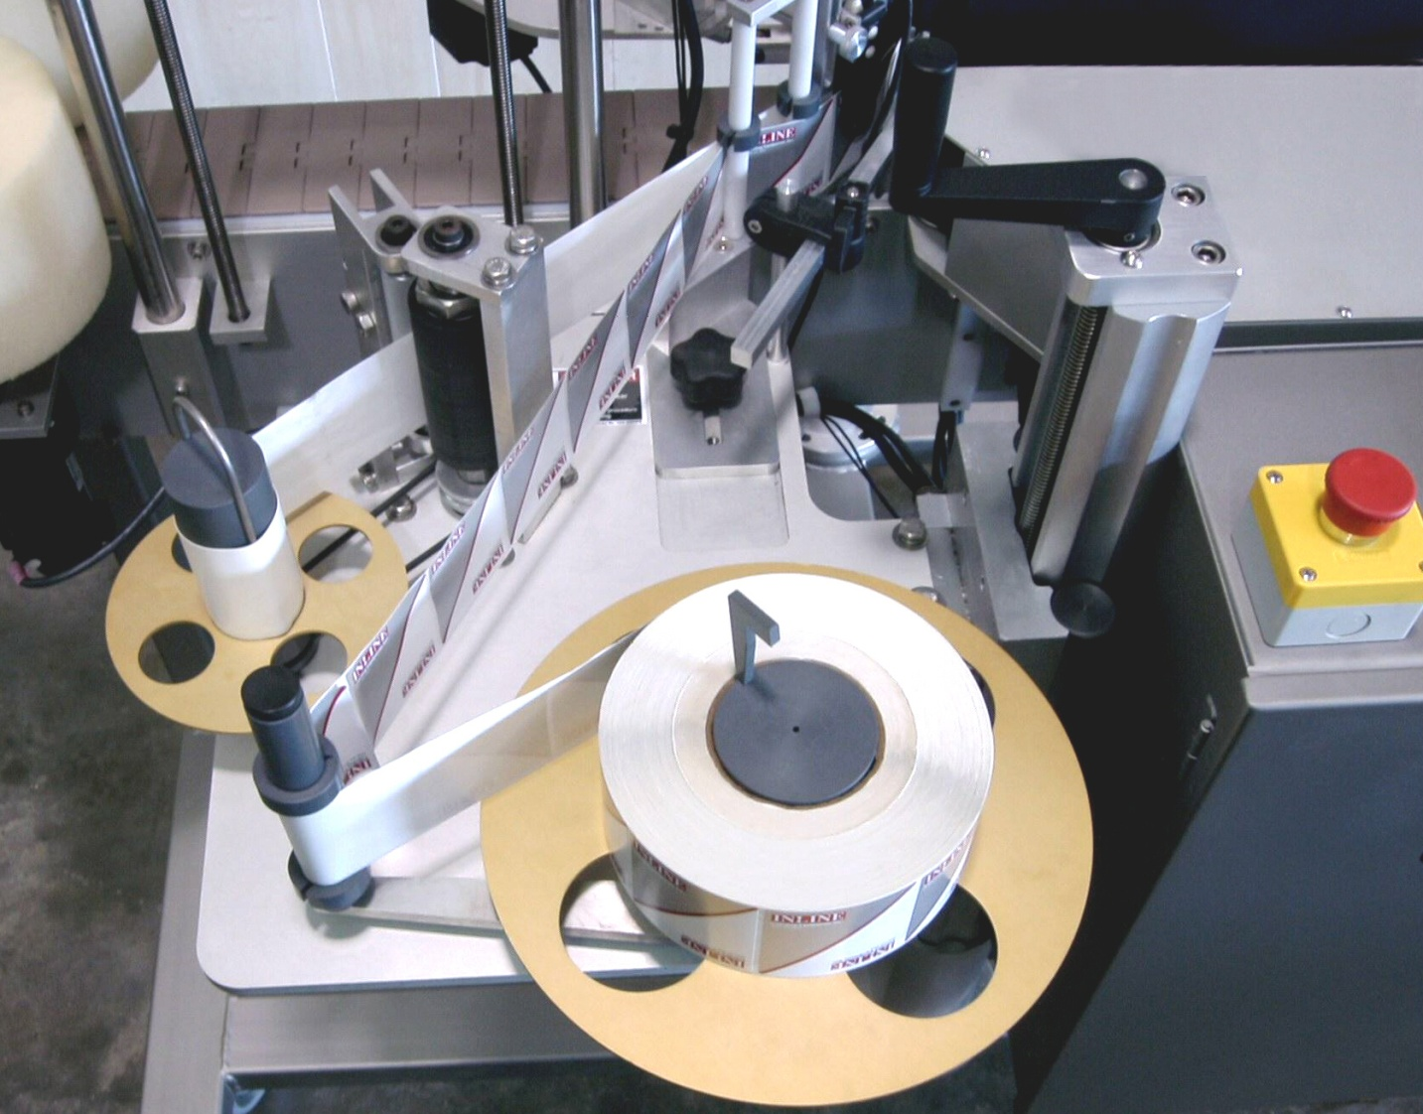
4
3

8
2

9
1

10

12

11

1. Take-up Reel 7. Wrap Station (for round containers)

2. Locking Pinch Roll 8. Label Height Adjustment Handle

3. Drive Roll 9. Peel Plate Adjustment Knob

4. Label Gap Sensor 10. Label Feed Reel

5. Peel Plate 11. Dancer Arm

6. Wiper Brush 12. Web Guides
(for non-round containers)

1.2 Specifications - Standard Machine

Item | Specification
Conveyor width | 4 ½ inches standard
Label width (height) | 1 inch to 4 ½ inches tall
Label length | 1 inch to 12 inches
Core size | 3 inches
Maximum roll diameter | 12 inches
Label height on container | 1/16 to 6 inches high on container
Container diameter/width range | 1 to 5 inches
Machine speed | Variable to 1200 ipm
Machine weight | 275 lbs
Overall dimensions | 84” long by 55 ½ ” wide by 68” high
Electric requirements | 120 VAC, 60 hz, 10 amp
Air requirements | 65 psi, 3-4 cfm, optional

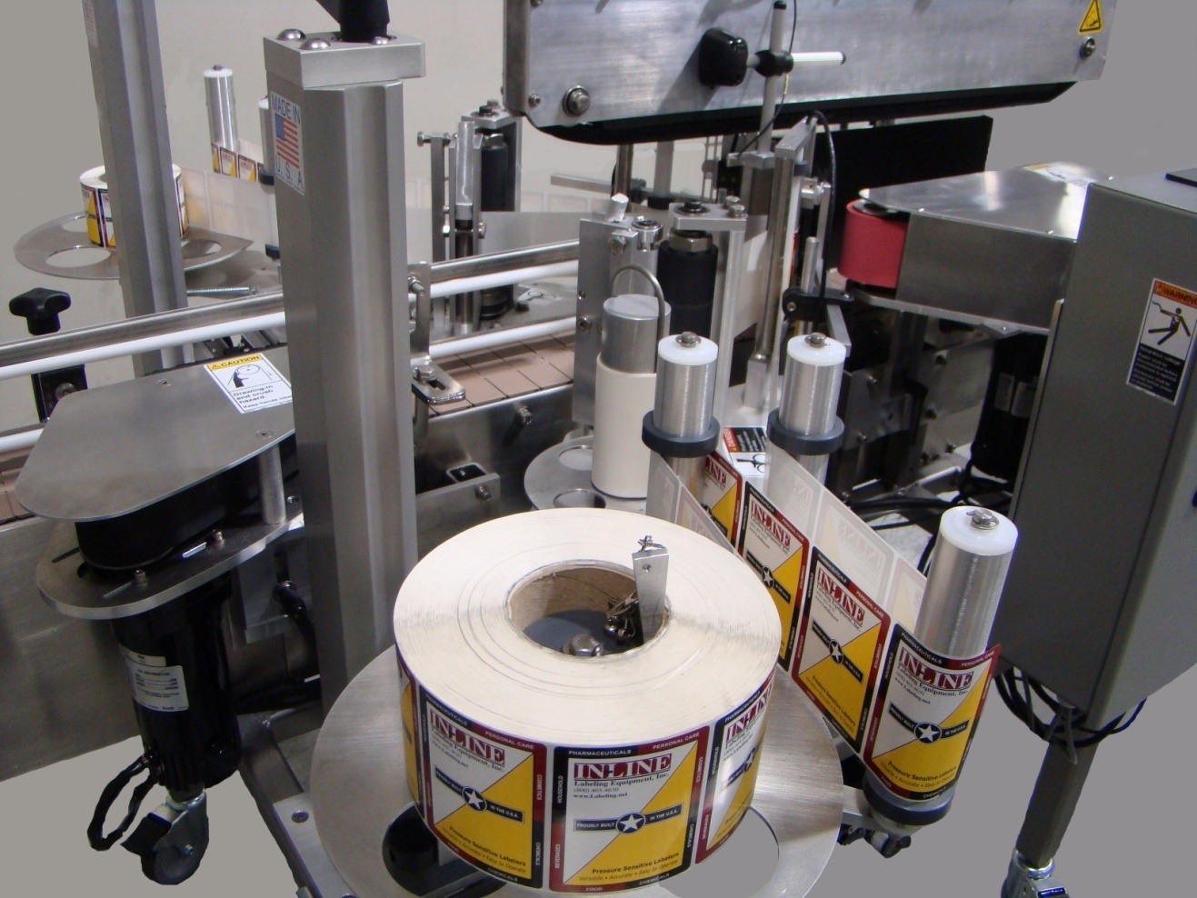

1.3 Functional Description of Machine

The Paradigm 700NR labeler is a fully automatic labeling machine capable of applying front and/or back labels to non-round containers, and with the option of front/back or single spot or wrap labels to round containers. The machine functions in this manner:

Containers pass through the spacing/aligning belt, which straightens and spaces the containers.
Containers come under the control of the Top Belt, and maintain their position as they travel through the labeling zone.
Containers are detected by the container Photoelectric Eye, usually mounted on the top belt.
This signal initiates the controller to count the position of the container, and after the adjustable count delay is met the Label Feed stepper motor engages, pulling the web around the Peel Plate, where a label dispenses.
As the label is dispensed from the Peel Plate the leading edge is applied to the side of the container. The label will continue to dispense until the end of label signal is received from the gap-sensing mechanism, generally a through-beam photoeye.
The photoeye will be adjusted to “see” through the gap between labels but not through the label itself, providing a signal to the controller while passing across the gap. The gap sensor may use light or in the case of some labels sound to detect.
When the label gap sensor detects the end-of-label gap the signal then starts an adjustable delay for the stopping position of the next label.
A follower brush is mounted to wipe down the label as it is being applied. For flat or oval containers this will complete the wiping of the label.
Round containers enter the Wrap Station, which consists of a Spin Belt on one side of the container and a back rubber pad. The container is slightly compressed between them and “spins up” the label between the belt and rubber pad, wiping the label down.
Once a container has cleared the container photoeye the next container can now enter and start the cycle again.

1.4 Basic Machine Controls Typically present on a Labeling Machine

1. Main Power Switch

2. Emergency Stop on Conveyor

3. Emergency Stop on Panel
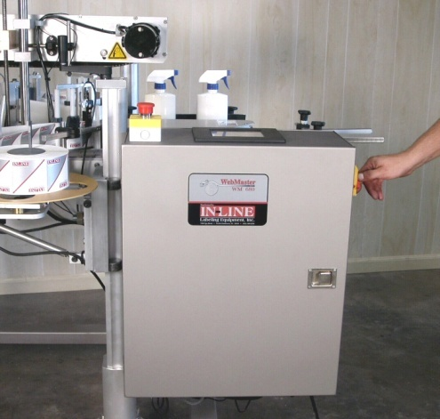

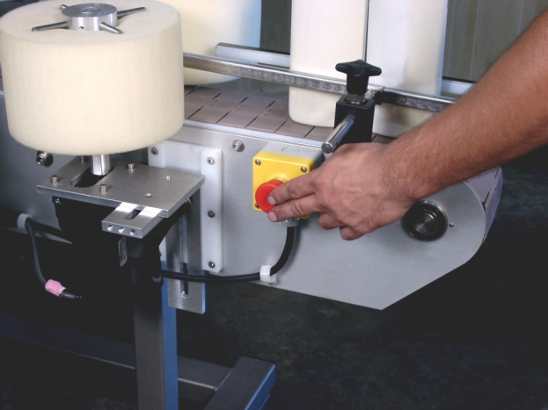

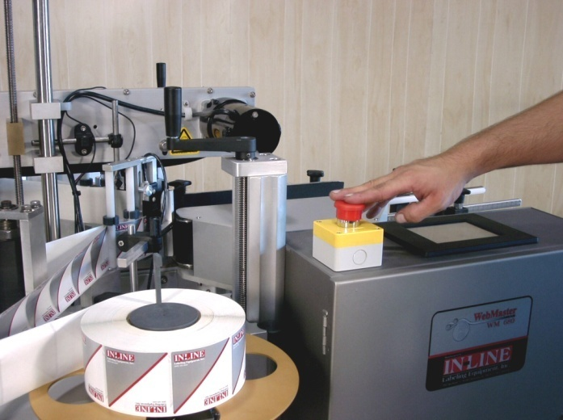
Section Two - Uncrating and Installation

2.1 Power and Air Connections

A grounded electrical male plug is provided with the machine, and is connected to the main electrical enclosure on the rear side of the machine. Plug this into any grounded receptacle. For machines requiring compressed air, on the machine is an air filter/reservoir with a 1/4” male quick disconnect attached. You can supply compressed air to the machine by either a mating quick disconnect on the end of an air hose, or you can permanently pipe air to the machine using standard pipe and connecting directly into the air filter using threaded pipe connections. If you permanently pipe into the system we recommend a cut-off valve be mounted at the machine. Some changeover adjustments are easier if the operator is able to temporarily turn off the air pressure.

2.2 Installing in Production Line

Move the machine into its permanent location. Adjust the conveyor height of the machine to match the heights of the adjoining machines as required. Four leveling pads are provided with the model 700NR that allows you some vertical adjustment. If necessary, make spacing blocks to raise the height. Approximately 18 inches of lineal space is provided on each end of the machine to allow a crossover from or to the next machine. Butt the conveyor sides as close to each other as possible and then use conveyor rails to guide the containers across narrow dead plates onto the conveyor.

2.3 Leveling the Base Machine

Once the machine is installed, level the main conveyor through the machine by using a bubble level. Place the bubble level along the length of the machine and also perpendicular to the conveyor at the Label Station. Leveling the machine is important to the quality of labeling since this will affect both the web path and container path. The squareness and straightness of the base machine will ensure the machine operates correctly.
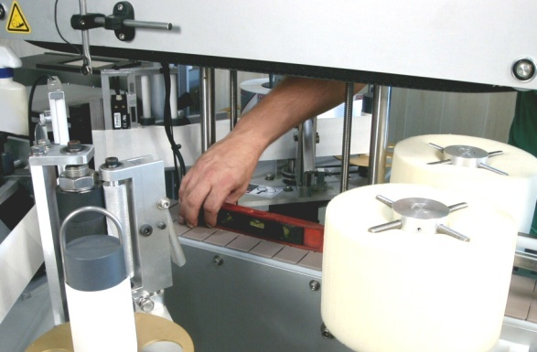

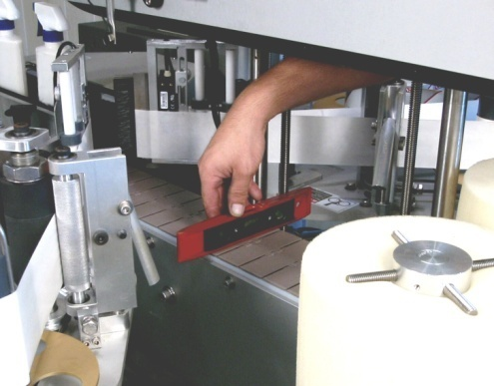

2.4 Leveling the Label Heads

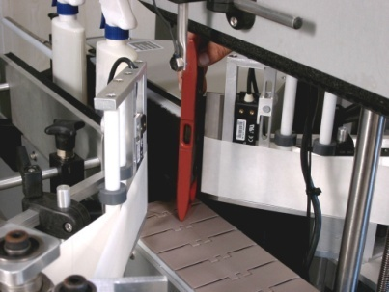
Next level the Label Head itself. This is best accomplished by using a small square (a machined square finish) or a bubble square. Place the square on the conveyor and reference it to the end and side of the Peel Plate.

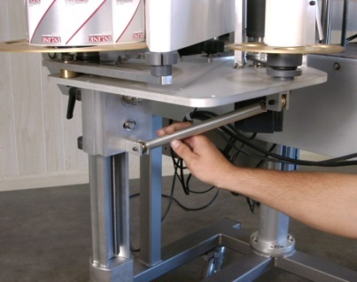
Adjust the Label Station taper turnbuckle support underneath to move the Label Head until the end of the Peel Plate and the side of the Peel Plate is square to the conveyor at the point of labeling. This will ensure that the label is feeding off the Peel Plate in a straight fashion onto the container. It may be necessary to shim between the support angle and the Labeling Head to establish squareness. This procedure is generally done at the factory prior to shipment.

The most common reason for skew in the labels is that the Peel Plate is not square to the conveyor, and labels are feeding out crooked in their relationship to the container.

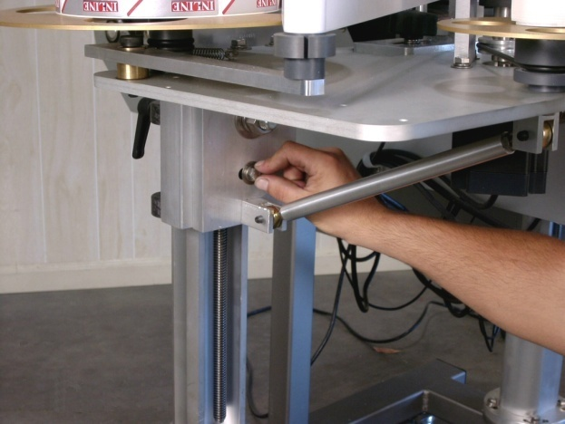
The appropriate adjustments may be performed by loosening the mounting nuts that attach the Label Head angle support to the upright vertical linear motion device. Then the angle bracket (and Label head) may be pivoted to adjust the squareness of the Peel Plate to the container. This adjustment is factory set but may loosen in shipping.

2.5 Adjusting Web Path and Height

Now that the main conveyor and Label Head are leveled, ensure that the web is tracking straight through the machine. The web is intended to travel at a height exactly 2 inches above the Top Plate of the Label Station. Since the bottom of the Peel Plate serves as a web base, measure it with a ruler. Then measure the height of each of the bottom guides at the point where the bottom of the web would travel and make sure they are equal. The web should now travel straight through the entire web path. The top Web Guides should be moved up or down to the label height (web width) of each label.

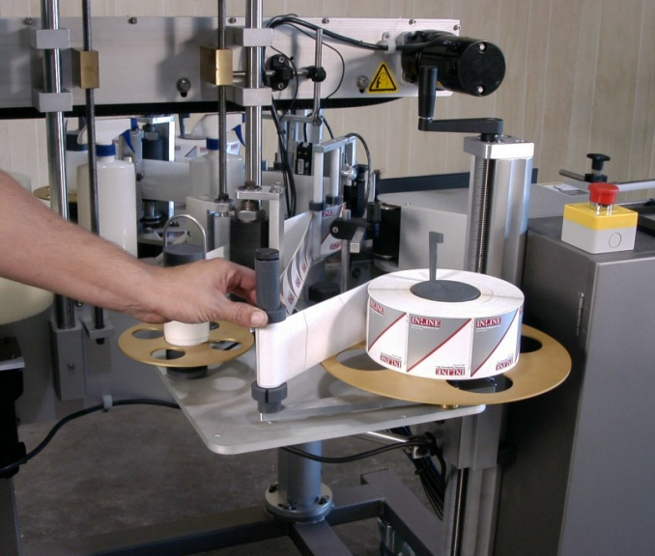

Section Three - Preparing to Label

3.1 Loading Label Reel
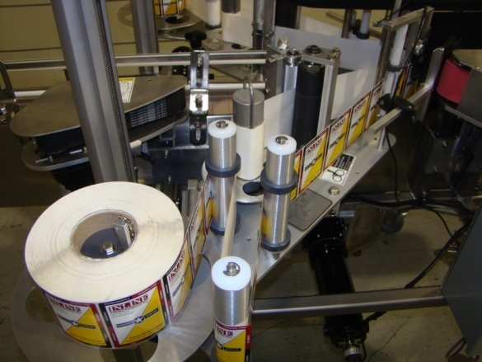
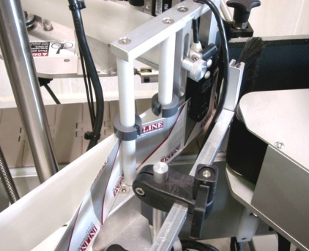
Slide the roll down onto the Feed Reel and lock it into place using the key to make sure it does not spin around the hub. For the dancer arm to maintain tension on the web the roll of labels cannot spin around the hub. Feed the labels around the first idler roll, then back to the Dancer Arm, around the rear guide roll, through the Label Gap Sensor, around the roll just behind the Peel Plate mount, across the face of the Peel Plate, around the end of the Peel Plate, back behind the Peel Plate, behind the roll at the rear of the Peel Plate mount, and then around the knurled aluminum Pinch Roll, between the Drive Roll and knurled Pinch Roll, and then around the Take-up Reel. Attach the spent web to the Take-up Reel using the supplied “Shepherd’s Hook”. Please review the picture for the correct web path.

3.2 Set Conveyor Guides to Container Size

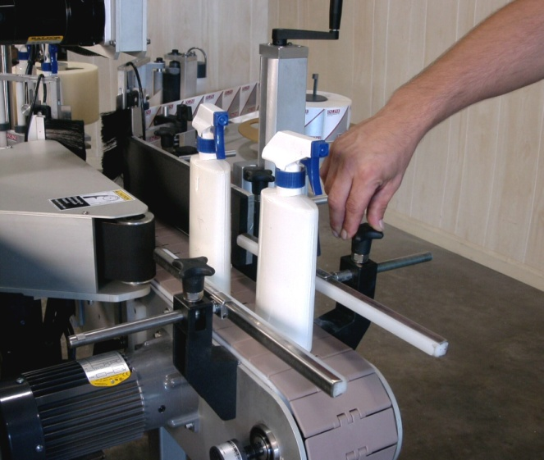
The Conveyor Guides must be set to the container size to ensure smooth control of the containers into and through the Labeler. On the 700NR the containers center on the conveyor through the machine, so the Conveyor Rails should be used to center the container as close as possible. Adjust by loosening the knobs holding the rods attached to the rail and then slide the rod in or out. Tighten the handle once complete. The correct tightness to the container diameter should allow about 1/8” to 1/4” of space greater than the width of the container.

3.3 Adjust Aligning/Spacing belt to Align Container

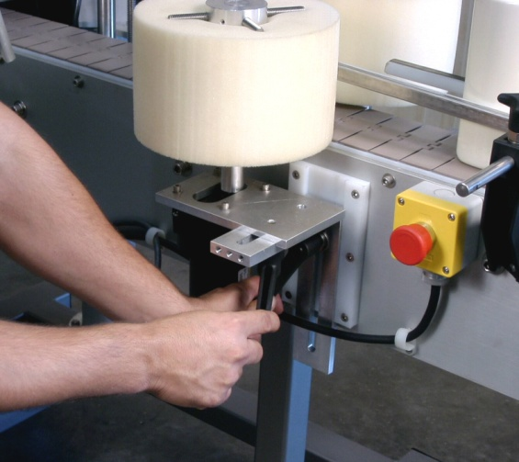
The Aligning/Spacing belt will compress the containers and square them as they enter under the Top Belt. First place a container on the center line of the conveyor and then move the outside rail to lightly touch the back of the container. Loosen the handles underneath the belt mechanism and on the side of the machine to move the belt housing in and out. Place a container in the widest part of the aligner, and then adjust the mechanism until the container is snug against the back rail. Not much tension is needed, only enough to straighten or align the container as it passes through the rolls, and provide space between containers so that labeling can be accomplished. The belt can be moved up or down on the container to provide the best control (no tipping).

3.4 Adjust Top Belt to Container Height

The purpose of the Top Belt is to maintain the alignment of the container through the labeling zone so that the labels are applied to the sides of the container. A light downward force on the container is all that is needed. To adjust the height, loosen the two jam nuts under the top bar of the top belt mechanism. Place a container at each end of the top belt where the belt is at its lowest. Now crank the handle on the end of the top belt until the belt is sitting on the cap or top of the container. Again, too much force will sometimes cock the container, rather than just holding it. Too little pressure and the container could move as it receives labels.

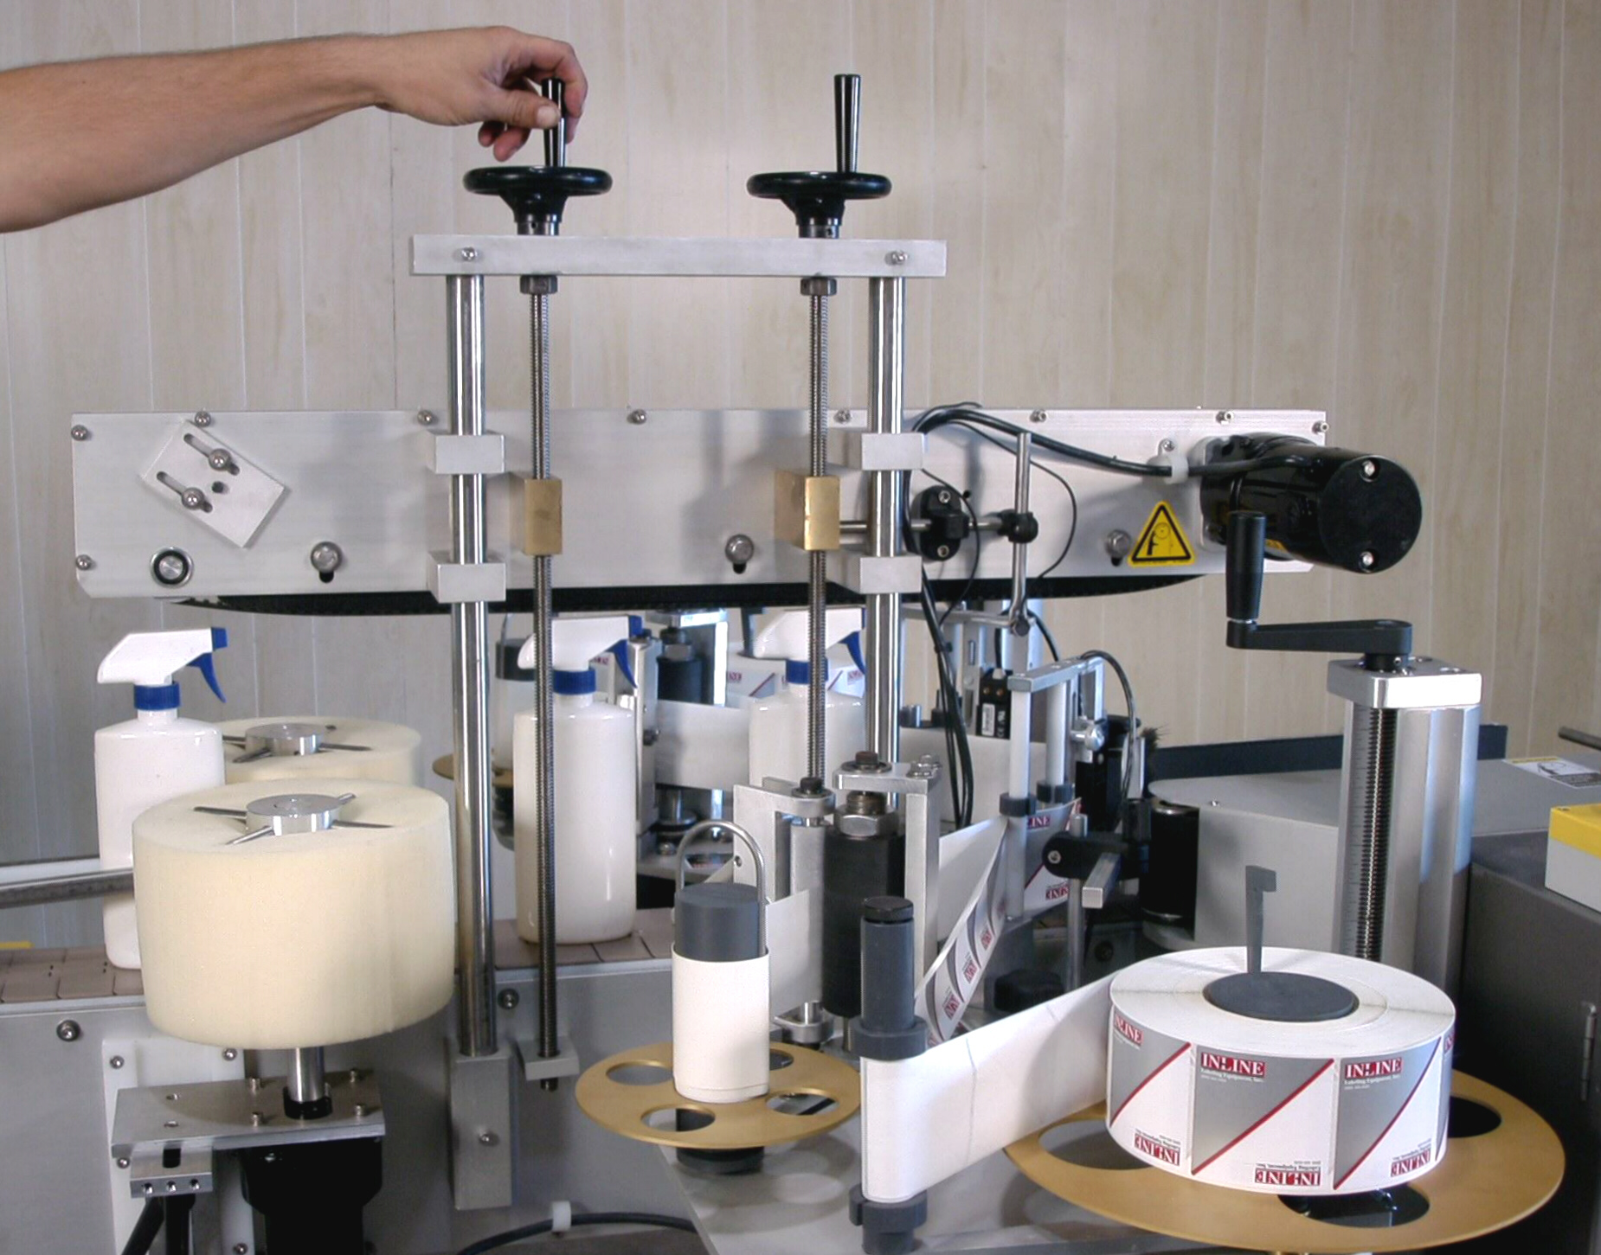

Jam nuts

3.5 Adjust Height of Label on Container

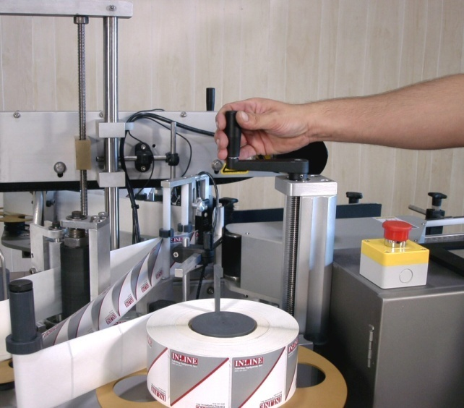
The entire Label Station moves up and down to move the label location vertically on the container. With the machine turned off, place one of the containers to be labeled on the conveyor by the Peel Plate and centered under the Top Belt. Now locate the handle located at the top of the Linear Motion Assembly. Turn the handle clockwise to raise the entire Label Station and the counter clockwise to lower it. The bottom of the Peel Plate is approximately the same height as the lower edge of the label, and you can use it to watch the relationship of the label to the container. Adjust until the label height is located where you desire.

3.6 Adjust Web Guides

There are several plastic Web Guides on the vertical silver rolls that guide the web through the machine. These Web Guides help to keep the label web tracking through the machine at the same height. This is essential to consistent labeling.
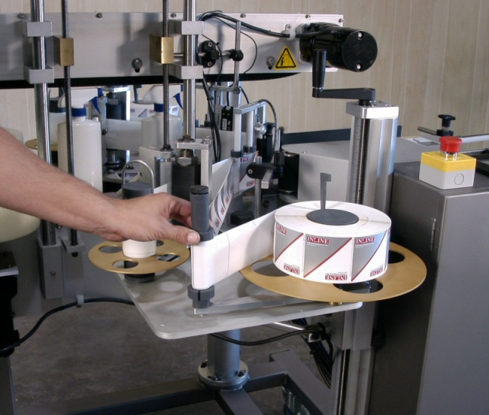
The lower edge of the label web is 2 inches from the top of the Label Plate and so the lower Web Guides should be at that level. These can be measured with a ruler. The top Web Guides can be then moved up or down depending on the height of the label web being run. They should be positioned to allow 1/16” clearance of the web. If the web rides up or down the guides will help hold it in place.

3.7 Adjusting Label Gap Sensor for Height of Label

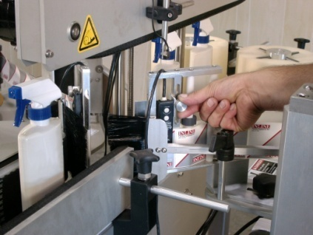
The Label Gap Sensor for detecting the gaps is present to stop the label in the correct location. The gap sensor on the 700NR labeler is positioned to stop the label and is two inches from end of the Peel Plate. The only adjustment necessary is for the height of the label. Loosen the knob to the right of the Label Gap Sensor and move the sensor up or down to the appropriate height. Tighten the knob.

3.8 Adjust Timing/Placement of Labels on Container

As the container passes through the container photoeye, a counter is started for each Label Station that is active (turned on). This counter is referenced to the conveyor in steps. By using the operator interface the position of the label can be changed by increasing or decreasing the value for Label Delay. See section 1.5 PLC Screens.

3.9 Adjust the Angle of the Peel Plate, the Taper of the Labeling Heads, and the In/Out Position of the Labeling Heads

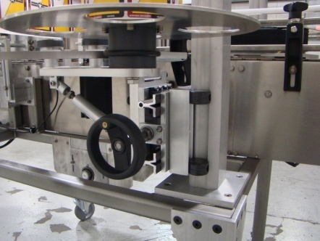
An important part of the setup is to ensure the Peel Plate matches the walls of the container. For containers with tapers (either regular or inverted) this is especially important. Place a container under the Top Belt between the Peel Plates, centered on the conveyor, and then look down the conveyor to see the position of the Peel Plates to the walls (sides) of the container. Adjust the in/out position of each Peel Plate by rotating the handle underneath the web feed reel.

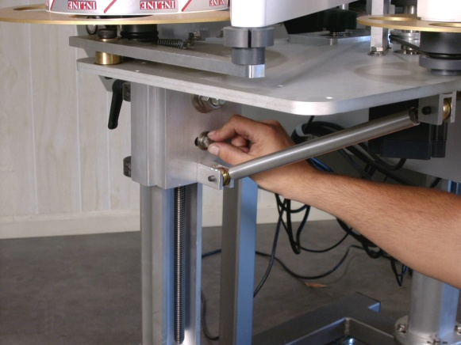

Now set the angle of the taper (or straightness) of the Peel Plate by adjusting the two bolts underneath the Labeling Head. Check the position periodically until it is at the desired point. This taper can then be locked by tightening the jam nuts.

3.10 Adjust the Skew of the Label

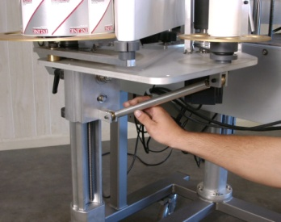
After a few test containers have been run, the skew (leaning) of the label can be adjusted. Under the side of each Label Station are two bolts where the Label Head is mounted to the stand. The Label Head pivots around the larger bolt. Loosen both bolts and tilt the Label Station to achieve the desired adjustment. Adjust the label Station and move the Label Head until the end of the Peel Plate and the side of the Peel Plate are square to the container. By adjusting this up or down the forward angle of the Peel Plate can be moved to correct any leaning of the label. Adjust these until the bottom edges of the label are flat with the base of the container.

3.11 Set the Spacing of the Containers (Optional Spacing Wheel)

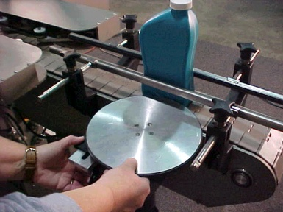
Some space between containers is necessary to ensure that the container Photoeye “resets” and can see the next container. This space is created by squeezing the containers between the Conveyor Rails and the Spacing Wheel on the infeed end of the machine. This will allow only one container to pass at a time. By varying the surface speed of the Spacing Wheel slower than the Conveyor Belt, space will be created between the containers. You should strive for a smooth flow of containers into the machine with fairly equal spacing between.

3.12 Adjust Brushes for Wiping Down Labels

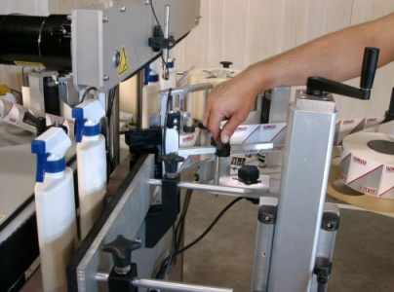
On the model 700NR, follower brushes are mounted on each label station and can be adjusted to apply a light pressure to the container where the label has just been applied. Generally, the brushes would extend beyond the peel plate by about 1 inch into the conveyor, to make contact with the container. Positioning the brushes is a matter of personal preference for each package, so experiment to find the best positions. Too much pressure from the brush can, however, either wrinkle the label or move the container, so don’t over do it. An equal amount of pressure should be exerted from each side to make sure the containers don’t cock to one side as they move through the labeling zone.

3.13 Adjust the Wrap Station to the Container Diameter (optional)

To set the Wrap Station Assembly to the container, there are two steps:

Adjust the Spin Belt up/down or in/out for proper contact on the container.
Adjust the Wiping Pad in/out to compress container.

Labeling a round container on the 700NR labeler still means that the container is centered on the conveyor and passes under the Top Belt. This means that the Wrap station must be adjusted to contact the container in the center of the conveyor. The Wrap Station operates by compressing the container between the Spin Belt and the Wiping Pad. This rotates the container and “spins up” the label onto the container. The Wiping Pad wipes the label down.

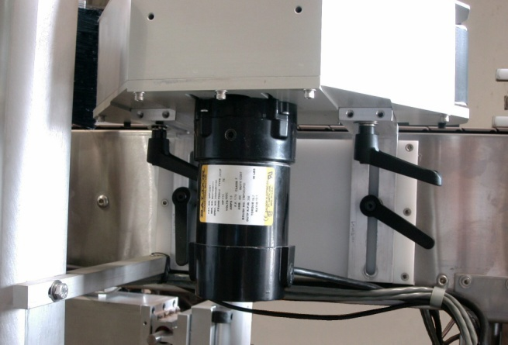
The Spin Belt is mounted on two angle slides. Loosening the knobs on the side of the conveyor frame allows you to move the whole Spin Belt Mechanism up and down to change where the belt contacts the container. Lock down the desired position by tightening the knobs. Underneath the housing of the Spin Belt are knobs, that when loosened, allow the Spin Belt to slide in/out. The Spin Belt should be positioned to contact the container.

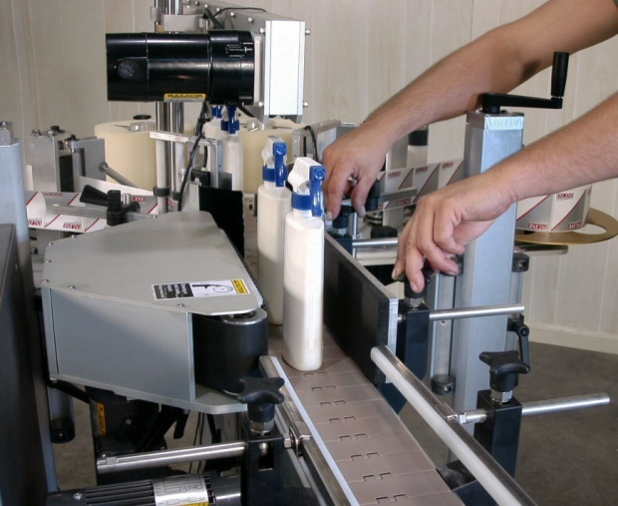
The Wiping Pad is moved in or out to slightly compress the container once the Spin Belt is positioned. There is no need for the compression to deform the container - a light amount of pressure is enough to wipe the label. There are also angle brackets on the Wiping Pad that allow you to square the pad to the wall of the container. Please make sure that the pad and the wall of the container are aligned.

It should be noted that for best labeling the container should move smoothly through the machine without “pausing” due to contact with something. The container should move consistently past the Peel Plate, receive the label, and begin to spin up in one smooth motion. Any interference of the container will likely result in a wrinkle or pucker on the label, since the label can hit something if the container stops.

Also, the movement of the container through the Wrap Station is critical to good labeling. Watch the container as it passes through to make sure it does not “ride up” and lift off of the conveyor surface. If it does, this means that there may be too much pressure, or that the Wiping Pad or Spin Belt is angled versus the wall of the container. Any pressure point will force the container to move. The result is typically a “leaning” label - not straight on the container - or wrinkles in the label from side-to-side.

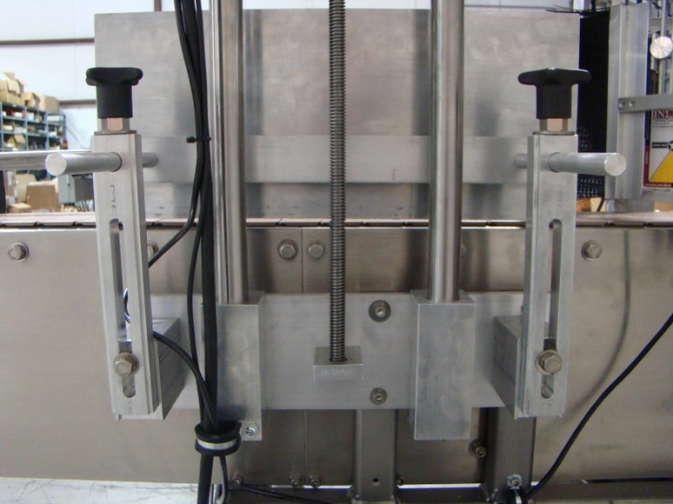

Section Four - Operational Adjustments

4.1 Adjusting Label Gap Sensor for Gap Detection

The Labeling Head on your 700NR requires periodic adjustment when changing label reels, and occasionally while running.
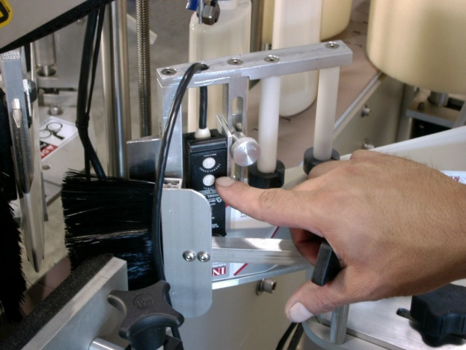
Position the arrow on top of the Label Gap Sensor so that it is in the gap between the labels. Press the “normal” button, which is on the top, for normal, opaque labels on white liner. The “translucent” button should be used for brown Kraft liners and/or for labels that are not opaque.

4.2 Adjusting Label Tracking and Presentation to Container

The tracking of the label through the machine is extremely important to consistent labeling. If the label web “rides” up or down then the label will generally be skewed to one side or the other. The presentation of the label to the container is also paramount. If the machine is set up correctly the web will track consistently at the same height through the machine, riding on the Web Guides and around the Peel Plate, then the label will be presented squarely to the wall of the container to be labeled. The label will dispense onto the container as it passes by, with the Follower Brushes wiping the label onto the container. With it set up this way consistent labeling will be achieved. There are three major factors to consider in labeling consistency:

1.) The Label Web Is Tracking Up and Down:
This changes the relative height on the container. If this is the case then uneven pressure or pull is being exerted on one or more points of the web, which causes it to move up or down. Some of the potential points to check are the web Feed Reel being too high or low, the Web Guides being misaligned, the upper Web Guides pinching the top of the web, the Pinch Roll being misaligned and putting more pressure on the bottom (or top) of the web when it pinches), or the Take-up Reel being too high or low. Any of these factors will cause the label web to establish and track an angle up or down. The obvious symptom is skew of the labels in a predictable fashion, leaning to one side on the container in the same way each container that is labeled.

2.) The Squareness of the Peel Plate to the Wall of the Container:
If the Peel Plate is angled versus the wall of the container then the label will feed out angled onto the container. This can be checked by using a square and placing it on the conveyor resting against the very end of the peel plate. Also, by placing a container centered under the Top Belt between the Peel Plates you can visually see if the label will be feeding out straight onto the wall of the container. Adjust the turnbuckle angle support under the Labeling Head to match the Peel Plate to the container.

3.) The Setup of the Wrap Station for Round Containers:

The Wrap Station should be setup to wipe the label with light pressure on the container, and with even pressure up and down the wall of the container. Too much pressure, or and angle somewhere, will cause the container to ride up in the Wrap Station, angling the label or creating wrinkles.

There will always be some variance from label to label. This is due to the numerous variables of paper, container, machine, etc. In an ideal world the variance will be normally distributed: that is, if a whole group (of say 100) containers are labeled the skew will be equally on one side or the other, with the average being exactly in the middle (no skew). If plotted it would appear as a bell-shaped curve.

The rule of thumb is this: if the skew is always to one side or the other then there remains some set-up problem or deficiency that is causing it.

4.3 Operator Interface and Machine Settings

The model 680NR labeler has a Touchscreen Operator Interface through which the operator can make adjustments. Here are the following screens available and explanations of how they are used.

Main Screen:

Batch Count The current batch count is displayed

Batch Target A target batch amount can be entered here and also on the Batch Function screen discussed later.

Batch Reset By pressing this screen button the batch count is reset to zero.

Main Speed The Main speed is displayed in inches per minute. Press the number and a numeric keypad will display, allowing you to enter a different speed.

Screen Access buttons on the right side will take you to that screen when touched. Descriptions of all screens follow.

Right Label Station:

Label Off/On Turn the Label Station on or off by toggling this button. The setting is remembered through power cycling.

Label Jog While the conveyor is running a label can be jogged by pressing this button

Label Delay The Label delay is entered in inches of container travel from detection by the photoeye.

Gap Delay The Gap delay is entered in inches of label travel from the detection of the gap.

Label Ratio The Label ratio is entered as a real number. At 1.0 the speed of the label is equal to the conveyor.

Left Label Station:

The screen for this label station mirrors the right label station.
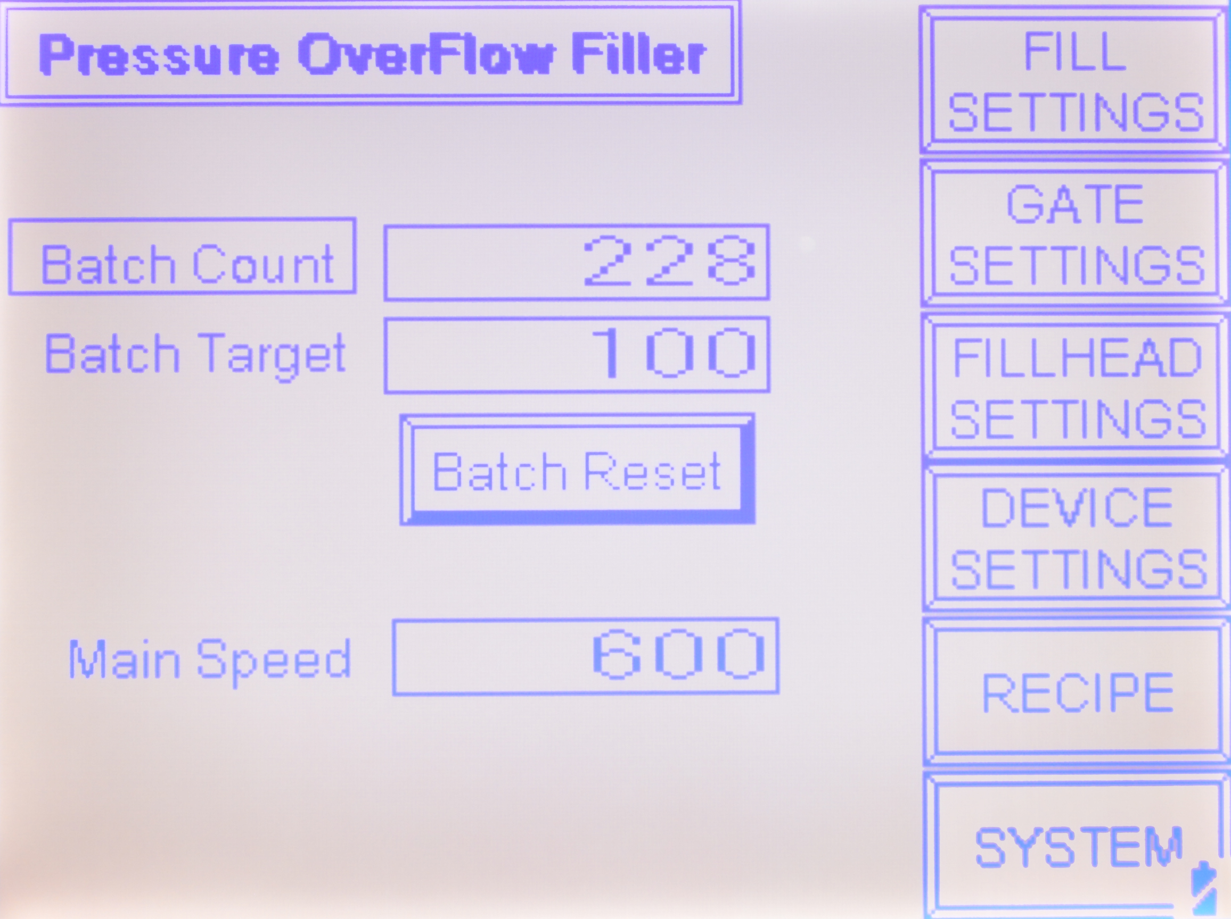

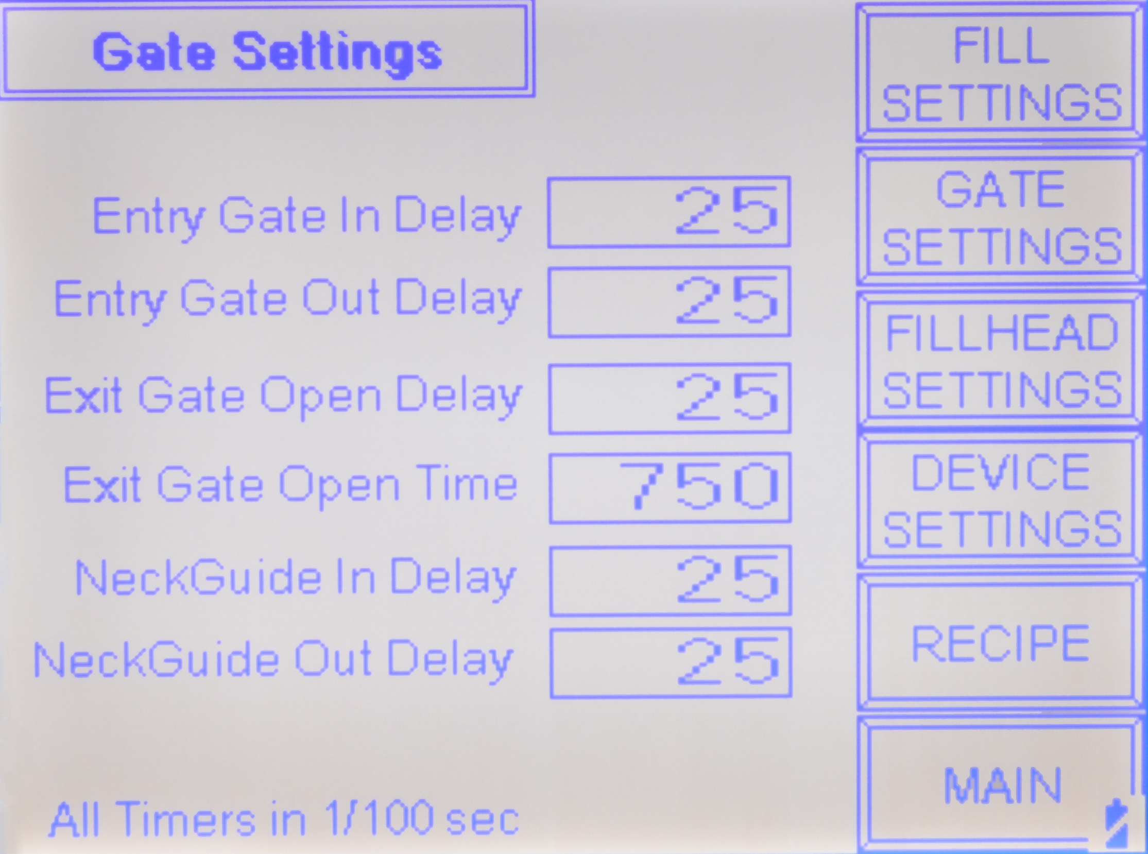
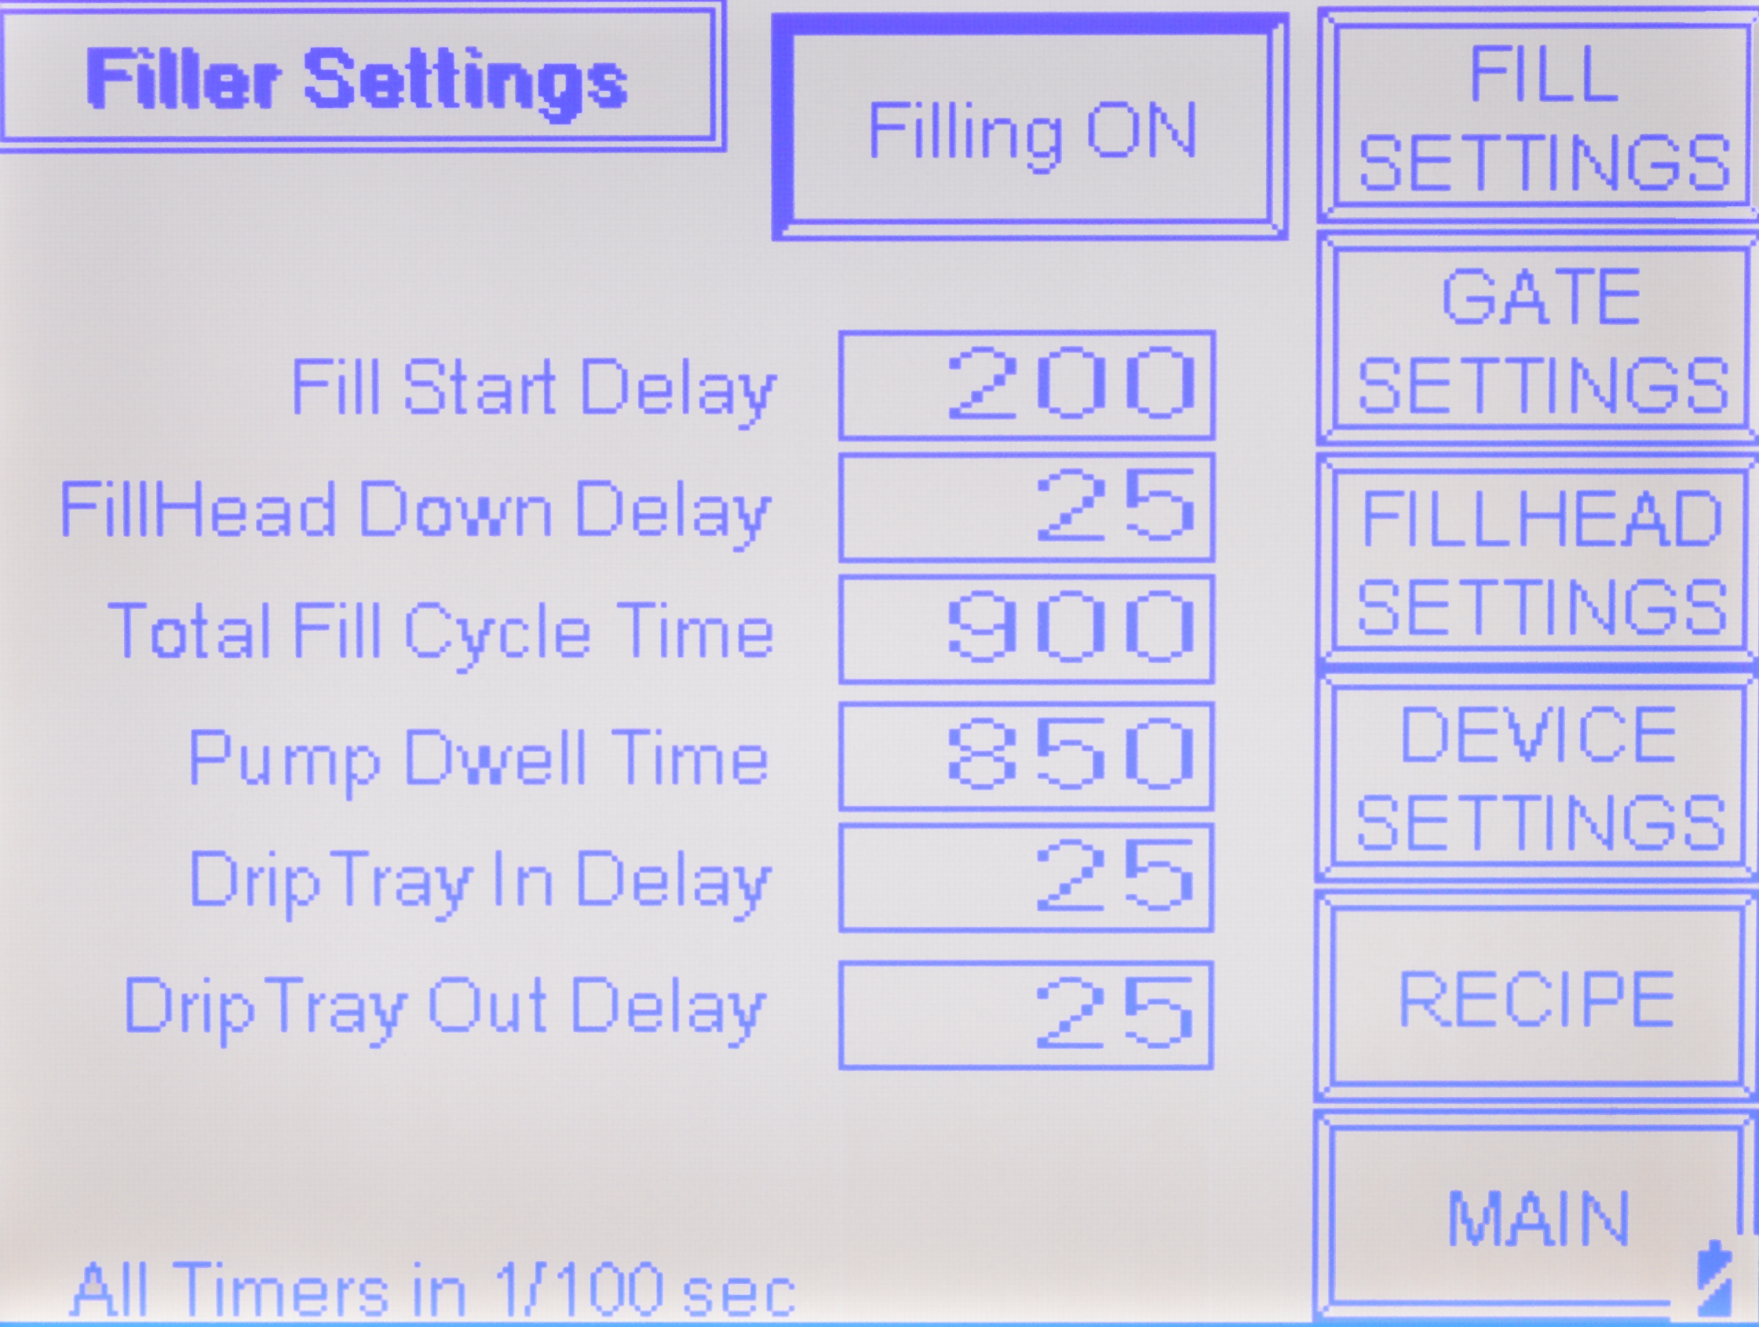
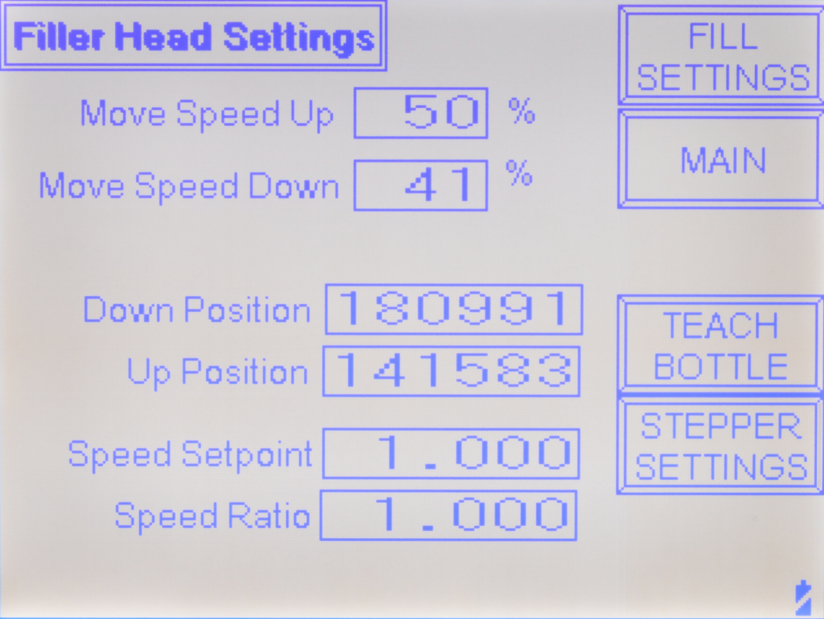
Recipe Functions:

Get Recipe Pressing this button will retrieve the saved settings for the recipe number displayed.

Save Recipe Pressing this button will save the current settings to the recipe number displayed.

Recipe Number Press this to enter a new recipe number to either save or get. Up to 99 recipes can be stored and virtually all settings are stored.

Speeds and Ratios:

All ratios are expressed as a real number where 1.0 is equal to the speed of the conveyor. A setting of 0.90 would be 90% of the conveyor speed and 1.1 is 110%.

Top Belt The belt above the conveyor.

Wrap Belt The belt that spins the bottle after the label is applied.

Orientors The belt that aligns and spaces the container as it enters the machine.

Main Speed The Main speed can be entered here as inches per minute up to 1200.

System Settings:

The buttons on this screen turn on or off the devices or features of the machine. These settings are retained through power down and the on or off status of the device is also.

Top Belt The belt above the conveyor
Spacing Optionally supplied for spacing
Wrap Optional for wrap labels
Belt Aligner The aligner/spacing belt.
Infeed Ctrl Optional with photoeye to regulate containers coming into machine
Backup Ctrl Optional with photoeye to regulate containers exiting the machine.
Gap Error Enabling this will stop the machine if the gap error timer completes without seeing the next gap.
Label Error Enabling this will stop the machine if the Label error timer completes meaning no labels are in the machine.

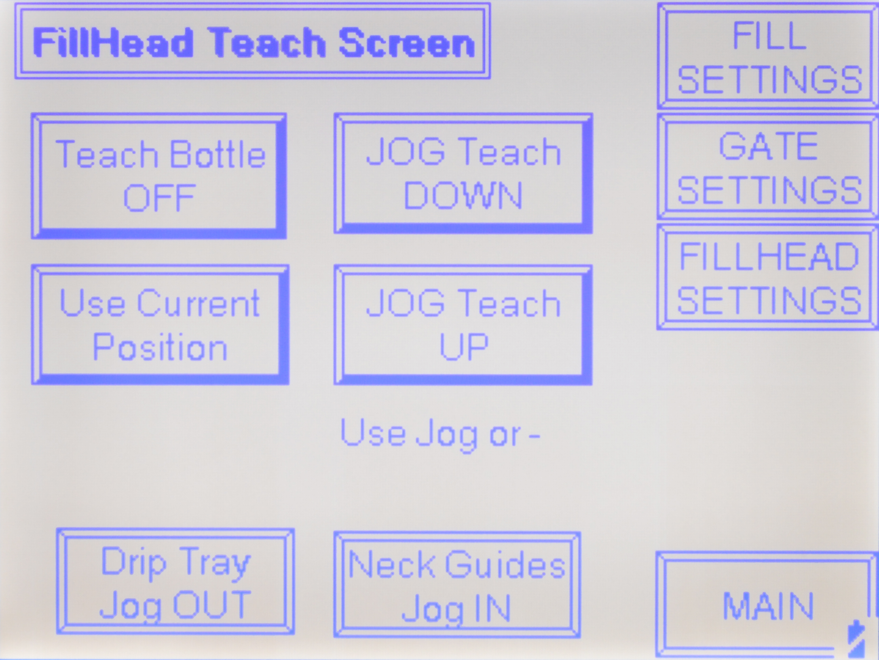

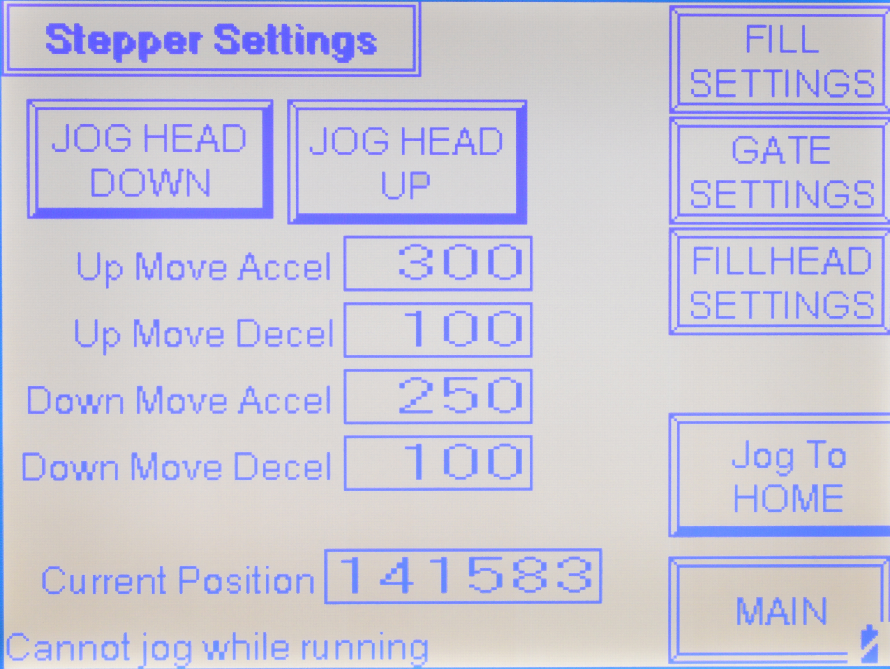

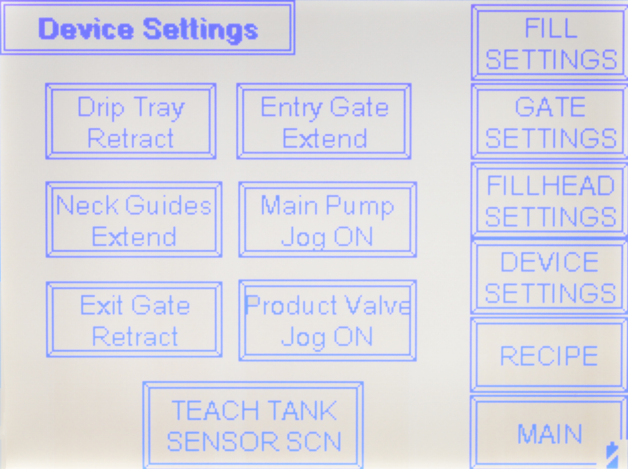
Main Screen:

Batch Count The current batch count is displayed

Batch Target A target batch amount can be entered here and also on the Batch Function screen discussed later.

Batch Reset By pressing this screen button the batch count is reset to zero.

Main Speed The Main speed is displayed in inches per minute. Press the number and a numeric keypad will display, allowing you to enter a different speed.

Screen Access buttons on the right side will take you to that screen when touched. Descriptions of all screens follow.

Right Label Station:

Label Off/On Turn the Label Station on or off by toggling this button. The setting is remembered through power cycling.

Label Jog While the conveyor is running a label can be jogged by pressing this button

Label Delay The Label delay is entered in inches of container travel from detection by the photoeye.

Gap Delay The Gap delay is entered in inches of label travel from the detection of the gap.

Label Ratio The Label ratio is entered as a real number. At 1.0 the speed of the label is equal to the conveyor.

Left Label Station:

The screen for this label station mirrors the right label station.

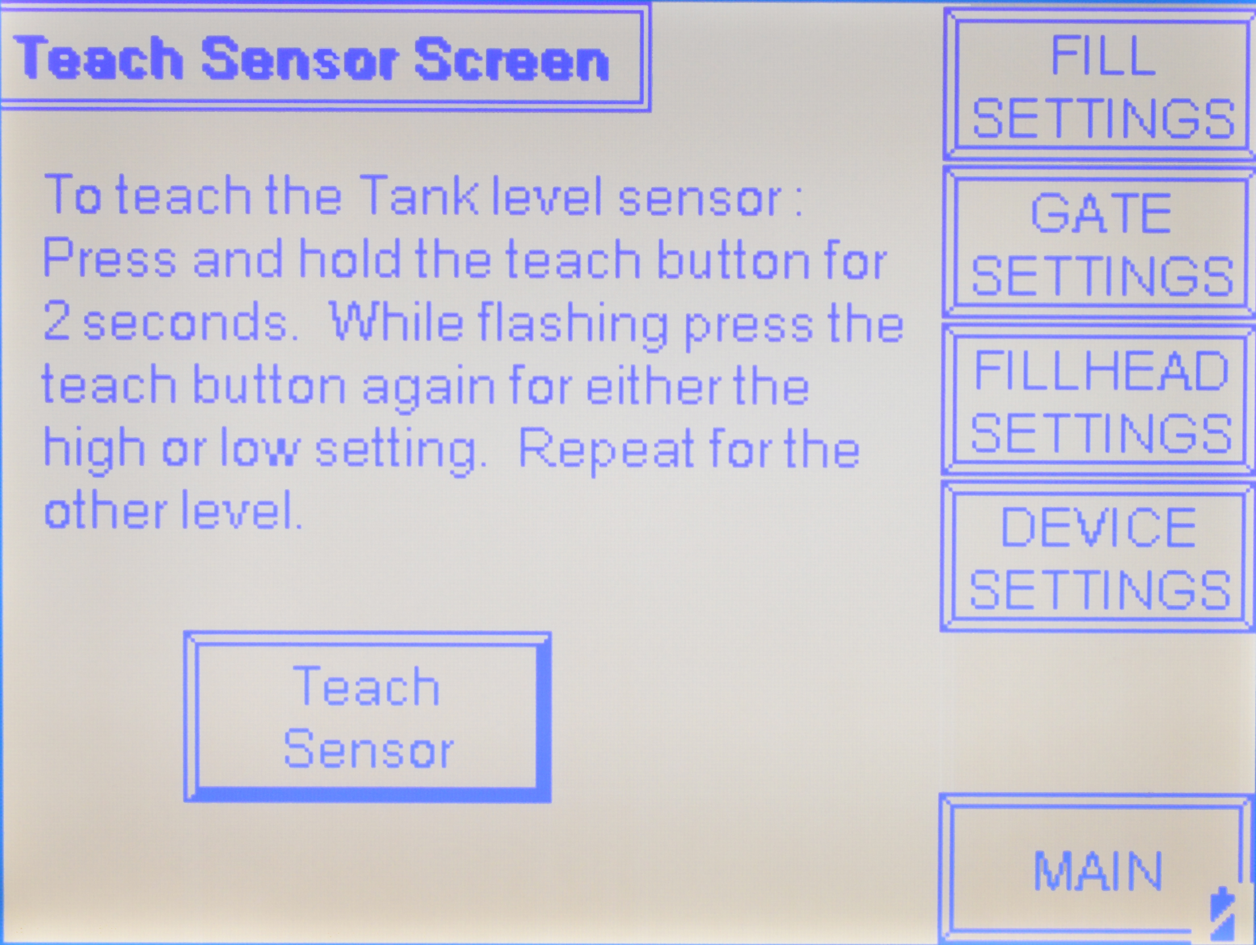
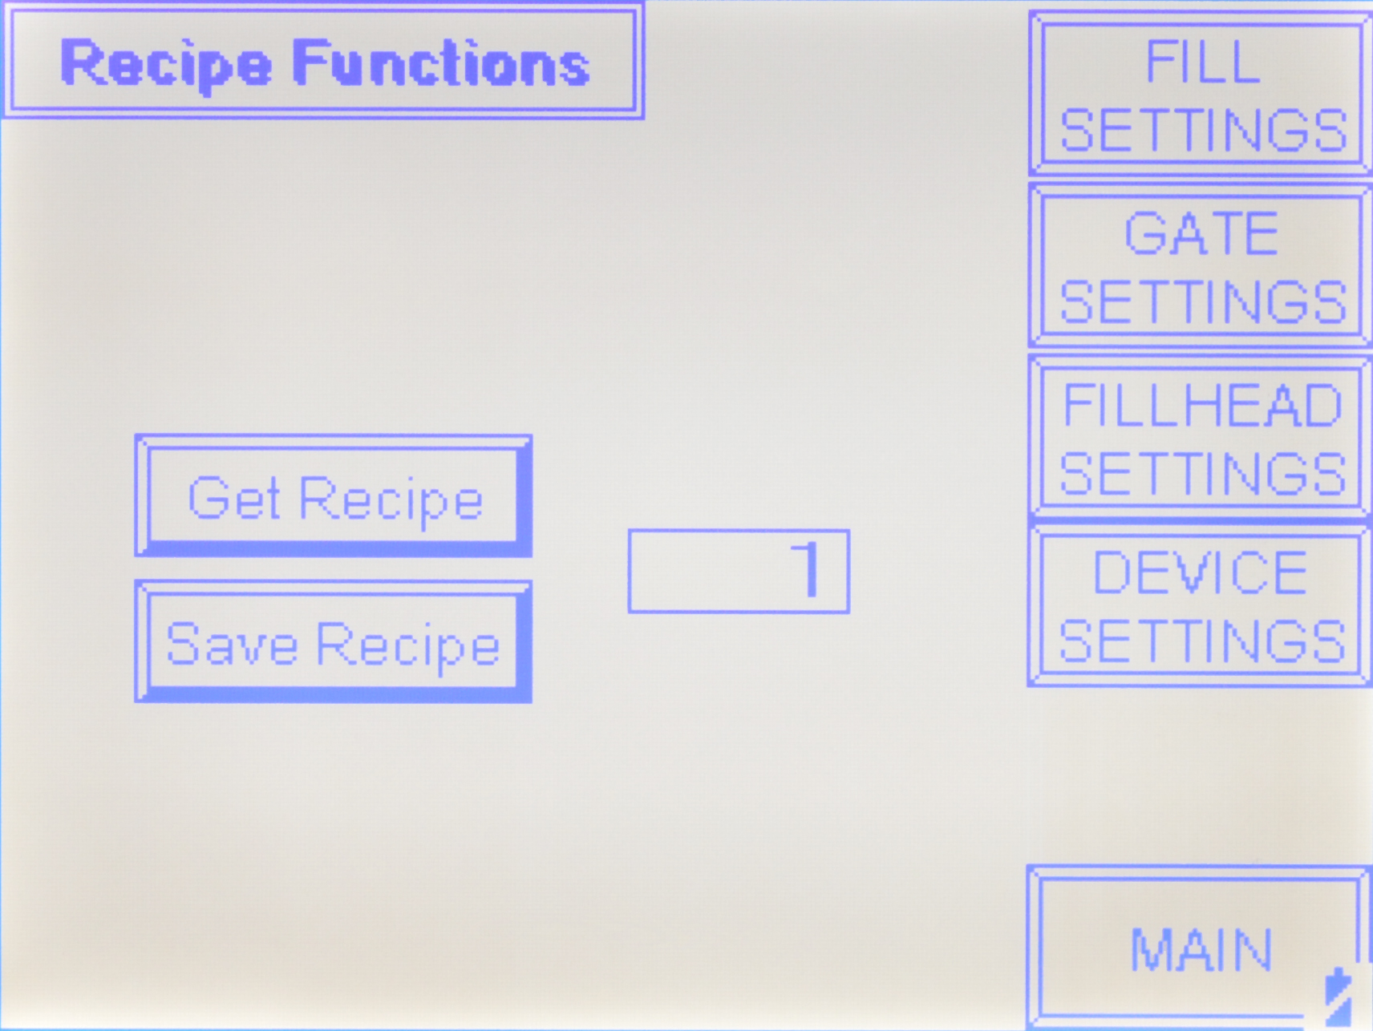
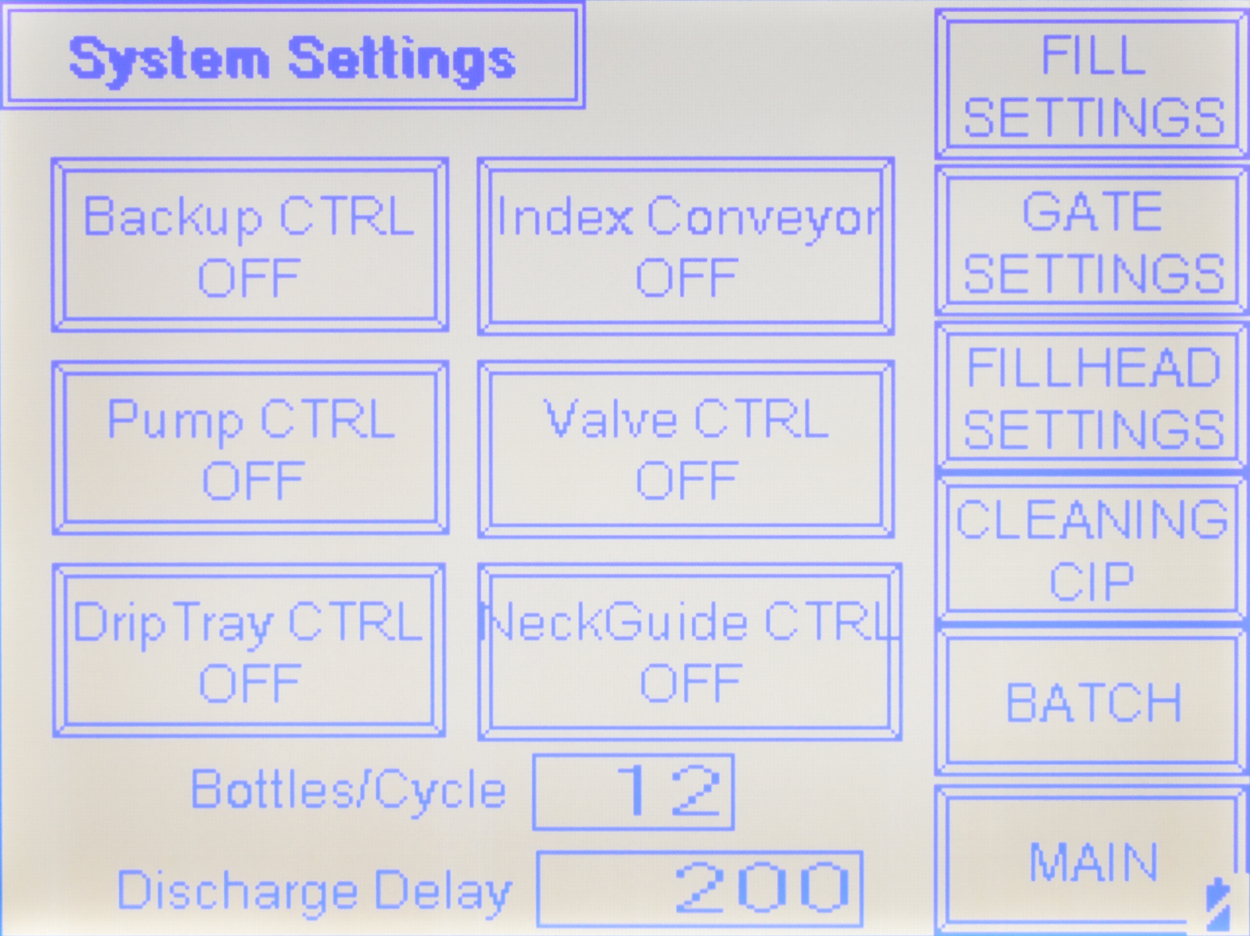
Main Screen:

Batch Count The current batch count is displayed

Batch Target A target batch amount can be entered here and also on the Batch Function screen discussed later.

Batch Reset By pressing this screen button the batch count is reset to zero.

Main Speed The Main speed is displayed in inches per minute. Press the number and a numeric keypad will display, allowing you to enter a different speed.

Screen Access buttons on the right side will take you to that screen when touched. Descriptions of all screens follow.

Right Label Station:

Label Off/On Turn the Label Station on or off by toggling this button. The setting is remembered through power cycling.

Label Jog While the conveyor is running a label can be jogged by pressing this button

Label Delay The Label delay is entered in inches of container travel from detection by the photoeye.

Gap Delay The Gap delay is entered in inches of label travel from the detection of the gap.

Label Ratio The Label ratio is entered as a real number. At 1.0 the speed of the label is equal to the conveyor.

Left Label Station:

The screen for this label station mirrors the right label station.
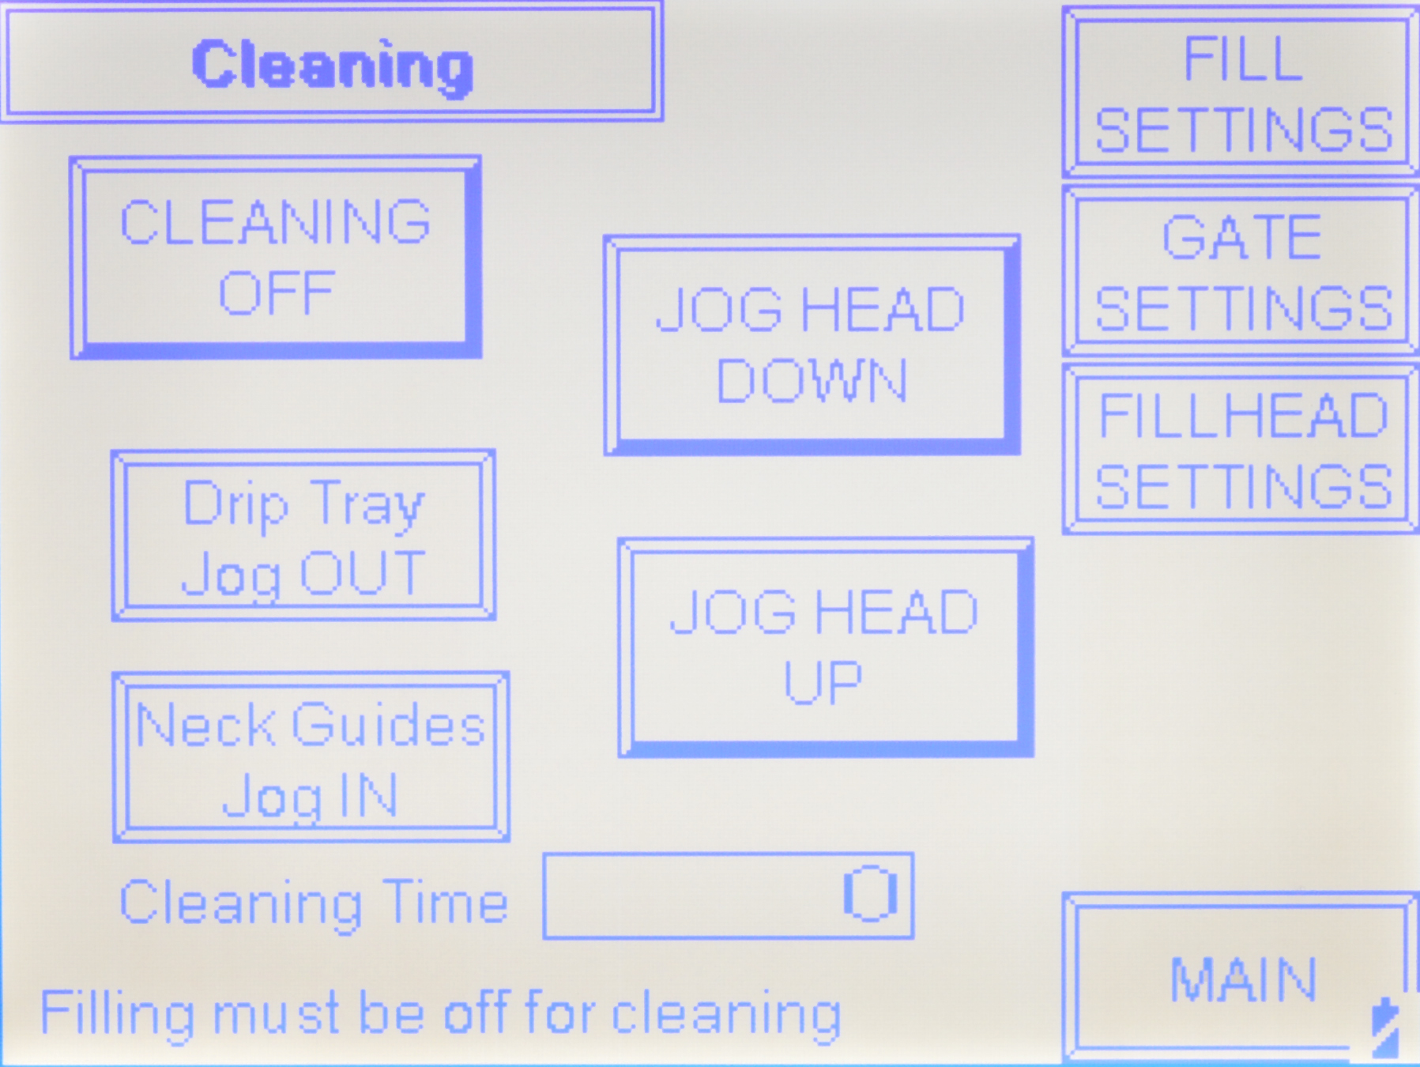

Section Five - Periodic Maintenance, Cleaning and Lubrication

Maintenance:

There are very few maintenance items on the 700NR labeler. The primary factors to consider are:

- Clean the Pinch Drive Roll regularly. As the machine is used you will notice a film or line around the black Drive Roll. This is usually from the extra adhesive that has oozed out from under the labels. This buildup of adhesive and dust can create problems with labels sticking to it, or the Drive Roll slipping on the label. Clean the roll with alcohol, mineral spirits, or acetone (whatever breaks down the adhesive best) and a clean rag. Doing this regularly will prevent problems. Don’t allow any solvent to sit on the roll for extended time or it may break down the rubber or urethane compound.

- For machines using compressed air drain the air inlet filter and reservoir. Compressed air typically has some condensation in it and your labeler has a drain trap for that. Turn the small knob in to allow the trapped water to drain out every day. The morning is the best time.

- The Peel Plate will need to be changed periodically. Paper is abrasive and over time and use will wear the stainless steel Peel Plate. This is done by removing the socket head cap screws and removing the old plate, putting the new one on and tightening the screws.

4. Frequently change the dancer arm spring and the o-ring brake underneath the web
feed reel. Good control of the web is best maintained by having good dancer arm
action and a good brake to stop web feeding when needing.

Cleaning the Machine:

The 700NR comes in stainless steel and anodized aluminum. It is best cleaned with a stainless cleaner or general purpose cleaner. Cleaning the machine regularly is recommended.

Lubrication:

The only lubrication points on the machine are:

- The web hub shaft (Feed Reel) sometimes needs thin oil lubrication to keep it from sticking and the feed reel moving freely. Place machine oil or thin lubricant between the gray PVC hub and the stainless shaft it rotates around.
- Any threaded rod for linear motion should have light oil applied to it periodically to prevent rust and to keep the mechanism moving freely.
Section Seven - Parts Diagrams

Section Eight - Options and/or Specials supplied with machine

