OPERATION MANUAL

TABLE-TOP FILLER/CAPPER

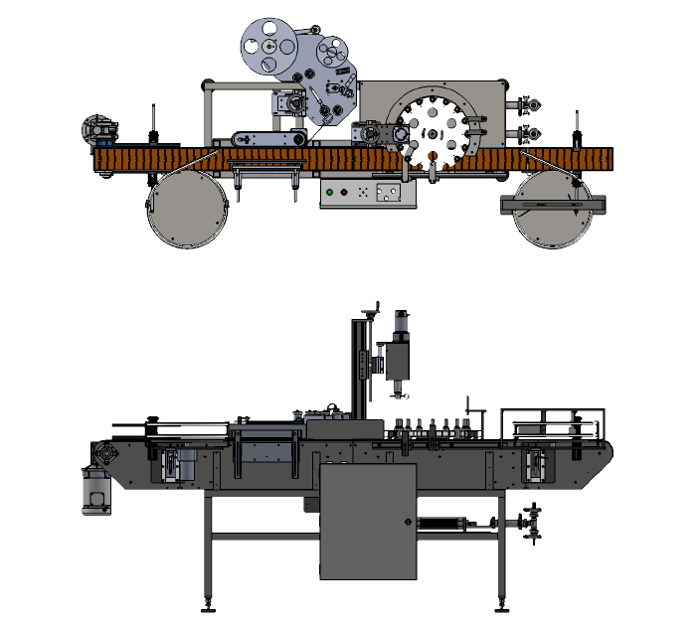

7282 SPA ROAD | NORTH CHARLESTON, SC 29418
PHONE: 843-569-2530 | FAX: 843-576-0798
WWW.INLINEPACK.COM

CAUTION!

Persons operating this machinery are reminded to observe their own company safety policies. In addition, the following safety rules should be observed:

DO NOT REACH INTO THE MACHINE WHILE IT IS IN OPERATION.

USE ONLY THE CORRECT TOOL FOR THE JOB BEING DONE.

STAY ALERT, REMEMBER LOCATION OF CONTROL SWITCHES.

PROPER VENTILATION IS REQUIRED WHERE FILLING MACHINES ARE IN USE.

MAINTENANCE
The main electric switch supplying power to the machinery should be locked out or disconnected when repairs are performed on this equipment.

Machine should be cleaned and inspected regularly. All safety switches must be operable, attachments secure and machine free of broken glass and paper.

Do not hand lubricate when the machine is in operation.
Work area should be kept clean and as dry as is practical.

The repair or adjustment of this equipment should be performed only by persons qualified through technical training and ability, as assigned by your company.

OPERATION
All guards should be securely in place before operating the machine.

Company rules on eye protection should be followed.

Loose clothing or jewelry such as neckties, rolled sleeves, over blouses, bracelets, watches and rings should not be worn when operating the machine.

Report all malfunctions, unusual operation and defects immediately.

Please exercise caution with any moving parts, including the conveyor and any pinch or drive rolls.

Stop the machine before placing hand or arms near or into any area where moving parts are located.

TABLE OF CONTENTS

OPERATIONAL AND MAINTENANCE SAFETY RECOMMENDATIONS
SECTION ONE – GENERAL INFORMATION
1.1 Terminology of Machine
1.2 Specifications and Requirements
1.3 Functional Description of Machine
1.4 Basic Machine Controls and Screen Settings

SECTION TWO – UNCRATING AND INSTALLATION
2.1 Power and Air Connections
2.2 Installing in Production Line
2.3 Leveling Base of Machine
2.4 Adjusting Components of Machine

SECTION THREE – PREPARING FOR OPERATION
3.1 Set Conveyor Rails
3.2 Adjust Machine Settings
3.3 Adjust Sensors

SECTION FOUR – OPERATIONAL ADJUSTMENTS

SECTION FIVE – PERIODIC MAINTENANCE, CLEANING, AND LUBRICATION
5.1 Maintenance
5.2 Cleaning the Machine
5.3 Lubrications

SECTION SIX – TROUBLESHOOTING
6.1 Nothing Works at All
6.2 Operational Inconsistencies

SECTION SEVEN – OPTIONS AND/OR SPECIAL COMPONENTS SUPPLIED WITH MACHINE

SECTION EIGHT – PARTS LIST AND DIAGRAMS

SECTION ONE – GENERAL INFORMATION

1.1 TERMINOLOGY OF MACHINE
3
5
4
1
2

Table Top Filler/Capper

1. Feed Table 4. Indexing Star Wheel
2. Cap Tightener 5. Piston/inlet
3. Label Head

1.2 SPECIFICATIONS – STANDARD MACHINE

ITEM | SPECIFICATION
CONVEYOR WIDTH | 4.5 INCHES STANDARD
MACHINE SPEED | VARIABLE UP TO 30 BPM
LABEL HEIGHT | 4.5 INCHES
OVERALL DIMENSIONS | 48x108 INCHES STANDARD
ELECTRIC REQUIREMENTS | 120VAC 6 AMPS
AIR REQUIREMENTS | 90 PSI @ 4-6 CFM

Features:
- 304-stainless steel frame construction
- Aluminum and plastic parts throughout the mechanism
- Stainless steel filling nozzles
- Positive container indexing and centering
- Hand crank adjustment for different height containers

1
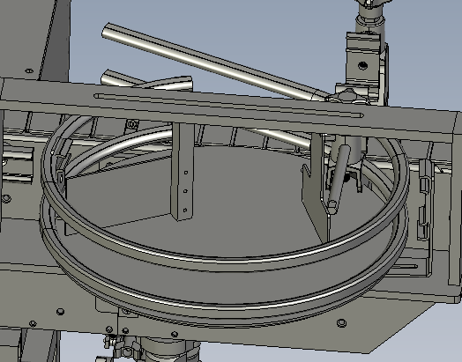
- Feed Table Sweep Arm
- Filling piston Unit.
- 3 Way Rotary valve
3
2

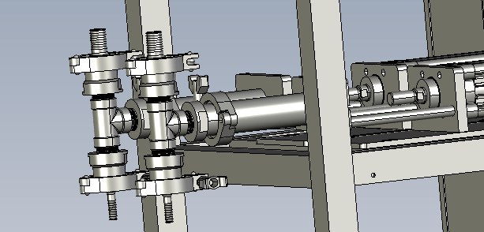

1
- Fill Volume Adjustment Collar
- Cap Torqueing Head
- Indexing Star Wheel

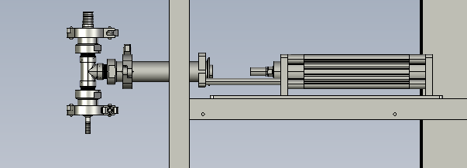

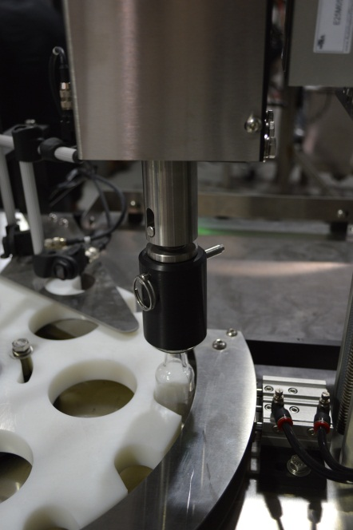
3

2

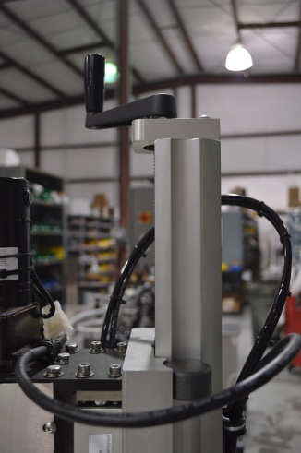
1

- Cap Torqueing height Adjustment

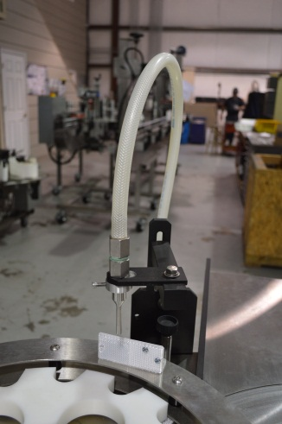
1

- Fill Nozzle (2 on dual piston models)
- Fill Position Bottle Sensor Reflector or sensor only on some model

2

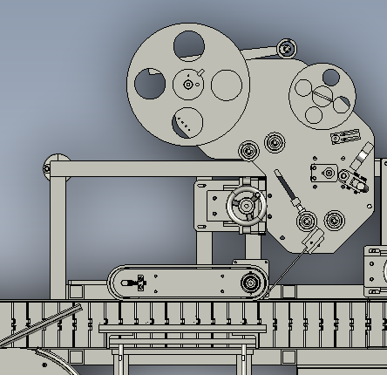
- Label Applicator Head
- Wrap Station
- Feed Reel
- Takeup Reel
- Peel Tip
- Label pinch Rolls
- Wrap Backpad
1.3 FUNCTIONAL DESCRIPTION OF MACHINE

The Inline Table-Top Filler is an automatic filling machine that can fill various sizes of containers with medium to low viscosity.

The filler indexes bottles into position using an inductive prox sensor by detecting the star pockets’ indexing recessed screws, and stopping the star under the filling head and cap tightener positions . The piston pump(s) start and the fill nozzle(s) dispense for filling. Once the filling cycle is complete the star wheel indexes to the next position (set by the filling cycle time). A new set of bottles is indexed into position and the cycle continues so long as bottles are present on the infeed conveyor. The star wheel only indexes when a bottle supply is detected at the infeed lane on the star wheel.

The pistons when signaled to dispense will change the 3-way valve from charge to dispense position allowing product to flow our of the nozzle. When the fill is complete and the piston reverses the 3-way valve also reverses allowing product from the supply tank to be pulled into the piston for the next cycle.

If Cap delivery is purchased the caps are sorted in a vibratory bowl and fed through a horizontal chute, bottles detected in the cap delivery location trigger a cap to be pressed onto the top of a filled bottle.

Caps then index to the cap tightener where caps are torqued. The torque setting is adjusted by removing the cover and adjusting the magnetic clutch using its 0-5 scale.

Bottles then exit the capping location returning to the conveyor and travel to the labeling head if equipped.

The bottle rotation speed is detected by an encoder on the wrap station, after a the bottle is detected by the product sensor traveling on the conveyor and a delay (label delay) is met the label feeds, this should be set to occur just as the bottle enters the nip of the wrap belt and backpad. The labels while feeding are thread3ed through a fork sensor which detects the gap between labels. When a label gap is detected the label feeds the distance (Gap/Flag Delay) required to fully dispense off the end of the peel tip.

1.4 BASIC MACHINE CONTROLS (exact box location may vary depending on application)

- Main Power Switch
- Start Push Button
- Stop Push Button

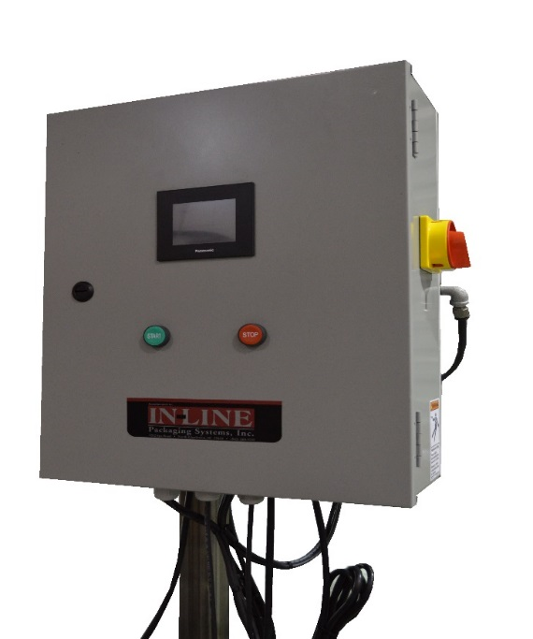
1

2
3

SCREEN SETTINGS

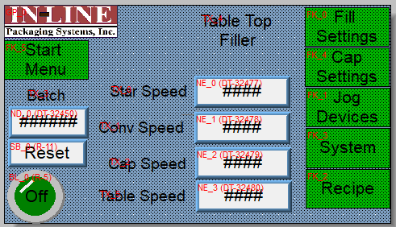 | Main Screen  Starwheel Speed: Enter speed of star as a percentage, other speeds are a scale of 0-1200.  Batch Count: displays current batch count  Batch Reset: Press to reset count to 0  Fill Settings: access screen for Filling  Cap Settings: access screen for cap control  Jog Device : Manually Jog devices  Recipe Functions: save/recall previous settings  System Settings: change settings/devices
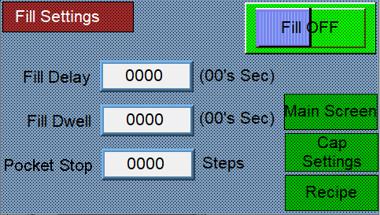 | Filler Settings Screen  Fill On/Off: Push to Toggle On or Off  Fill Delay: Push Number to enter new delay. This is time for the piston to dispense after the star index is complete.  Fill dwell : Push Number to enter the total length of the fill cycle. This must be long enough to allow the piston to fully stroke.  Pocket Stop: This is the number of the star travel distance after the index sensor triggers.
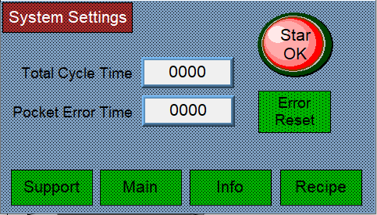 | System Settings Screen:  Cycle Time: This is the total length of the machine cycle, all filling and capping functions must be set within the length of this cycle.  Pocket Error: If the star wheel moves this many steps without seeing a star pocket the machine will stop and error( check that the pocket eye and reflector are working if this occurs)
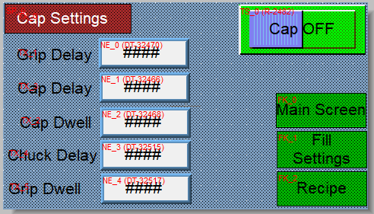 | Cap Settings:  Grip Delay: This number is the time delay for the gripper to extend to capture the bottle for capping.  Capper Delay: This number is time after the gripper closes before the cap head lowers.  Capper Dwell: This is the length of time the capping head stays down for torqueing.  Chuck Delay and Grip Dwell: These times are used with a pneumatic chuck to delay the closing of the jaws and delays the opening of the gripper.
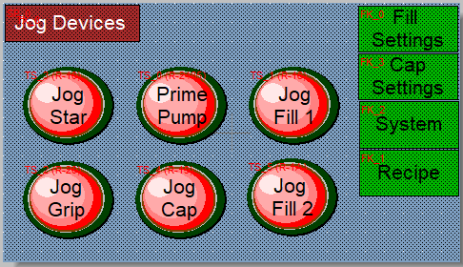 | Device Jog Settings Screen:  Starwheel, the pump and devices can be manually jogged from this screen.  Jog Fill and Prime Pump can be used for clearing air from the filling lines prior to starting.
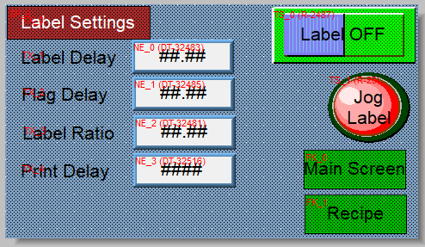 | Label Settings Screen:  The label delay is the distance for starting a label after bottle detection.  The Flag delay is the label stop distance after a gap.  Label Ratio is the label feed speed relative to the wrap speed.  Print delay is the print delay if the inkjet coding option is purchased.

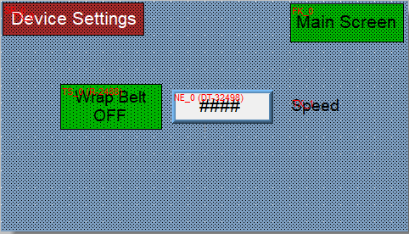 | Device Settings Screen:  Wrap Belt on/off selection.  The speed is a scale of 0-1200 inches per minute.
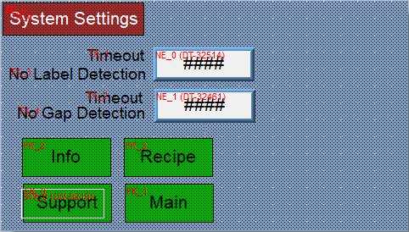 | System Settings Screen:  The timeouts stop the machine if either occurs.  No labels present on the machine, or if a gap is not detected when the label is feeding. 100=1 Second

SECTION TWO – UNCRATING AND INSTALLATION

2.1 POWER AND AIR CONNECTIONS

A grounded electrical male plug is provided with the machine, and is connected to the main electrical enclosure on the rear side of the machine. Plug this into any grounded receptacle. For compressed air, behind the electrical enclosure is an air filter/reservoir with a 1/4” male quick disconnect attached. You can supply compressed air to the machine by either a mating quick disconnect on the end of an air hose, or you can permanently pipe air to the machine using standard pipe and connecting directly into the air filter using threaded pipe connections. If you permanently pipe into the system we recommend a cut-off valve be mounted at the machine. Some changeover adjustments are easier if the operator is able to temporarily turn off the air pressure.

2.2 INSTALLING IN PRODUCTION LINE

Move the machine into its permanent location. Adjust the conveyor height of the machine to match the heights of the adjoining machines as required. Leveling pads are provided with the Econo-Filler that allow you some vertical adjustment. If necessary, make spacing blocks to raise the height. Additional lineal space is provided on each end of the machine to allow a crossover from or to the next machine. Position the conveyor ends as close to each other as possible and then use conveyor rails to guide the containers across narrow dead plates onto the conveyor.

2.3 LEVELING THE BASE MACHINE

Once the machine is installed, level the main conveyor through the machine by using a bubble level. Place the bubble level along the length of the machine. Leveling the machine is important to the flow of the line as it allows for more seamless transitions between machines. The squaring and straightness of the base machine will ensure the machine operates correctly.

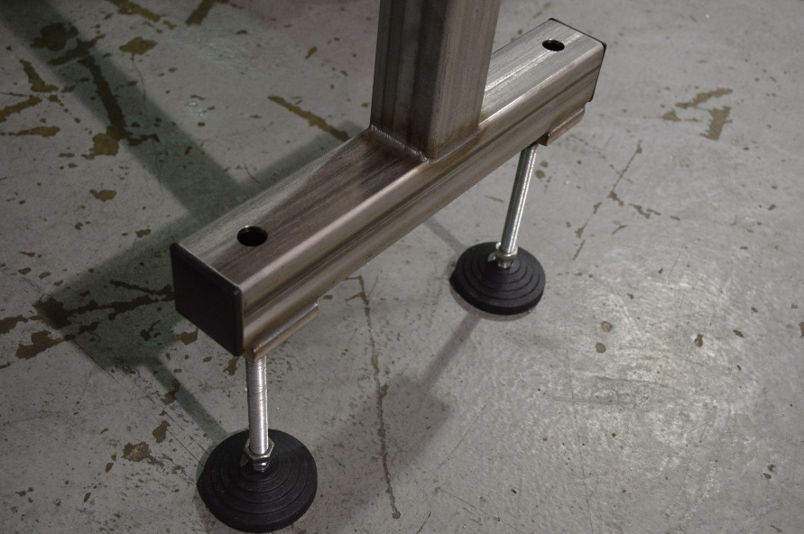

SECTION THREE – PREPARING TO FILL

3.1 LOADING PRODUCT INTO THE TANK
Fill the supply tank 2/3 full of product (Customer Provided). Visually monitor tank level throughout bottling run and refill when desired

3.2 SET TABLE
The feed table speed is adjusted using the table speed in the screen. The sweep arm can be adjusted for optimal feed. Note the table should not be completely filled

3.3 ADJUST HEIGHT AND SPACING OF NOZZLES

The height of the nozzle is adjusted using SAE wrenches, the centering over the bottle is also adjustable. The fill level is adjusted by limiting the stroke of the piston drive air cylinder using the plastic knob near the indexing star. Use supplies angle wrench for loosening the jam nut.
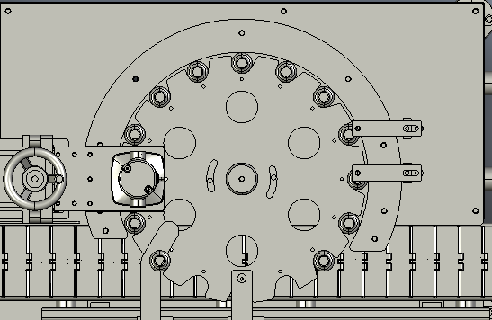

3.4 ADJUST capping height.

The capping head is vertically adjustable using the hand crank, the speed of the spindle rotation is adjusted using the speed setting on screen.
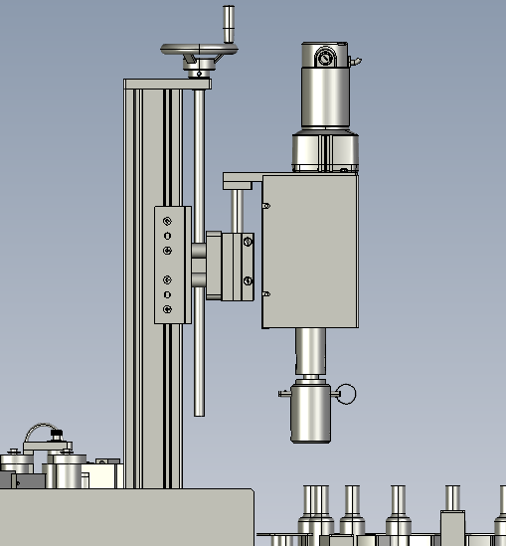

3.5 Adjust label settings.

The label height is adjusted using the handwheel on the vertical stand. The angle adjustment is managed using the turnbuckle and smiley face plate under the label head. The wrap and back pad should be set to ensure continuous rotation during labeling, be careful to avoid over tightening this adjustment.

Label tracking on the peel tip and takeup is managed using the jam screw on the pinch roll stop vertical block. Tighten the top screw to track upward, the bottom to track downward.
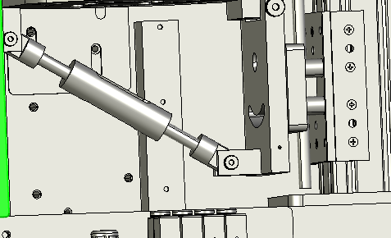

SECTION FOUR – OPERATIONAL ADJUSTMENTS

4.1 ADJUSTING FILL LEVELS

As stated above the fill volume is adjusted using the shaft collars on the Air cylinder push rods.

To adjust the level log the piston on in the settings screen this will extend the piston to its fill complete position. Allowing a greater travel increases volume. For instance moving the shaft collar to the left will increase the fill level, moving it to the right will decrease travel of the piston and reduce fill volume.

On two head units each piston will half fill a bottle to increase overall throughput and reduce the fill cycle time.

The fill speed is set using the flow controls on the air cylinders closing the flow control on the left will lower the dispense speed. Closing the flow controls on the right will lower the piston charging speed.
Flow Controls

Shaft Collars

SECTION FIVE – PERIODIC MAINTENANCE, CLEANING, AND LUBRICATION

MAINTENANCE

Ensure that you perform a monthly visual inspection for wear on the fill heads, conveyor chain, and pump leaks.

CLEANING THE MACHINE

The Table-Top Filler comes in stainless and aluminum construction. Cleaning the machine regularly is recommended using soap and water, but not by spraying the machine down.

LUBRICATION

The only lubrication points on the machine are:

- Any threaded rod for linear motion should have light oil applied to it periodically to prevent rust and to keep the mechanism moving freely. The conveyor bearings should be lubricated with a grease gun once every 3-6 months.

SECTION SIX - TROUBLESHOOTING

The list below represents a few scenarios in which troubleshooting may need to occur.

6.1 NOTHING WORKS AT ALL/POWER IS ON BUT NOTHING WORKS

- Check main power. Is machine plugged in? Is main power switch turned on?
- Check fuses inside control panel.
- Are speed controls turned up above zero?

6.2 OPERATIONAL INCONSISTENCIES (NOTHING IS BEING FILLED)

- Confirm that filling is on and that the bottle eye is changing states between bottles.
- Confirm that air supply is on.

