OPERATION MANUAL

PRESSURE OVERFLOW FILLER

7282 SPA ROAD | NORTH CHARLESTON, SC 29418
PHONE: 843-569-2530 | FAX: 843-576-0798
WWW.INLINEPACK.COM

CAUTION!

Persons operating this machinery are reminded to observe their own company safety policies. In addition, the following safety rules should be observed:

DO NOT REACH INTO THE MACHINE WHILE IT IS IN OPERATION.

USE ONLY THE CORRECT TOOL FOR THE JOB BEING DONE.

STAY ALERT, REMEMBER LOCATION OF CONTROL SWITCHES.

MAINTENANCE
The main electric switch supplying power to the machinery should be locked out or disconnected when repairs are performed on this equipment.

Machine should be cleaned and inspected regularly. All safety switches must be operable, attachments secure and machine free of broken glass and paper.

Do not hand lubricate when the machine is in operation.
Work area should be kept clean and as dry as is practical.

The repair or adjustment of this equipment should be performed only by persons qualified through technical training and ability, as assigned by your company.

OPERATION
All guards should be securely in place before operating the machine.

Company rules on eye protection should be followed.

Loose clothing or jewelry such as neckties, rolled sleeves, over blouses, bracelets, watches and rings should not be worn when operating the machine.

Report all malfunctions, unusual operation and defects immediately.

Please exercise caution with any moving parts, including the conveyor and any pinch or drive rolls.

Stop the machine before placing hand or arms near or into any area where moving parts are located.

TABLE OF CONTENTS

OPERATIONAL AND MAINTENANCE SAFETY RECOMMENDATIONS
SECTION ONE – GENERAL INFORMATION
1.1 Terminology of Machine
1.2 Specifications and Requirements
1.3 Functional Description of Machine
1.4 Basic Machine Controls and Screen Settings

SECTION TWO – UNCRATING AND INSTALLATION
2.1 Power and Air Connections
2.2 Installing in Production Line
2.3 Leveling Base of Machine
2.4 Adjusting Components of Machine

SECTION THREE – PREPARING FOR OPERATION
3.1 Set Conveyor Rails
3.2 Adjust Machine Settings
3.3 Adjust Sensors

SECTION FOUR – OPERATIONAL ADJUSTMENTS

SECTION FIVE – PERIODIC MAINTENANCE, CLEANING, AND LUBRICATION
5.1 Maintenance
5.2 Cleaning the Machine
5.3 Lubrications

SECTION SIX – TROUBLESHOOTING
6.1 Nothing Works at All
6.2 Sensor Malfunctioning
6.3 Operational Inconsistencies

SECTION SEVEN – OPTIONS AND/OR SPECIAL COMPONENTS SUPPLIED WITH MACHINE

SECTION EIGHT – PARTS LIST AND DIAGRAMS

SECTION ONE – GENERAL INFORMATION

The Pressure Overflow Filler is a fully automatic Filling machine consisting of a main conveyor, a servo-controlled filling head and nozzle bar, bottle-handling guides for isolating the group of bottles to be filled, neck guides for centering the opening of the bottle underneath the heads, a drip tray for catching any product that drips after the fill cycle, a product cart for holding and pumping the product into the manifold, and the product manifold and hoses for carrying the product to the filling nozzles.

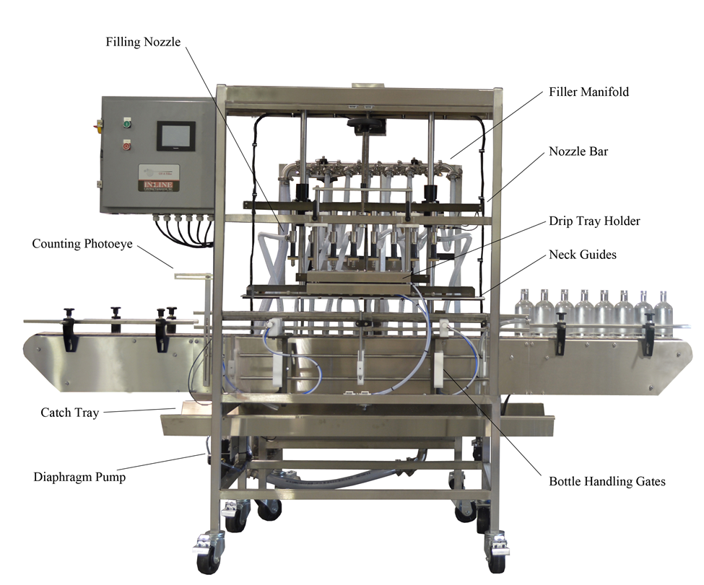
1.1 TERMINOLOGY OF MACHINE

Typical Filling Machine

1. Filling Nozzle 6. Nozzle Bar
2. Product Counting Eye 7. Drip Tray and Holder
3. Catch Tray 8. Neck Guides
4. Diaphragm Pump 9. Bottle Handling Gates and guides
5. Main Product Manifold

1.2 SPECIFICATIONS – STANDARD MACHINE

ITEM | SPECIFICATION
CONVEYOR WIDTH | 4 ½ INCHES STANDARD
BOTTLE WIDTH | 1 INCH TO 8 INCHES WIDE
BOTTLE HEIGHT | 1 INCH TO 14 INCHES
# OF FILL HEADS | 4 TO 12 AT VARIABLE ORDER
CONVEYOR SPEED | VARIABLE TO 1200 IPM
MACHINE WEIGHT | 900 LBS
OVERALL DIMENSIONS | 96” LONG BY 55 ½ ” WIDE BY 79” HIGH
ELECTRIC REQUIREMENTS | 120/230 VAC, 60 HZ, 1 PH, 10 AMP
AIR REQUIREMENTS | 90 PSI, 5-6 CFM

1.3 FUNCTIONAL DESCRIPTION OF MACHINE

- The Pressure Overflow Filler is a fully automatic machine capable of filling thin and semi-viscous liquids. The machine functions in this manner:
- Containers enter the filler on the conveyor, and pass through a product photo-eye and reflector which counts each one individually.
- In the screen the number of bottles per cycle can be entered.
- Once the full number of bottles is reached, the filling cycle begins.
- The conveyor stops, the drip tray retracts, and the neck guides come in to center the opening of the containers underneath the filling nozzles.
- Once the neck guides have control of the bottle, the nozzle bar begins to lower into the bottle.
- At this time the pump energizes and brings product into the manifold and to the filling nozzles.
- As the nozzle lowers into the container the spring collapses, opening the valve.
- Product begins to flow into the container through the bottom port of the valve.
- Product continues to flow until the level in the container reaches the upper port of the valve, which is set by adding to or subtracting from the spacers in a combination. Excess product then flows through that port back into the tubes that lead down back into the product tank.
- The time cycle on the pump dwell, and the overall filling cycle time should be set so that all containers in the group reach their full level before the pump stops.
- Once the filling cycle time is complete the head raises, the neck guide retracts and the drip tray extends.
- The front gate (exit side) opens and the conveyor restarts, carrying bottles out of the machine. The front gate remains open for an adjustable dwell, which should be just long enough for the entire group of bottles to pass by before the gate extends again.
- After a short delay from the front gate the infeed gate opens to allow new containers to enter. This delay creates a gap between the group leaving and the next group entering and that is the gap for the front gate to extend into.
- Now the filling cycle begins again.

SECTION TWO – UNCRATING AND INSTALLATION

2.1 POWER AND AIR CONNECTIONS

The electrical requirements for the machine are 120/230 volts AC, single phase, 60 hertz. On the back of the main power switch inside the enclosure will be three wires indicating where line,
neutral and ground should be connected These wires will be labeled. Connect your plant power and be sure to follow local electrical codes for disconnects or circuit breaker sizing.
For machines requiring compressed air, on the machine is an air filter/reservoir with a 1/4” male quick disconnect attached. You can supply compressed air to the machine by either a mating quick disconnect on the end of an air hose, or you can permanently pipe air to the machine using standard pipe and connecting directly into the air filter using threaded pipe connections. If you permanently pipe into the system we recommend a cut-off valve be mounted at the machine. Some changeover adjustments are easier if the operator is able to temporarily turn off the air pressure.

2.2 INSTALLING IN PRODUCTION LINE

Move the machine into its permanent location. Adjust the conveyor height of the machine to match the heights of the adjoining machines as required. Leveling pads are provided with the Econo-Filler that allow you some vertical adjustment. If necessary, make spacing blocks to raise the height. Additional lineal space is provided on each end of the machine to allow a crossover from or to the next machine. Position the conveyor ends as close to each other as possible and then use conveyor rails to guide the containers across narrow dead plates onto the conveyor.

2.3 LEVELING THE BASE MACHINE

Once the machine is installed, level the main conveyor through the machine by using a bubble level. Place the bubble level along the length of the machine. Leveling the machine is important to the flow of the line as it allows for more seamless transitions between machines. The squaring and straightness of the base machine will ensure the machine operates correctly.

SECTION THREE – PREPARING TO FILL

3.1 LOADING PRODUCT INTO THE TANK

Using the appropriate wrench, place a full group of bottles on the conveyor, making sure they are centered on the conveyor along the length. The Filler operates off of the centerline of the conveyor. Loosen the bolts holding the back guide and move it in or out until the back guide is gently touching the back of the containers. The top plastic neck brace must also be adjusted to lightly touch the back of the necks of the bottles.

3.2 ADJUST FRONT BOTTLE HANDLING RAILS

The front bottle handling rails must be set to the container size to ensure smooth control of the containers into and through the Filler. Loosen the allen head screws on the front cross blocks and adjust the rails in or out to lightly touch the bottle. The correct tightness to the container diameter should allow about 1/8” to 1/4” of space greater than the width of the container.

3.3 ADJUST BOTTLE GATES TO THE FULL GROUP OF CONTAINERS

Now place a complete set of bottles on the conveyor inside of the machine. Now using the ratcheting handles slide the gates (front and rear) back or forth to capture the bottles underneath the filling nozzles. A vertical adjustment and also an in/out adjustment are also provided to adequately capture the bottles and control them while the filling nozzles are lowered into the bottle.

3.4 ADJUST NECK GUIDES FOR CENTERING THE OPENING OF THE BOTTLE

The purpose of the Neck guides is to control the top of the bottle and center the opening so that the filling nozzles cleanly enter and exit the bottle. To adjust, each neck guide can be loosened and then slide back and forth to position it where the “V” is centered on the neck of the bottle. This should be done with all bottles touching each other. When finished the necks of the bottle should be lightly touching the V and also the back linear brace behind.

3.5 ADJUST DRIP TRAY TO HEIGHT CONTAINER

The entire Drip tray and Neck guide mechanism moves up and down using the rotating handle just above the drip tray holder. Loosen the ratcheting knobs on each side and crank the mechanism up or down until the neck guides are positioned where you want them. Once they are located, tighten the locking knobs on the side. To fine adjust the position of the drip tray in relationship to the neck guides loosen the bolts just below as shown in the picture and slide the drip tray in or out as needed. Tighten when complete.

3.6 ADJUST THE FILL LEVEL USING THE SUPPLIED SPACERS

Now that we have a complete group of containers centered on the conveyor and with the gates and neck guides in place we can adjust the filling nozzles so that they are correctly aligned over each bottle. If they are not then the steps of centering the bottle on the conveyor or one of the other steps may have to be repeated.

There are several plastic spacers supplied with each filling nozzle. These dictate the level of the return overflow port in the bottle and subsequently the level of the liquid in the bottle. Use some combination of these to achieve the desired level in the bottle. Small, thin spacers may be needed to change individual levels if one or more bottles results in a different level (over several groups – never make a decision based on one bottle).

3.7 SETTING THE HEIGHT OF THE BOTTLE USING THE PROGRAM IN THE OPERATOR INTERFACE

The Fill Nozzle bar is Air operated and is adjustable using the large handwheel in the back of the filling bar. Raise the bar up to clear bottles when the air cylinder is in the lowered (actuated) position using the jog function. Once the filling head is Jogged in its extended position manually lower the heads into bottles until the springs are fully compressed on the filling nozzles.

3.9 FINE-TUNE THE FILL LEVEL ONCE OPERATIONAL

Once operational you may notice one or more fill levels in the bottles that need fine-tuning to get all the levels consistent. This is done by adding or subtracting the spacers in some combination to raise or lower the fill level in that head. Again, this should be done with more than one sample to make sure the pattern is true.

3.10 ADJUST THE PUMP PRESSURE TO THE MANIFOLD

During the Fill cycle the pump will be running. The flow and pressure of the liquid being supplied for the fill can be adjusted using the air control on the normal diaphragm pump supplied with the machine. Using the knob turn it to increase or decrease the rate at which the pump cycles. This will increase or decrease the flow and pressure of the liquid.

SECTION FOUR – OPERATIONAL ADJUSTMENTS

OPERATOR SCREENS

Main Screen

Batch Count: The current batch count is displayed.
Batch Target: A target batch amount can be entered here and also on the Batch Function screen discussed later.
Batch Reset: By pressing this screen button the batch count is reset to zero.
Main Speed: The Main speed is displayed in inches per minute. Press the number and a numeric
keypad will display, allowing you to enter a different speed.

Screen Access buttons on the right side will take you to that
screen when touched. Descriptions of all screens follow.
Filler Settings Screen

Filling Off/On: Turn the Filling on or off by toggling this button. The setting is remembered through
power cycling.
Fill Start: After complete count of bottles, this delay allows bottles to settle before starting cycle.
Fillhead Down: After the cycle starts and the drip tray is out and the neck guides in, this delay is
before nozzle bar moves.
Fill Cycle Time: The total time the fill heads are in the down position.
Pump Dwell: The length of time the pump runs within the Fill cycle time.
Drip Tray In: After the Fill start delay, a short delay before moving the drip tray in
Drip Tray Out: At the end of the cycle after the neck guides retract, this delay before the drip
tray extends.
Gate Settings:

Entry Gate In: After the fill cycle starts before the entry gate comes in to separate the group being filled from the bottles before it.
Entry Gate Out: After the exit gate opens this delay begins, to allow a gap between the groups.
Exit Gate Open: At the end of the fill cycle to allow the containers to exit.
Exit Gate Time: The length of time for the exit gate to be open to allow filled bottles to exit.
Neck Guide In: After the drip tray has retracted, to the extending of the neck guides.
Neck Guide Out: After the fill heads lift up, a delay before the neck guides retract.
Device Settings

The buttons on this screen allow you to “jog” the device on or off
while the machine is not running. These can be used to test the
mechanical settings to ensure proper operation.

The Teach tank sensor screen takes you to that screen.

4.1 ADJUSTING FILL LEVELS

Add or remove spacer washers above the sealing washer to raise or lower the fill level in the bottle. The fewer the spacers the lower the fill level, and vice versa.

Section Five - Periodic Maintenance, Cleaning and Lubrication

Maintenance:

Ensure that you perform a monthly visual inspection for wear on the fill heads, conveyor chain, and pump leaks.

Cleaning the Machine:

The Filler comes in stainless and aluminum construction. Cleaning the machine regularly is recommended using soap and water.

The cleaning cycle consists of lowering the heads onto bottles and filling the supply/overflow tank with the cleaning solution desired depending on the product. Activating the pump from the jog screen and allowing product to cycle through the heads and tank while on bottles. Please rinse with water after cleaning. Then drain the system.

Lubrication:

The only lubrication points on the machine are:

- The conveyor idler sprockets inside the frame of the machine may need some grease once/year. The conveyor idler sprockets are located under the conveyor chain.
- Any threaded rod for linear motion should have light oil applied to it periodically to prevent rust and to keep the mechanism moving freely.

Section Six – Troubleshooting

The list below represents a few scenarios in which troubleshooting may need to occur.

6.1 Nothing Works at all or Has Power and Nothing Works

- Check main power. Is machine plugged in? Is main power switch turned on?
- Check fuses inside control panel.
- Are speed controls turned up above zero?

6.2 Nothing is being filled

- Confirm that filling is on and that the counting eye is changing states between bottles.
- Confirm that air supply is on.
- Confirm bottles per cycle is not set to zero.

