  - PRESSURE OVERFLOW FILLER
  - – Operation Manual

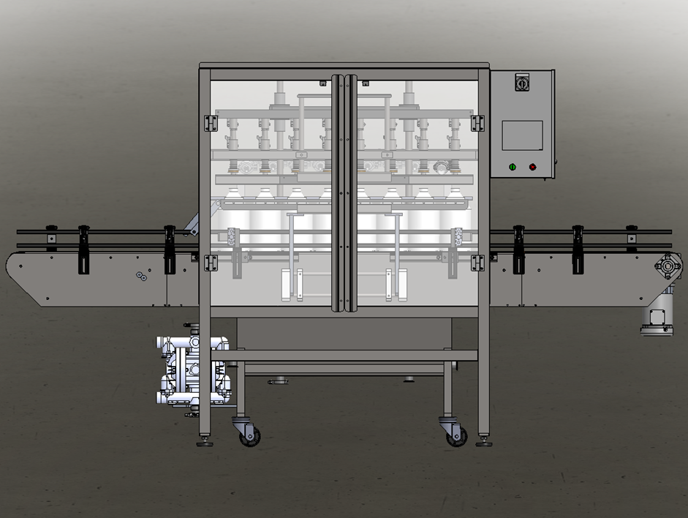

For helpful how-to videos visit our
YouTube channel - Inlinelabeling1

Follow us on:
Instagram @inlinepackaging
Facebook @inlinepack

CAUTION!

Persons operating this machinery are reminded to observe their own company safety policies. In addition, the following safety rules should be observed:

- DO NOT REACH INTO THE MACHINE WHILE IT IS IN OPERATION.
- USE ONLY THE CORRECT TOOL FOR THE JOB BEING DONE.
- STAY ALERT, REMEMBER LOCATION OF CONTROL SWITCHES.

MAINTENANCE
The main electric switch supplying power to the machinery should be locked out or disconnected when repairs are performed on this equipment.

Machine should be cleaned and inspected regularly. All safety switches must be operable, attachments secure and machine free of broken glass and paper.

Do not hand lubricate when the machine is in operation.
Work area should be kept clean and as dry as is practical.

The repair or adjustment of this equipment should be performed only by persons qualified through technical training and ability, as assigned by your company.

OPERATION
All guards should be securely in place before operating the machine. Close all doors when operating machine.

Company rules on eye protection should be followed.

Loose clothing or jewelry such as neckties, rolled sleeves, over blouses, bracelets, watches and rings should not be worn when operating the machine.

Report all malfunctions, unusual operation, and defects immediately.

Please exercise caution with any moving parts, including the conveyor and any pinch or drive rolls.

Stop the machine before placing hand or arms near or into any area where moving parts are located.

TABLE OF CONTENTS

SECTION ONE – GENERAL INFORMATION

1.1 | Terminology of Machine | pg. 4
1.2 | Specifications and Requirements | pg. 5
1.3 | Functional Description of Machine | pg. 6

SECTION TWO – UNCRATING AND INSTALLATION

2.1 | Electrical | pg. 16
2.2 | Communication Cables | pg. 16
2.3 | Pneumatic | pg. 17
2.4 | Installing in Production Line | pg. 18
2.5 | Leveling Base of Machine | pg. 18

SECTION THREE – OPERATIONAL ADJUSTMENTS

3.1 | Adjusting Fill Levels | pg. 19
3.2 | Foam Issues | pg. 19

SECTION FOUR – PERIODIC MAINTENANCE, CLEANING, AND LUBRICATION

4.1 | Maintenance | pg. 20
4.2 | Cleaning the Machine | pg. 20
4.3 | Lubrication | pg. 20

SECTION FIVE – TROUBLESHOOTING

5.1 | Nothing Works at All | pg. 21
5.2 | Operational Inconsistencies | pg. 21

SECTION SIX – SCREENS

6.1 | Main Screen | pg. 22
6.2 | Bottler Screens | pg. 23
6.3 | Rinser Settings | pg. 28
6.4 | Labeler Settings | pg. 30
6.5 | System Settings | pg. 32

SECTION SEVEN – CLEANING CYCLE
REFERENCES
WIRING BLOCK DIAGRAMS

SECTION ONE – GENERAL INFORMATION

TERMINOLOGY OF MACHINE

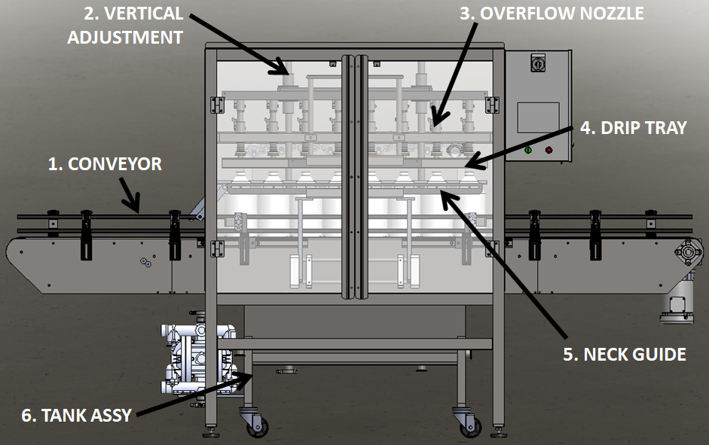
Pressure Overflow Filler
Item No. | Assembly Name | Description
1 | Conveyor | Moves bottles through system
2 | Vertical Adjustment | Moves up and down for different bottle heights
3 | Overflow Nozzle | Fill tubes
4 | Drip Tray | Prevents liquid from dropping on top of bottles
5 | Neck Guide | Straightens bottles under nozzles
6 | Tank Assembly | Overflow tank assembly

SPECIFICATIONS – STANDARD MACHINE

ITEM | SPECIFICATION
CONVEYOR WIDTH | 4.5 INCHES STANDARD
MACHINE SPEED | VARIABLE UP TO 32 Bottles per Minute (BPM)
OVERALL DIMENSIONS | h: 71 1/2”; L: 126” (varies); w: 61”
ELECTRIC REQUIREMENTS | 110VAC 6 AMPS
AIR REQUIREMENTS | 90 PSI @ 10 CFM

FUNCTIONAL DESCRIPTION OF MACHINE

The In-line Micro Filler is a fully automatic in-line carbonated filling machine that can fill various bottle sizes with minimal amounts of waste. This means less product down the drain and more bottles filled.
The machine can be configured as a 4-, 6-, or 8-head machine.
The machine indexes the set target of bottles into position under the fill tubes. The straightener closes on the bottles, further aligning them to the fill tubes, and the filling manifold lowers down onto the bottles. The fill cycle consists of the following: pulling vacuum, charging bottles with CO₂, filling bottles to a consistent fill level, removing pressure from the bottle, and releasing the bottles to move down the line. The next group then indexes in and the cycle is repeated.
After filling, the bottles move into the Crowner section of the machine. A crown is placed onto the top of the bottle and then formed over the bottle to provide a sufficient seal. The bottles index one at a time to have the crowns formed.

Conveyor

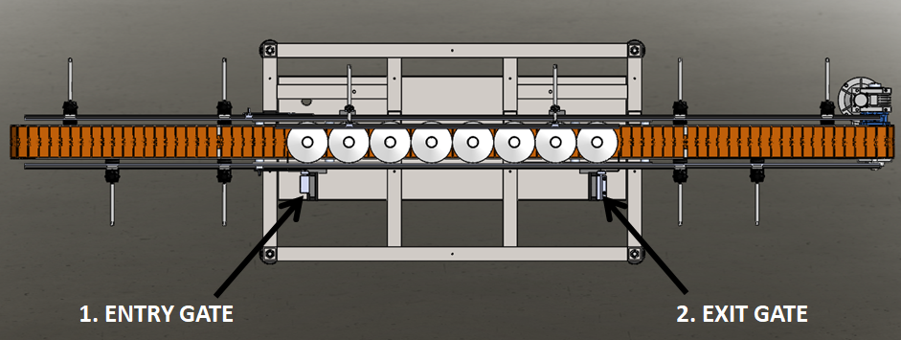
The Conveyor for the Filler controls the indexing of bottles for filling and the positioning of the bottles under the fill tubes.
- Entry Gate – creates spacing between cycles
- Exit Gate – positions bottles under fill tubes

Adjustments
Place multiple bottles on the conveyor in different locations and adjust all railing accordingly.
Center bottles on conveyor and adjust entry gate and exit gate accordingly.

Vertical Adjustment

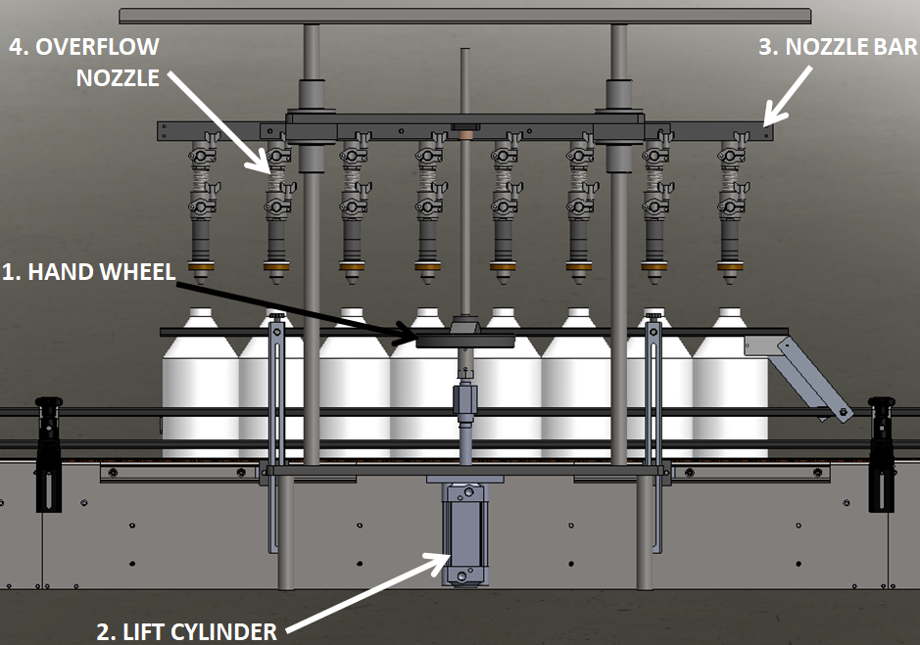 | The Vertical Adjustment controls the height of the Overflow Nozzles and is what is used to raise and lower the nozzles during filling.  - Hand Wheel - moves Nozzle Bar up and down for different bottle heights  - Lift Cylinder – moves Overflow Nozzles up and down during filling  - Nozzle Bar – Overflow Nozzles are attached here; allows for adjustment for different diameter bottle sizes  - Overflow Nozzle – various sizes available; product flow through these into the bottles

Adjustments

Use the Hand Wheel to adjust from one bottle height to another. Adjust the Overflow Nozzles side to side on the Nozzle Bar for different bottle diameters.

Overflow Nozzle

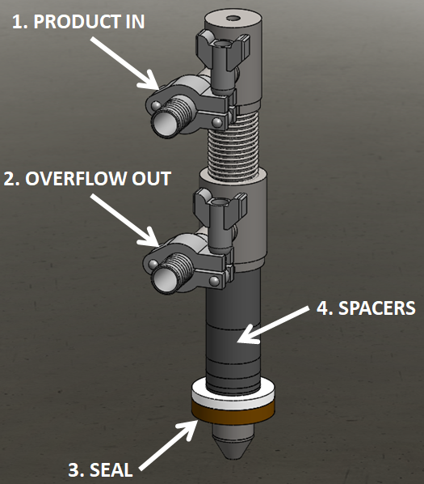 | The Overflow Nozzle is what is used to fill the bottles with product.  - Product In – product flows from the Tank Assembly into the nozzle through this connection point  - Overflow Out – all excess product flows back into the Tank Assembly  - Seal – provides complete seal across the top of the bottles  - Spacers – allows for adjustable fill levels in your bottles

Adjustments

Add or remove spacers as necessary to reach the desired fill level in the bottles. If multiple nozzle sizes were ordered then replace as needed for changeovers.

Drip Tray

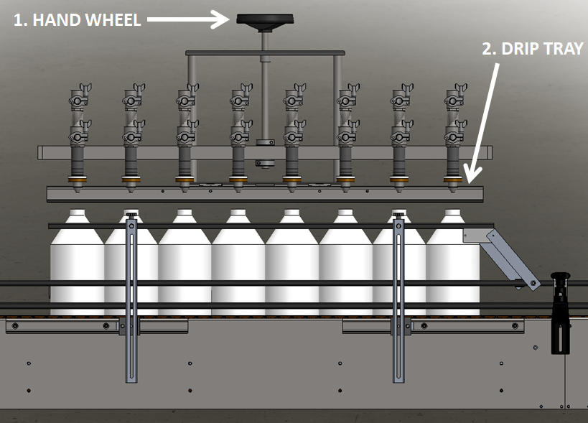 | The Drip Tray is used to prevent any excess product from getting onto the sides of the bottles as they index out/in.  - Hand Wheel – moves the Drip Tray up and down for different height bottles  - Drip Tray – extends out, under the Overflow Nozzles in-between fill cycles

Adjustments

Raise or lower as needed when changing bottle sizes.

Neck Guide

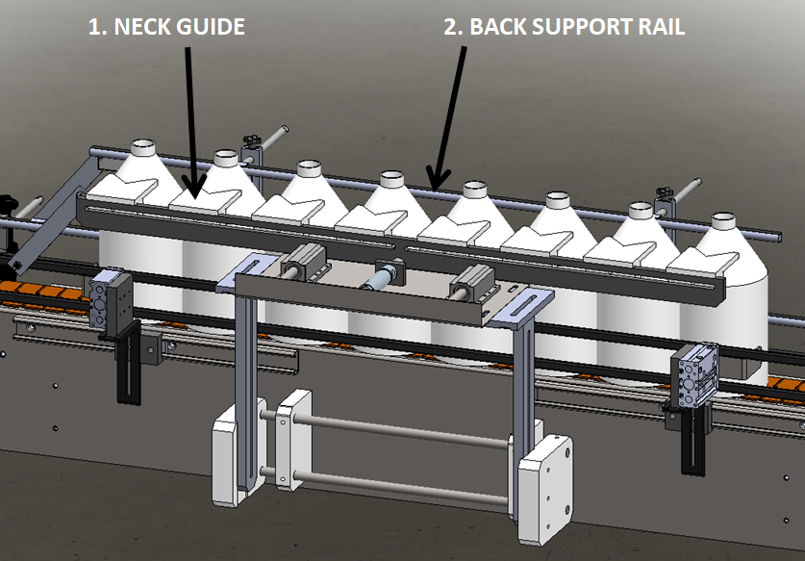
This is the part of the filler that aligns the bottles under the Overflow Nozzles.
- Neck Guide – centers bottles under Overflow Nozzles
- Back Support Rail – provides necessary support to the back of the bottles

Adjustments

Both the Neck Guide and the Back Support Rail are adjustable vertically and in and out to compensate for different bottle heights and diameters.

Tank Assembly

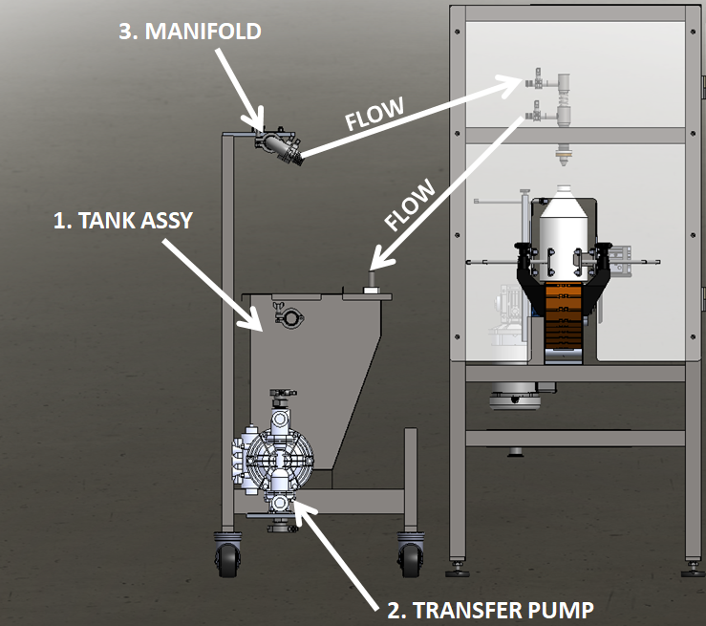
Customer moves product from their tank to this tank to fill. This Tank Assembly comes with a float switch to automatically bring more product in when it gets low.
- Tank Assembly – product storage tank
- Transfer Pump – pump used to fill bottles with product
- Manifold – used to spread fill across each Overflow Nozzle

SECTION TWO – UNCRATING AND INSTALLATION

2.1 ELECTRICAL

A grounded electrical male plug is provided with the machine, and is connected to the main electrical enclosure on the rear side of the machine. Plug this into any grounded receptacle. The main power switch can be found on the right side of the Electrical Enclosure.

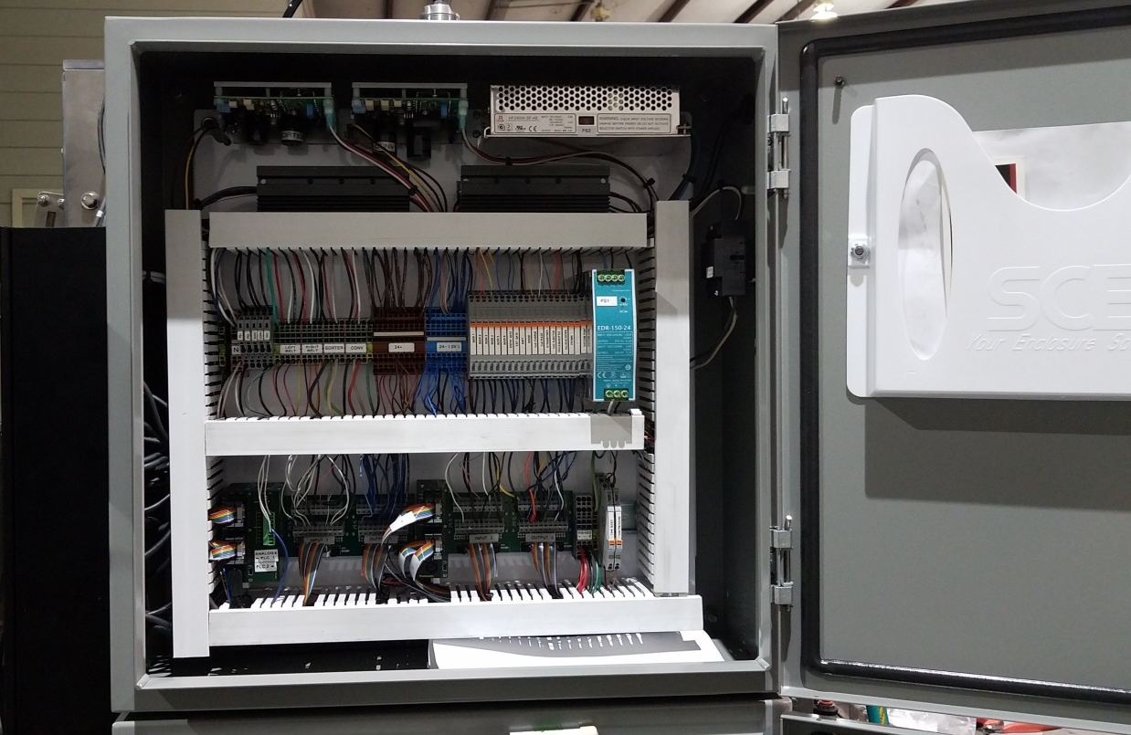

2.2 COMMUNICATION CABLES
If installed with Rinser and Labeler, connect M12 communication cables between the machines.

2.3 PNEUMATIC
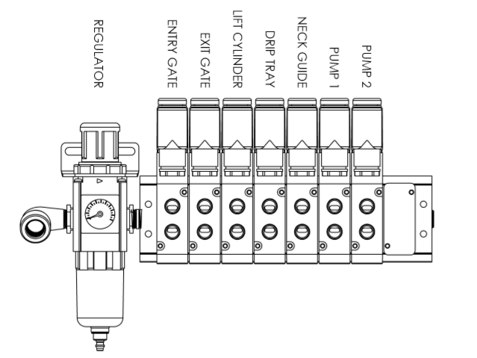
This pneumatic assembly can be found on the back side of the electrical enclosure. The regulator has a 1/4” male quick disconnect attached. You can supply compressed air to the machine by either a mating quick disconnect on the end of an air hose, or you can permanently pipe air to the machine using standard pipe and connecting directly into the air filter using threaded pipe connections. If you permanently pipe into the system we recommend a cut-off valve be mounted at the machine. Some changeover adjustments are easier if the operator is able to temporarily turn off the air pressure.

2.4 INSTALLING IN PRODUCTION LINE
Move the machine into its permanent location. Adjust the conveyor height of the machine to match the heights of the adjoining machines as required. Leveling casters are provided with the Micro Filler that allow you some vertical adjustment. Position the conveyor ends as close to each other as possible and then use conveyor rails to guide the containers across narrow dead plates onto the conveyor.

2.5 LEVELING THE BASE MACHINE
Once the machine is installed, level the main conveyor through the machine by using a bubble level. Place the bubble level along the length of the machine. Leveling the machine is important to the flow of the line as it allows for more seamless transitions between machines. The squaring and straightness of the base machine will ensure the machine operates correctly.
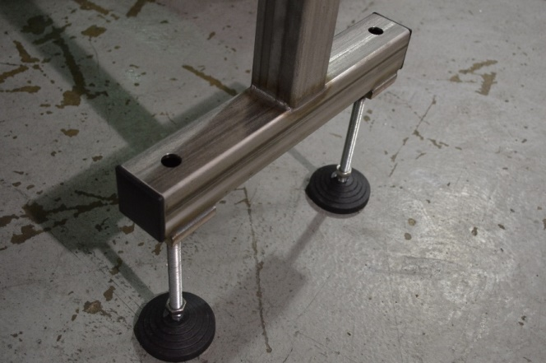

SECTION THREE – PERIODIC MAINTENANCE, CLEANING, AND LUBRICATION

3.1 MAINTENANCE
Ensure that you perform a monthly visual inspection for wear on the Filling Manifold seals, conveyor chain, Side Belts, and Crowning Head.

3.2 CLEANING THE MACHINE
The Micro Filler comes in stainless and aluminum construction. Cleaning the machine regularly is recommended.
Hook up at the Customer Connection point and run the Cleaning cycle on the Systems Settings page.
- Load bottles under the filling head, jog straightener in, lower filling heads onto bottle.
- Prepare cleaning solutions, (HOT CAUSTIC RECOMMEND 160 DEGREES 170 MAX.)
- From the system menu select the cleaning time per stage (speed, snift, vacuum paths).
- Connect cleaning solution product supply manifold.
- Select Cleaning ON. Switch to the monitoring menu to observe progress.
- When the vacuum valve opens remove the tube from the vacuum pump to the tank to fill the tanks with cleaning solution, then drain the tank.
- Repeat hot water through the machine, same process with sanitizer prior to fill
  - Pressure not to exceed 25psi

Wash down conveyors and components with hot water.

3.3 LUBRICATION
The only lubrication points on the machine are:
- The conveyor idler sprockets inside the frame of the machine need grease quarterly. The conveyor idler sprockets are located under the conveyor chain.
- Any threaded rod for linear motion should have light oil (food safe) applied to it periodically to prevent rust and to keep the mechanism moving freely.
- Flange mount bearings; these have grease fittings and should be lubricated quarterly

SECTION FOUR - TROUBLESHOOTING

The list below represents a few scenarios in which troubleshooting may need to occur.

4.1 NOTHING WORKS AT ALL/POWER IS ON BUT NOTHING WORKS
- Check main power. Is machine plugged in? Is main power switch turned on?
- Check fuses inside control panel.
- Are conveyor speed controls turned up above zero (in the Touchscreen)?

4.2 OPERATIONAL INCONSISTENCIES (NOTHING IS BEING FILLED)
- Confirm that filling is on and that the counting eye is changing states between bottles.
- Confirm that air supply is on.
- Confirm bottles per cycle is not set to zero.
- Confirm CO₂ pressure is set 5-10psi above tank head pressure.

SECTION FIVE – SCREENS

5.1 Main Screen
The Main Screen has three subsections: Bottler Settings, Rinser Settings, and Labeler Settings. The commonly edited items for each machine are listed on this screen. Below each subsection are screen buttons that take you to specific screens. Bottler screens are blue, Rinser screens are green, and Labeler screens are red.
A batch count is carried in the top right corner and a reset button is there to reset the count back to zero.
There are multiple jog buttons throughout each screen. Each one will have a stated status. The stated status is what the status of each function is. If a certain function is desired to run, then stated status must say on.
Example: The button that says Filling On indicates that the filling function is on. If it said Filling Off then the filling function would be turned off.
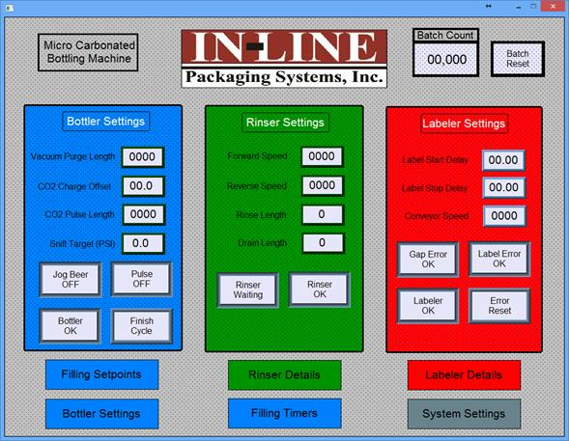

SECTION SIX – CLEANING CYCLE

- Lower heads onto bottles
- Connect sanitizer
- Open beer valves
- Open speed valve for 2 minutes
- Close speed valve
- Open snift valve for 2 minutes
- Close snift valve
- Open vacuum valve for 2 minutes
  - Remove top tube on vacuum tank, when sanitizer comes out, open bottom valves
- Flush with hot water at the end of the cycle

