Operation Manual
RSC Rinser

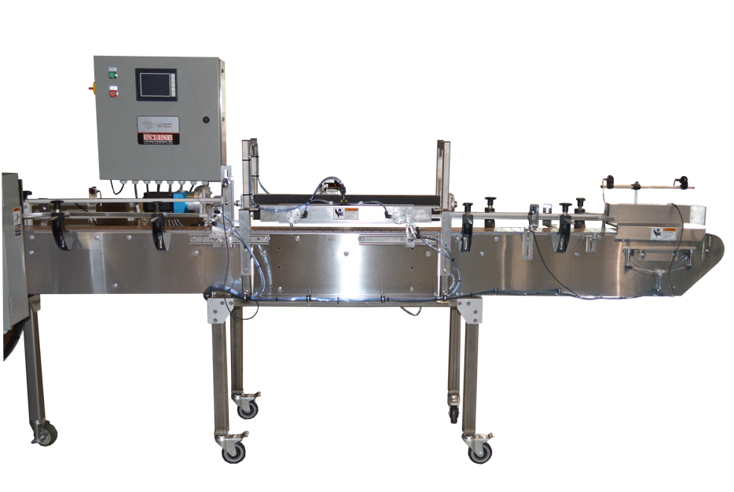
Operation Manual
Automatic Rinser &
Feeder for Merlin Bottler

In-Line Labeling Equipment, Inc.
7282 Spa Road, North Charleston, SC 29418
Phone: 843.569.2530 Fax: 843.569.2531
www.labeling.net

RSC Rinser

CAUTION!
Automatic Rinser &
Feeder for Merlin Bottler

In-Line Labeling Equipment, Inc.
7282 Spa Road, North Charleston, SC 29418
Phone: 843.569.2530 Fax: 843.569.2531
www.labeling.net

Persons operating this machinery are reminded to observe their own company safety policies. In addition, the following safety rules should be observed:

DO NOT REACH INTO THE MACHINE WHILE IT IS IN OPERATION.

USE ONLY THE CORRECT TOOL FOR THE JOB BEING DONE.

STAY ALERT, REMEMBER LOCATION OF CONTROL SWITCHES.

MAINTENANCE

The main electric switch supplying power to the machinery should be locked out or disconnected when repairs are performed on this equipment.

Machine should be cleaned and inspected regularly. All safety switches must be operable, attachments secure and machine free of broken glass and paper.

Do not hand lubricate when the machine is in operation.
Work area should be kept clean and as dry as is practical.

The repair or adjustment of this equipment should be performed only by persons qualified through technical training and ability, as assigned by your company.

OPERATION

All guards should be securely in place before operating the machine.

Company rules on eye protection should be followed.

Loose clothing or jewelry such as neckties, rolled sleeves, over blouses, bracelets, watches and rings should not be worn when operating the machine.

Report all malfunctions, unusual operation and defects immediately.

Please exercise caution with any moving parts, including the conveyor and any pinch or drive rolls.

Stop the machine before placing hand or arms near or into any area where moving parts are located.

Table of Contents

Section

General Information
1.1 Terminology of Machine
1.2 Functional Description of Machine
1.3 PLC Screens

Section One - General Information

The Rinser Feeder is a fully automatic machine for cleaning bottles and then loading them into a 4 or 6 at a time Bottler. Various settings allow for you to set a production rate that is slightly faster than the bottler, then the backup photoeye will regulate the release of clean bottles as needed.

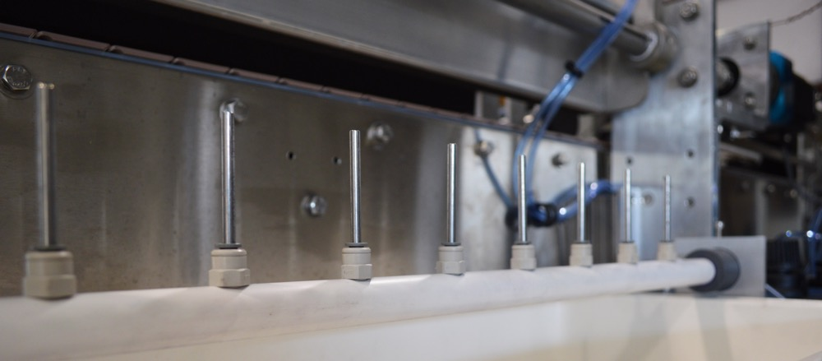
  - Terminology of a Rinser/Feeder

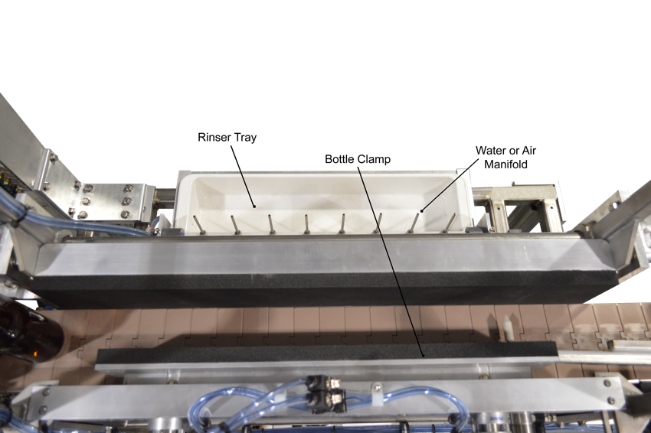

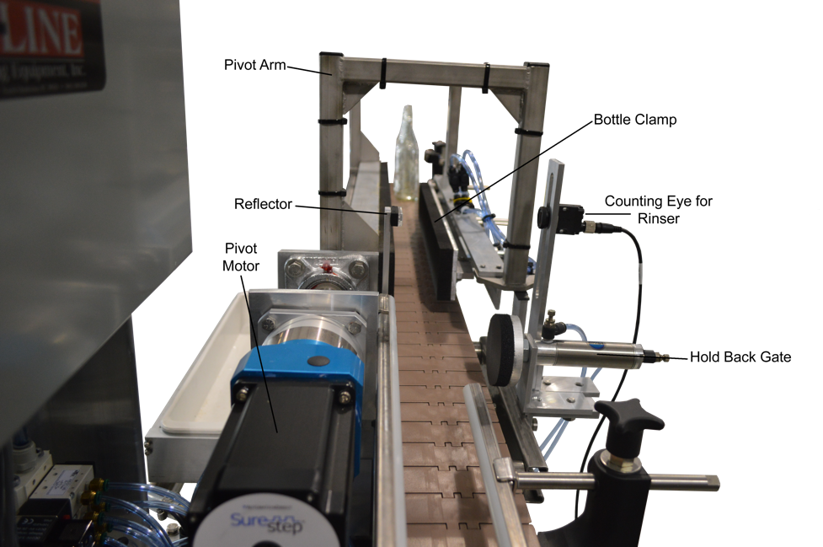
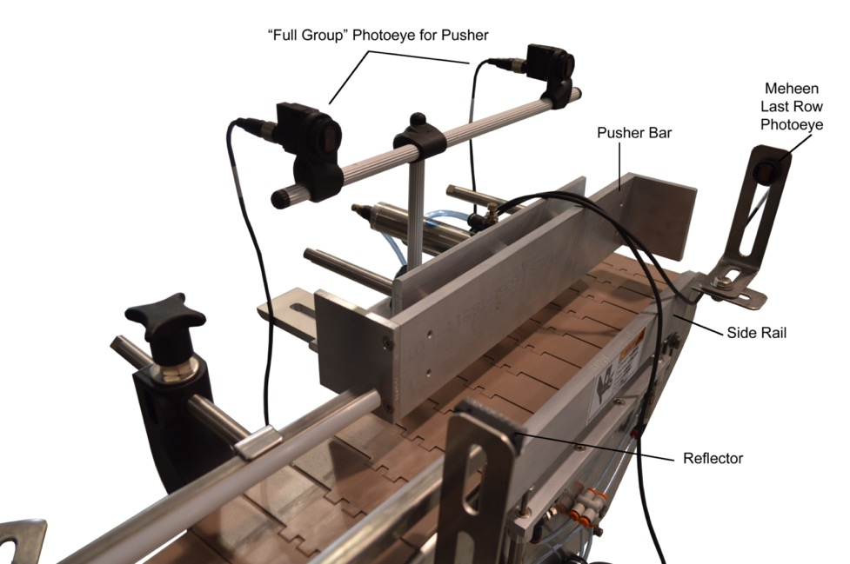

1.2 Functional Description of Machine

The Rinser/Feeder is designed to take incoming containers, invert them for rinsing or air cleaning, return them to upright, then collect them in a preset group and push off one row at a time. Ideally, the machine is positioned to push rows of containers into a Meheen Merlin Bottler – usually taking rows of 6 containers. In this way the infeed of the Bottler is automated and no longer requires a person to manually rinse and load bottles. The machine funtions in this way:

- Bottles are counted as they enter the rinser area by the counting eye. When the bottles per cycle count is complete (this count is changed in the Systems settings screes) the holdback gate fires, preventing any further bottles from entering the rinser.
- After the completion of the clamp delay the bottles are clamped and held.
- A pivot delay starts, and when complete the pivot move begins to invert the bottles.
- The pivot speed, pivot move length, accel and decal parameters control how the inverter mechanism inverts the bottles to position them above the rinser manifold.
- After the move is complete, a water jet delay begins and when complete the water pump turns off, forcing water up through the water jets and into the bottles.
- The water is on for the water jet dwell, and then stops. The drain length allows the water to run out and drain from the bottles.
- When that is complete the inverter mechanism returns the bottles back to the conveyor.
- A clamp release delay completes and the bottle clamp turns off.
- A Front gate delay then begins. When the delay is complete. The front gate opens and allows the rinsed bottles to exit. The gate remains open the length of the front gate dwell – which should be just enough time for the containers to pass the front gate. After the dwell the gate closes to start collecting the next cycle.
- The backup photoeye, if blocked for the length of the Discharge backup delay, will prevent the front gate from opening. It will remain closed until the backup eye clears at which time the entire cycle will resume.
- When the front gate opens a holdback gate retract delay begins. When complete the holdback gate opens and allows new containers to pass the counting eye.
- The pusher bar operates by collecting a group of bottles – seeing the first and last bottles in the group. When the group is full, and when the last row of bottles in the Bottler is open, the side rail down delay begins.
- When the side rail delay is complete the side rail drops, starting a short delay for the pusher bar. When complete the pusher bar extends and remains extended for the pusher bar dwell length.
- When complete the pusher bar retracts, starting the side rail up delay. When complete the side rail returns up and the next group of bottles begins moving into the pusher bar zone.

1.3 PLC Screens

Main Screen:

Batch Count The current batch count is displayed

Batch Reset By pressing this screen button the batch count is reset to zero.

Run Mode When waiting for the start button, the display will read “Ready”. After start button is depressed the screen will display “Run”.

Screen Access buttons below will take you to that screen when touched. Descriptions of all screens follow.

Pivot Settings:

Pivot Speed The speed of the pivot arm ranges between 0 and a maximum speed of 3500. A higher setting with heavy bottles may cause the stepper motor to stall.

Move Length This is the distane of the pivot move. A value of 8000 should represent the full 180 degree pivot.

Accel Delay The ramp up time in 1/10ths of a second. Setting of 5 recommended.

Decel Delay The ramp down time in 1/10ths of a second. Setting of 5 recommended.

Rinser Gate Settings:

Holdback Gate Delay after counting eye detects the last bottle and the holdback gate extends.
Front Gate Delay after rinse cycle is complete before front gate retracts to allow bottles through.
Holdback Retract Delay after front gate retracts before holdback gate retracts. This creates space so front gate can get between old group and new group.
Front Dwell Length of time front gate is open to allow group of bottles to pass before extending back into conveyor.
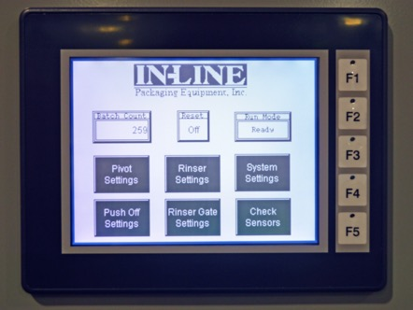

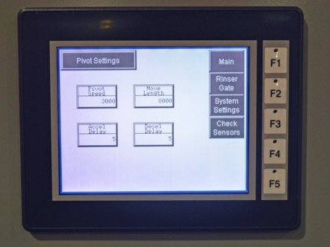

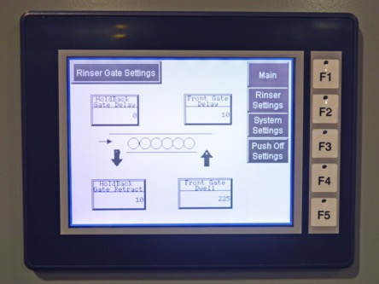

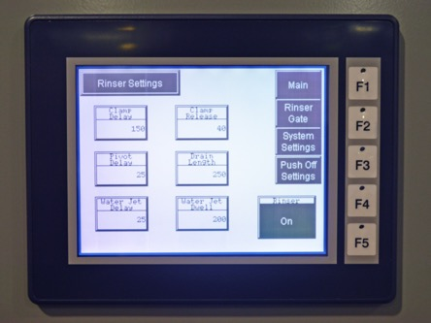
Rinser Settings:

Clamp Delay Delay after full group of bottles is counted until the clamp extends.

Clamp Release Delay after rinse and pivot has returned until the clamp releases the group.

Pivot Delay Delay after bottles have clamped before pivot begins.
Water Jet Delay After pivot has completed, a delay before water jet turns on

Water Jet Dwell Length of time water jet is turned on

Drain Length Length of time to drain water

System Settings:

The Buttons to the left are manual On/Off buttons to allow you to manually jog each device to see if it is setup correctly. You can simulate the entire cycle using these buttons.

Discharge Bkup Length of time for photoeye to be blocked before front gate prevents release of new group.

Bottles/Cycle Used by the counting eye to make a full group. Should match water manifold.

Push Off Settings:

Side Rail Down After The empty row is seen, with number of bottles present, the delay before the side rail goes down to allow push off.

Side Rail Up After pusher dwell is complete, time to allow pusher bar to retract and side rail to come up.

Pusher Bar Dly After Side rail is down, the delay before the pusher bar extends.

Pusher Dwell Length of time the pusher bar is extended.

Pusher On/Off Turns the Push-off function on or off.

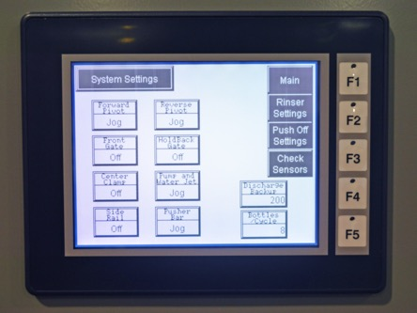

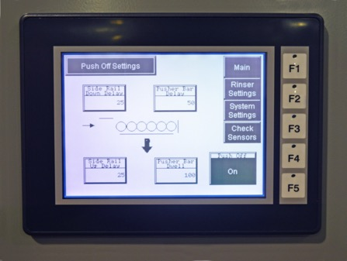

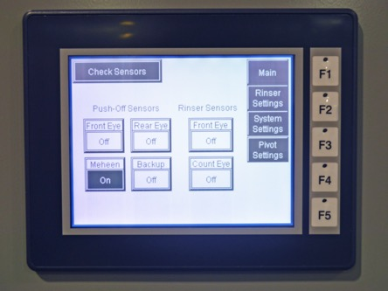

Check Sensors:

These display buttons show the status of each sensor in the machine. They are used to see if the function of the sensor is correct at the PLC input.

.

