  - SERVO CAN FILLER – Operation Manual

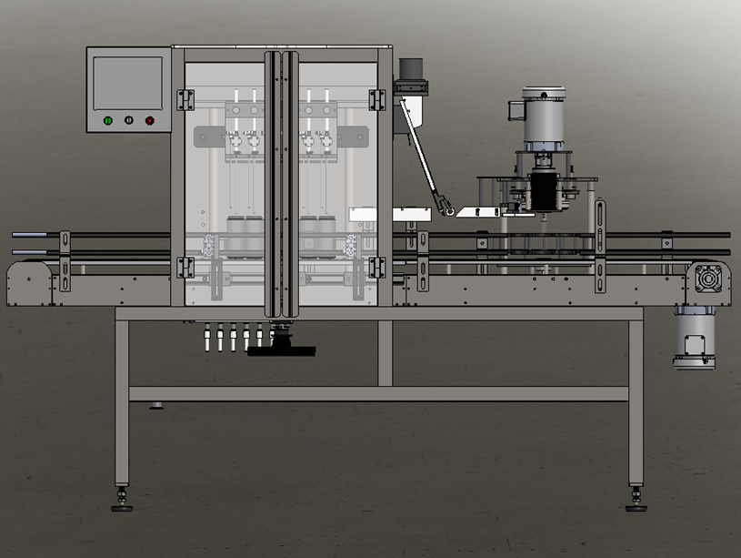

For helpful how-to videos visit our
YouTube channel - Inlinelabeling1

Follow us on:
Instagram @inlinepackaging
Facebook @inlinepack

CAUTION!

Persons operating this machinery are reminded to observe their own company safety policies. In addition, the following safety rules should be observed:

- DO NOT REACH INTO THE MACHINE WHILE IT IS IN OPERATION.
- USE ONLY THE CORRECT TOOL FOR THE JOB BEING DONE.
- STAY ALERT, REMEMBER LOCATION OF CONTROL SWITCHES.

MAINTENANCE
The main electric switch supplying power to the machinery should be locked out or disconnected when repairs are performed on this equipment.

Machine should be cleaned and inspected regularly. All safety switches must be operable, attachments secure and machine free of broken glass and paper.

Do not hand lubricate when the machine is in operation.
Work area should be kept clean and as dry as is practical.

The repair or adjustment of this equipment should be performed only by persons qualified through technical training and ability, as assigned by your company.

OPERATION
All guards should be securely in place before operating the machine. Close all doors when operating machine.

Company rules on eye protection should be followed.

Loose clothing or jewelry such as neckties, rolled sleeves, over blouses, bracelets, watches and rings should not be worn when operating the machine.

Report all malfunctions, unusual operation, and defects immediately.

Please exercise caution with any moving parts, including the conveyor and any pinch or drive rolls.

Stop the machine before placing hand or arms near or into any area where moving parts are located.

TABLE OF CONTENTS

SECTION ONE – GENERAL INFORMATION

1.1 | Terminology of Machine | pg. 4
1.2 | Specifications and Requirements | pg. 5
1.3 | Functional Description of Machine | pg. 6

SECTION TWO – UNCRATING AND INSTALLATION

2.1 | Electrical | pg. 16
2.2 | Communication Cables | pg. 16
2.3 | Pneumatic | pg. 17
2.4 | Installing in Production Line | pg. 18
2.5 | Leveling Base of Machine | pg. 18

SECTION THREE – OPERATIONAL ADJUSTMENTS

3.1 | Adjusting Fill Levels | pg. 19
3.2 | Foam Issues | pg. 19

SECTION FOUR – PERIODIC MAINTENANCE, CLEANING, AND LUBRICATION

4.1 | Maintenance | pg. 20
4.2 | Cleaning the Machine | pg. 20
4.3 | Lubrication | pg. 20

SECTION FIVE – TROUBLESHOOTING

5.1 | Nothing Works at All | pg. 21
5.2 | Operational Inconsistencies | pg. 21

SECTION SIX – SCREENS

6.1 | Main Screen | pg. 22
6.2 | Bottler Screens | pg. 23
6.3 | Rinser Settings | pg. 28
6.4 | Labeler Settings | pg. 30
6.5 | System Settings | pg. 32

SECTION SEVEN – CLEANING CYCLE
REFERENCES
WIRING BLOCK DIAGRAMS

SECTION ONE – GENERAL INFORMATION

TERMINOLOGY OF MACHINE

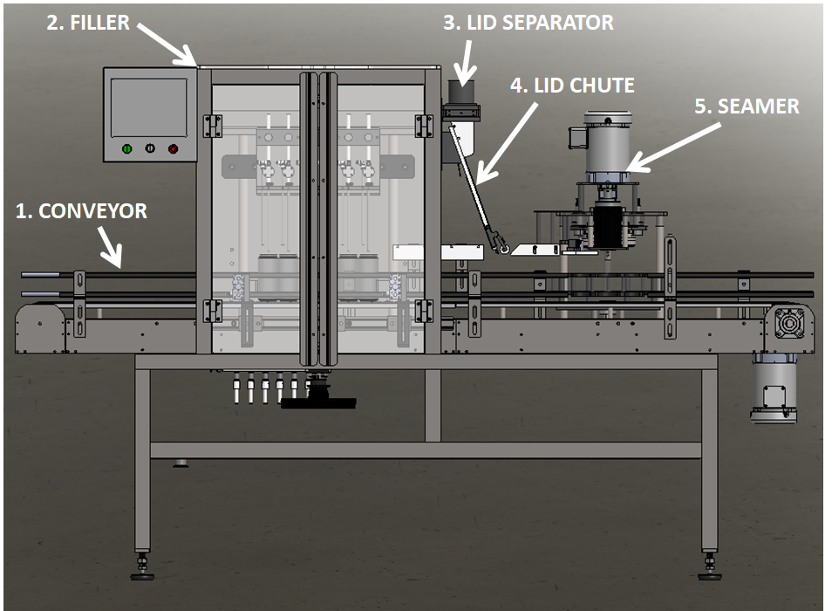
Can Filler
Item No. | Assembly Name | Description
1 | Conveyor | Moves cans from one operation to the next
2 | Filler | Fills the cans with product
3 | Lid Separator | Separates lids from stack
4 | Lid Chute | Places lids in position to be put on top of cans
5 | Seamer | Forms the lid of the can to the body of the can

SPECIFICATIONS – STANDARD MACHINE

ITEM | SPECIFICATION
CONVEYOR WIDTH | 4.5 inches standard
MACHINE SPEED | 35-40 cans per minute
OVERALL DIMENSIONS | h: 67 2/3”; L: 104”; w: 31”
ELECTRIC REQUIREMENTS | 110VAC 6 AMPS
AIR REQUIREMENTS | 90-100 PSI @ 10 CFM

FUNCTIONAL DESCRIPTION OF MACHINE

The In-Line Canner is a 6-head filler with a single seamer. The throughput of this machine is 35-40 cans per minute or 87-100 cases per hour. The cans run on a sanitary conveyor through the fill area, under the CO2 curtain, through the lid pick-off area, and then into the seamer. Having a sanitary conveyor allows for easier rinsing of the machine to prevent bacteria or anything else from finding a place to live. Each area of the machine is washdown rated so taking a hose to the line is not only okay to do but highly suggested at the end of each run.

Conveyor
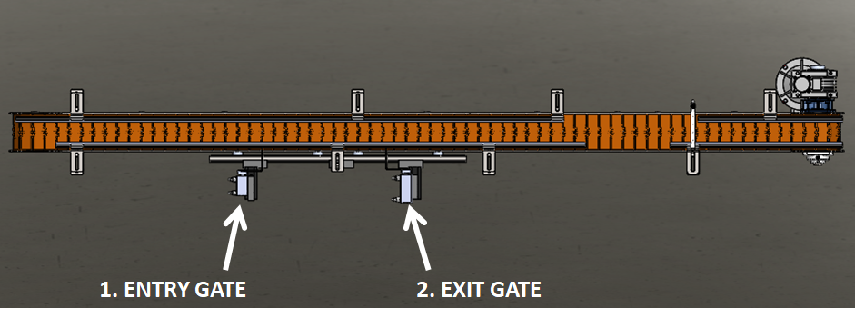
The Can Filler Conveyor is an automated, sanitary conveyor that moves cans from one operation to the next. This is the part of the machine that ensures each can is moving through the Filler, Lid Chute, and Seamer.
- Entry Gate – creates necessary spacing between can groupings
- Exit Gate – aligns cans under the fill tubes

Adjustments
The only time to move either of the Entry or Exit Gates is when changing over from one can diameter size to another. If each can size you run on your line is the same diameter then these will never need to be moved or adjusted.

Filler
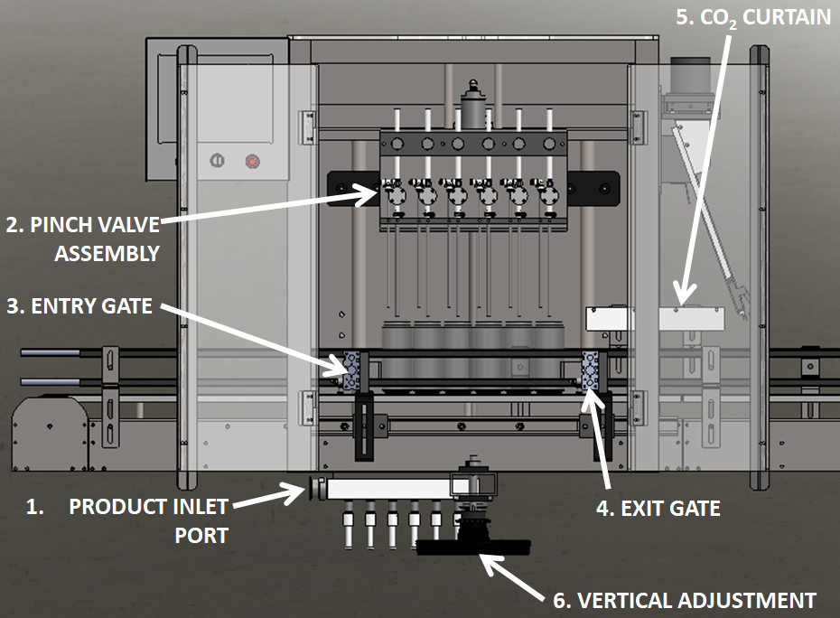
The Filler is the part of the machine that puts your product into empty cans!
- Product Inlet Port – customer connection point to allow for product flow into the Filler
- Pinch Valve Assembly – restricts flow, stops and starts flow, and fills empty cans with CO₂
- Entry Gate – creates necessary spacing between can groupings
- Exit Gate – aligns cans under the fill tubes
- CO₂ Curtain – creates CO₂ rich environment for cans all the way to the Lid Chute
- Vertical Adjustment – moves Pinch Valve Assembly up and down for different can heights
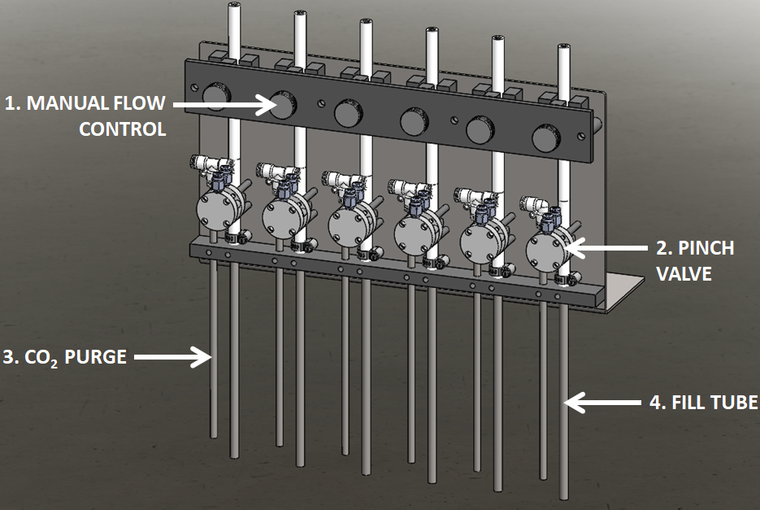 | The Pinch Valve Assembly is the most critical part to the Filler. This is what is used to purge the cans with CO₂ and then fill them with product.  - Manual Flow Control – allows for fine control of each fill tube to ensure accurate and repeatable fills  - Pinch Valve – opens to allow flow and closes to stop flow of product  - CO₂ Purge – tube that puts CO₂ into empty cans prior to filling  - Fill Tube – tube that product flow through into cans

Adjustments
Use the Manual Flow Control knobs or bolts to pinch down on the tubes to create the proper fill speed and to limit foam. This is where the fine adjustment is done for each fill head to create a repeatable fill in each can position.
Use the handwheel at the bottom of the Filler to move the Pinch Valve Assembly up and down for different can heights.
The CO₂ Curtain will need to move up and down when changing can heights. The way we set it up is to put about 7 lids on the top of an empty can and let the plastic ride on top of this. This creates the gap between the CO₂ and the top of the cans that we are looking for (~.750”).

Filling Process
- The Exit Gate opens to allow the previous cycle to exit the filling area
- The Entry Gate opens to allow the next set of cans into the filling area
  - The Counting Eye counts the number of cans that pass by and initiates the next cycle when the targeted count is reached (6)
- The Filling Head lowers to have the tubes dive into the cans
- The CO2 solenoid opens to purge the cans
- The Pinch Valves open to allow product to flow into the cans
- After a specified amount of time, the Fill Head begins to slowly move up during the fill
- Once the specified length of time is reached, the Pinch Valves close and the Fill Head is moved fully into the up position
- The Exit Gate opens to allow the cycle to exit the filling area (Step 1)

Lid Separator & Lid Chute

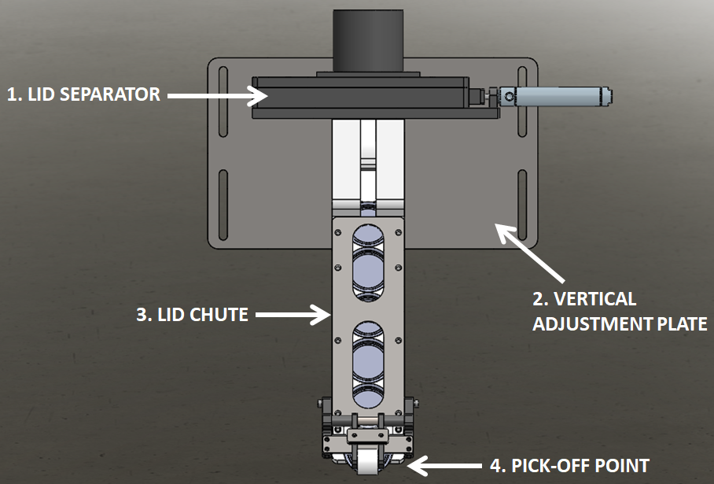
The Lid Separator and Lid Chute are used to take a sleeve of lids and align the lids one by one to be placed on the top of filled can bodies.
- Lid Separator - used to remove one lid at a time from the stack
- Vertical Adjustment Plate - allows for adjustment for different height cans
- Lid Chute - used to put the lids in line to be picked off
- Pick-Off Point – the spot where the can picks off the lowest lid in the chute

Adjustments

The only adjustment is moving the assembly up or down to ensure that the can bodies pick-off the lid at the bottom of the chute.

Seamer

Seamer Conveyor

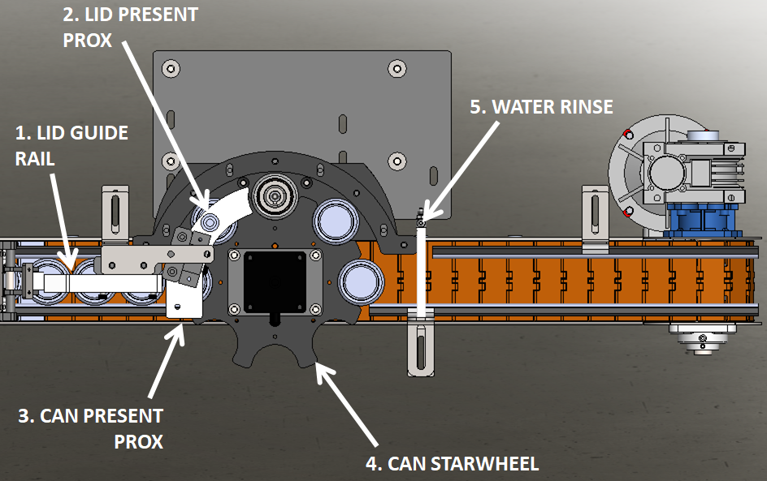
This part of the machine is what gets the filled can and lid over to the seamer and places it in position to be seamed.
- Lid Guide Rail – keeps lids on top of bodies; there is a straight and a curved guide rail for this design
- Lid Present Prox – ensures a lid is present in order to lift to seam
- Can Present Prox – used to engage Can Push cylinder
- Can Starwheel – moves a can with lid on it to the lift assembly
- Water Rinse – rinses off the top of the cans to remove any remaining beer

Seamer
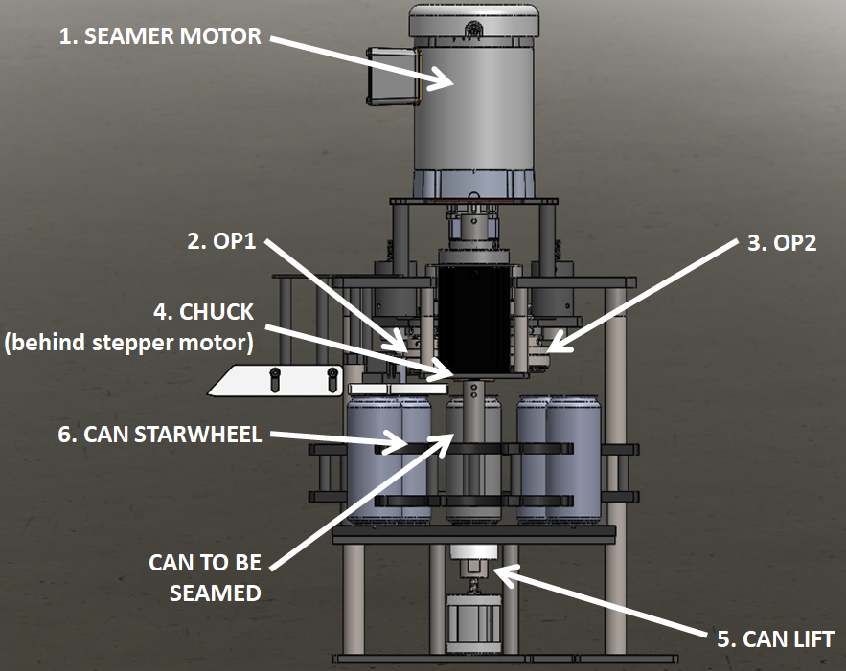
This is the part of the machine that seams the lid to the can body.
- Seaming Motor – rotates the can at the required rpm (adjustable in the screen)
- OP1 – folds the lid around the can body
- OP2 – smashes the lid and body together
- Chuck – fits in the can lid and is used to spin the can at the required rpm
- Can Lift – lifts the can into the chuck
- Can Starwheel – moves cans around to lift and back to conveyor

Seaming Process
- Lids are picked off onto the top of each can body
  - The operator needs to keep an eye on the amount of lids left in the vertical chute to know when to replace it with the next sleeve of lids.
- The cans move under the floating weight that keeps the lid in place
- The first can moves into pocket one of the Starwheel
- Once the Can Present Eye sees a can in place, the Starwheel indexes one time
  - The first can moves from pocket one to pocket two
  - The second can moves into pocket one
- The Lid Present eye detects whether a lid is on the can in pocket two or not, the Starwheel indexes one time
- Lifting:
  - If a lid was detected for the can now in pocket three then the Lift Cylinder lifts the can into the Chuck above it and the seaming process is initiated
  - If a lid was not detected for the can now in pocket three then the Lift Cylinder does nothing
- If the can is lifted into the Chuck then it begins to rotate at the speed specified by the motor speed. The first operation roll comes in and folds the lid around the body and then the second operation roll comes in and smashes the two together to form the seam.
  - Once this cycle has been completed the can is lowered back down by the Lift Cylinder and the Starwheel indexes
  - If the Lift Cylinder never lifts the can, there is no lid present, then the Starwheel goes ahead and indexes
- Once the Starwheel has indexed, the can from pocket three goes to pocket four, the one from two goes to three, the one from one goes to two, and the next can in line goes to pocket one.
- When the can is back on the conveyor it goes under a rinser that removes all of the overflow of the product from the outside of the can and lid.
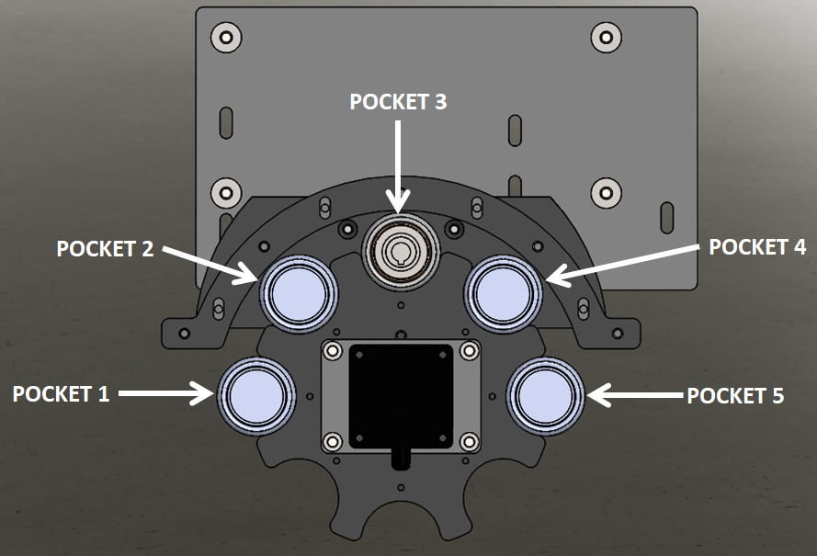

SECTION TWO – UNCRATING AND INSTALLATION

2.1 ELECTRICAL

A grounded electrical male plug is provided with the machine, and is connected to the main electrical enclosure on the rear side of the machine. Plug this into any grounded receptacle. The main power switch can be found on the right side of the Electrical Enclosure.

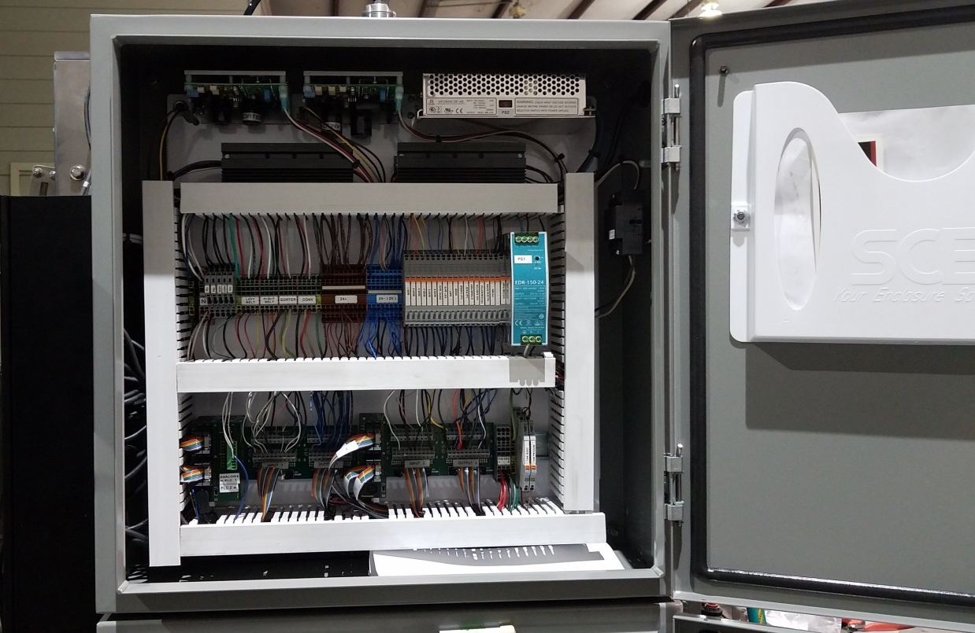

2.3 PNEUMATIC
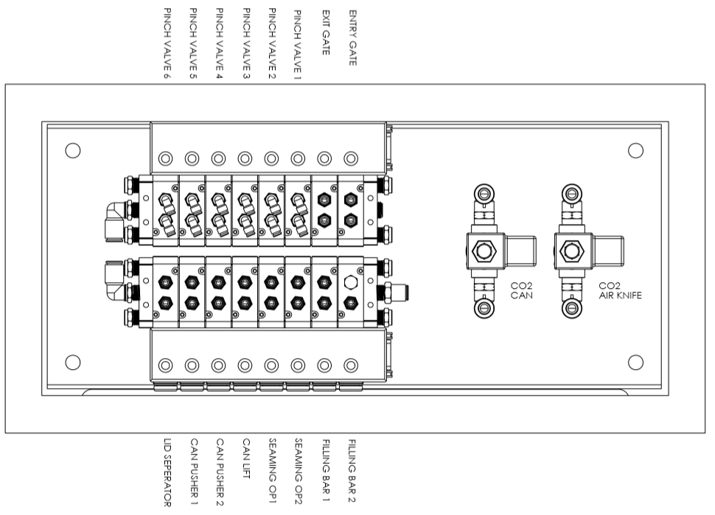
For compressed air, to the right of the Pneumatic Enclosure is an air filter/regulator with a 1/4” male quick disconnect attached. You can supply compressed air to the machine by either a mating quick disconnect on the end of an air hose, or you can permanently pipe air to the machine using standard pipe and connecting directly into the air filter using threaded pipe connections.
The regulator on the left is for air and the one on the right is for CO₂.

2.4 INSTALLING IN PRODUCTION LINE
Move the machine into its permanent location. Adjust the conveyor height of the machine to match the heights of the adjoining machines as required. Leveling feet are provided with the Micro Filler that allow you some vertical adjustment. Position the conveyor ends as close to each other as possible and then use conveyor rails to guide the containers across narrow dead plates onto the conveyor.

2.5 LEVELING THE BASE MACHINE
Once the machine is installed, level the main conveyor through the machine by using a bubble level. Place the bubble level along the length of the machine. Leveling the machine is important to the flow of the line as it allows for more seamless transitions between machines. The squaring and straightness of the base machine will ensure the machine operates correctly.
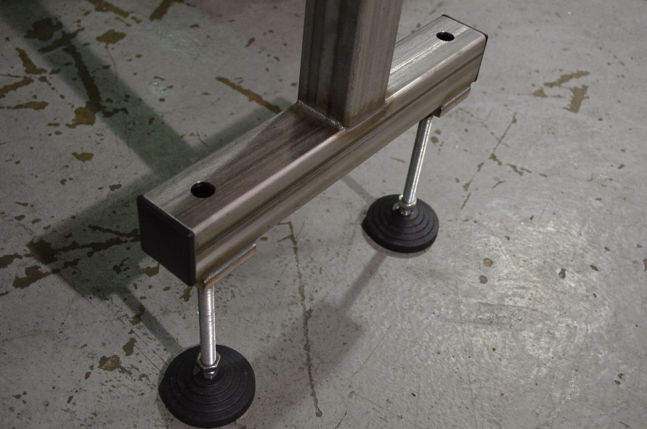

SECTION THREE – OPERATIONAL ADJUSTMENTS

3.1 ADJUSTING FILL LEVELS
It is recommended to set all 6 fill timers to the same value. Then use the Manual Flow Control knobs to adjust each head individually.

3.2 SEAM SETUP
- The first step is to setup the can lift puck to the correct height. The gap between the top of this puck and the bottom of the chuck is referred to as the “Pin Height”.
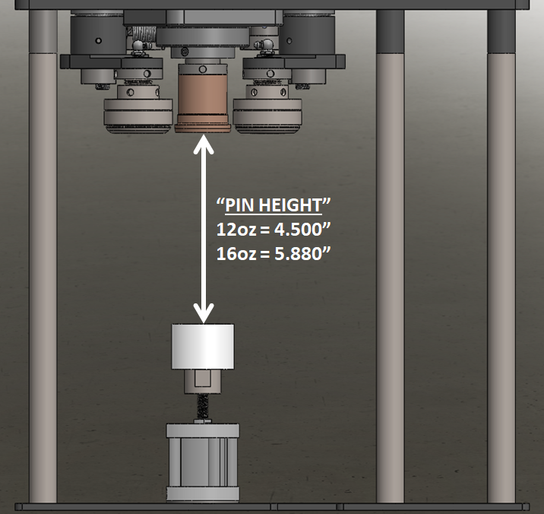
- The second step is to setup the correct height of each OP roll. This is the distance between the top edge of the roll profile and the top edge of the chuck.
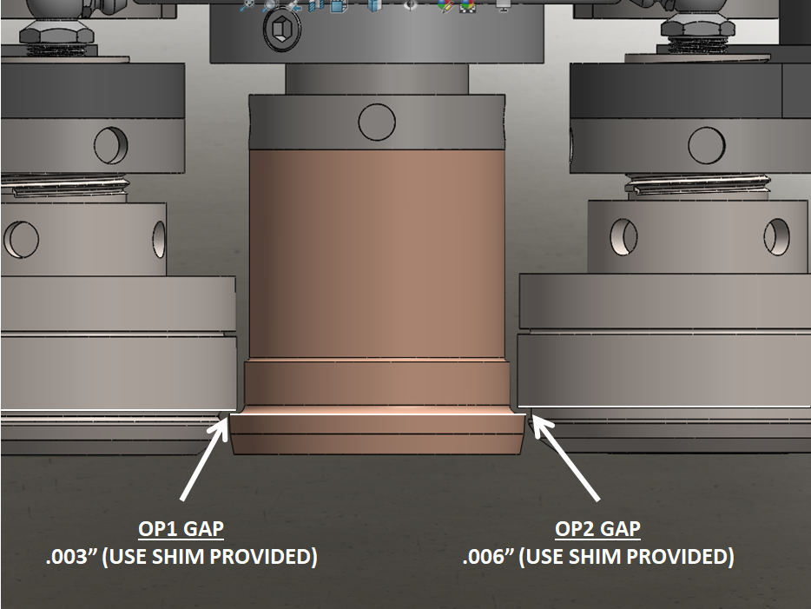
- After these two steps are completed, jog OP1 roll in and ensure that it can spin freely. Then jog it back out.
- Once this is confirmed we will go to the Seamer Settings screen and change the OP2 dwell time to 1 (take note of what the dwell was before changing it because we will need to put it back in). This will allow us to run a cycle of only OP1 to check our specifications.
  - Place a seamed, filled can on the can lift and then place a can full of water on the conveyor. You may have to jog the exit and entry gates to get a can in place. Make sure the can either has a lid on it or that it will pick a lid off from the chute.
  - Hit start and let the machine do the seaming process. Only OP1 should have come in.
  - Press stop
  - Remove the can and measure the Seam Thickness and check against the acceptable range given by your can supplier.
- Go to the touchscreen and adjust how far in the roll comes by adjusting the value on the screen. Each increase by “1” is a change of a tenth of a degree.
- Once OP1 measurements are in spec, go back to the screen and put the original dwell time back in for the OP2 roll.
  - Once this is done, repeat the steps above to complete a full seam cycle on a new can.
  - Measure the Seam Thickness and Seam Height and check against the can manufacturers specification sheet.
  - Adjust OP2 values just like you did for OP1 to get seam into spec.

SECTION FOUR – PERIODIC MAINTENANCE, CLEANING, AND LUBRICATION

4.1 MAINTENANCE
Ensure that you perform a monthly visual inspection of all moving components for wear. Lubricate all brearings and grease fittings with Lubriplate Fgl-0 food grade lube.
Lube seam rollers weekly, but inspect at each run. Lubricate seaming arm fittings weekly as well as inspecting at each run.4.2 CLEANING THE MACHINE
The Micro Filler comes in stainless and aluminum construction. Cleaning the machine regularly is recommended.
Hook up at the Customer Connection point and run the Cleaning cycle on the Systems Settings page.
- Load cans under the filling heads
- Prepare cleaning solutions, (HOT CAUSTIC RECOMMEND 160 DEGREES 170 MAX.)
- From the jog devices menu jog all heads open.
- Connect cleaning solution product supply manifold.
- Either recirculate product from drain pan or drain to floor drain for the desired period.
- Repeat with hot or cold water through the machine to rinse the caustic out. Same process with sanitizer prior to fill
  - Pressure not to exceed 25psi

Wash down conveyors and components with hot water.

4.3 LUBRICATION
The only lubrication points on the machine are:
- The conveyor idler sprockets inside the frame of the machine need grease quarterly. The conveyor idler sprockets are located under the conveyor chain.
- Any threaded rod for linear motion should have light oil (food safe) applied to it periodically to prevent rust and to keep the mechanism moving freely.
- Flange mount bearings; these have grease fittings and should be lubricated quarterly

SECTION FIVE - TROUBLESHOOTING

The list below represents a few scenarios in which troubleshooting may need to occur.

5.1 NOTHING WORKS AT ALL/POWER IS ON BUT NOTHING WORKS
- Check main power. Is machine plugged in? Is main power switch turned on?
- Check fuses inside control panel.
- Are conveyor speed controls turned up above zero (in the Touchscreen)?

5.2 OPERATIONAL INCONSISTENCIES (NOTHING IS BEING FILLED)
- Confirm that filling is on and that the counting eye is changing states between bottles.
- Confirm that air supply is on.
- Confirm bottles per cycle is not set to zero.
- Confirm CO₂ pressure is set 5-10psi above tank head pressure.

SECTION SIX – SCREENS

Main Screen
The Main Screen has three subsections: The commonly edited items for each machine are listed on this screen. Below each subsection are screen buttons that take you to specific screens.
A batch count is carried in the top right corner and a reset button is there to reset the count back to zero.
There are multiple jog buttons throughout each screen. Each one will have a stated status. The stated status is what the status of each function is. If a certain function is desired to run, then stated status must say on.
Example: The button that says Filling On indicates that the filling function is on. If it said Filling Off then the filling function would be turned off.
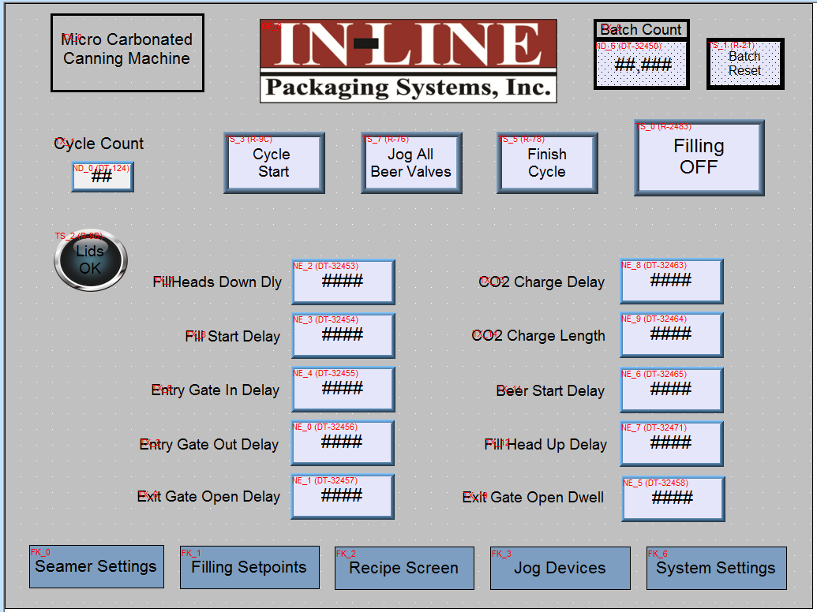

6.2 Canner Screens

6.2.1 Filling Set Points

Each filling head (numbered from left to right) has its own set point target. This allows for dialing in to specific fill levels on each head, a setting between 100 = 1 second fill time.
When a cycle is running, each of the vertical bars will begin to fill in to show the progress of each fill head. When the filling has reached its set point, the color on the bar will change from a dark red to bright red. The last bottle to fill will remain a darker red to show which fill head has the slowest fill.
Below each bar is a Jog button. This button allows liquid to flow through the specified fill head to ensure each one is working properly or to remove any foam that may be present in the line. This allows for the user to go one by one and check that each one is good. However, in the top right there is a Jog All Beer Valves button that will open each fill head at once.
This should be used at the beginning to push product through, cool down all lines, and push any foam through the lines. It should also be used at the end of each run to allow for cleaning.
Also in the upper right corner is the Finish Cycle button, which should be used when filling is in progress and the machine has stopped. When the Finish Cycle button is pressed, each fill head and the speed valve will close, and the machine will go on into the snift cycle to completion. This lets you move on rather than stop the machine and clear out bottles. The Cycle Start button begins a cycle without counting cans.
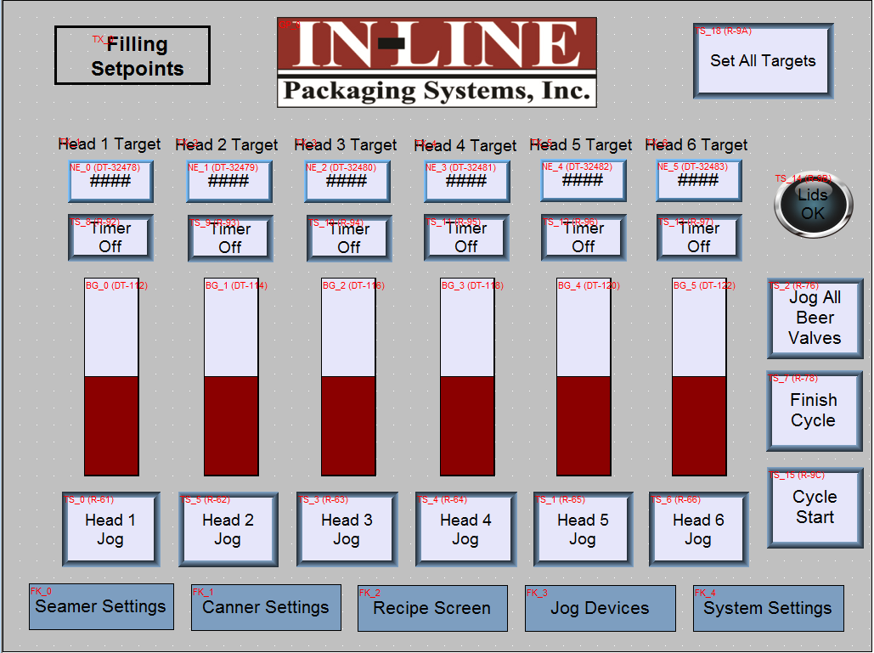

6.2.2 Canner Settings
Cycle Count | Displays the current count of bottles as the filling cycle is occurring
Cycle Start | Manually Begins a filling cycle
Finish cycle | Ends the current filling cycle manually.
Filling On/Off | If off, the Filling Manifold will never come down and engage
Fill Start Delay | This delay is the start time from a completed can count.
Fill head up delay | This delay raises the head after filling begins.
Gate delays | These delays are the timing of the opening and closing of the gates.
CO2 Delays | This timer purges the cans with CO2 and precedes the beer delay.
Beer Start Delay | Timing of beer starting to fill cans after purge.
Jog All Beer Valves | As stated above, pushing this button will open all beer lines at once.

6.2.3 Filling Timers
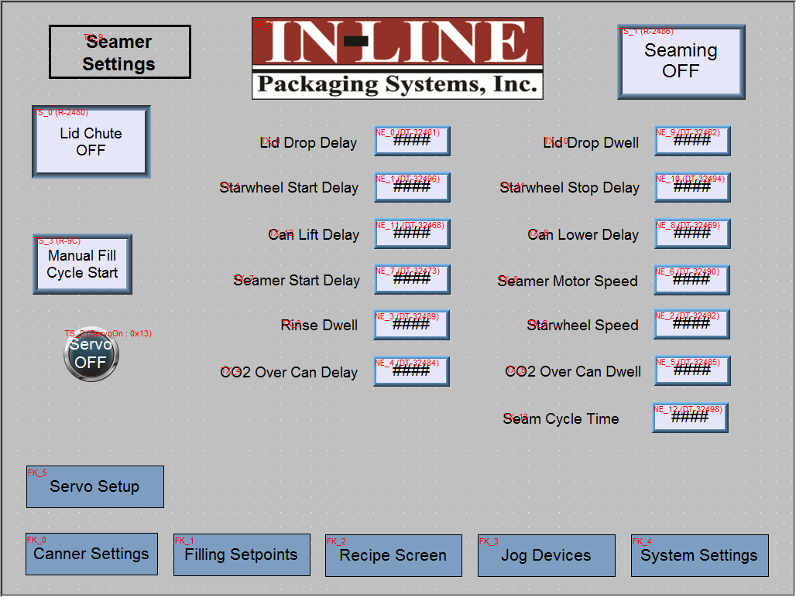
Lid Drop Delay | Time for the chute to drop the next lid (all timers are 100th of 1 second. 100=1 Second
Lid Drop Dwell | The dwell time for the lid separator to return home.
Starwheel Start Delay | The delay for indexing a can through the star wheel.
Starwheel Stop Delay | This sets the seamer starwheel stop position, this aligns the can with the lift.
Seamer Start Delay | A delay to start the seaming operation on each can after indexing.
Seamer motor speed | The scale is from 0-1200 1200=1750RPM 600= 785 RPM
Can eject delay and dwell | The timers for ejecting the can from the previous seam cycle.
CO2 over can delay and dwell | After the exit gate opens this delay sends CO2 over the cans as they pick up lids.
Seam Cycle time | The length of time the can is lifted onto the chuck, all seam operations must fit in this time window.

6.3 System Settings

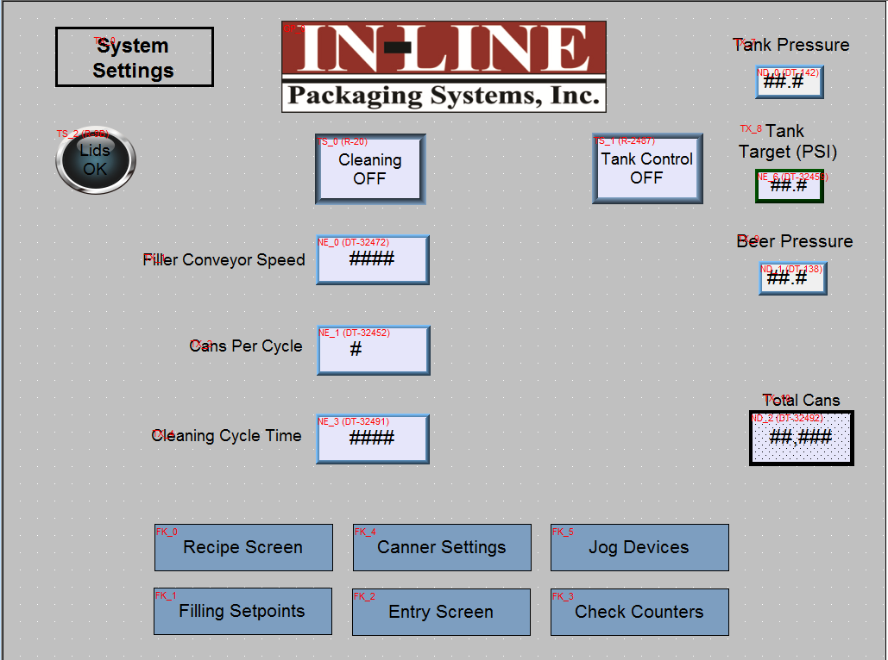
Tank Control | Bright tank pressure management
Cleaning On/Off | Turn this on to initiate cleaning functions
Cans Per Cycle | The number of filling heads used/installed.
Tank Pressure | The pressure of the tank displayed
Tank Target Pressure | The pressure setpoint
Sorter Belt Speed | This sets the speed of the Micro Elevator belt

Each of the lower buttons takes you to a different screen.

6.3.1 Jog Devices
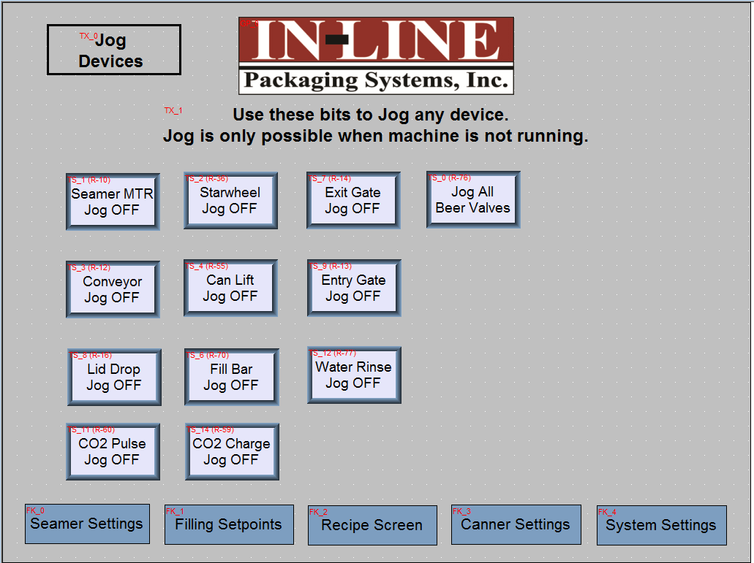

Each button will jog a specified function. This is a very useful screen for setup and troubleshooting purposes.
Each of the lower buttons takes you to a different screen.

6.3.2 Check Counters
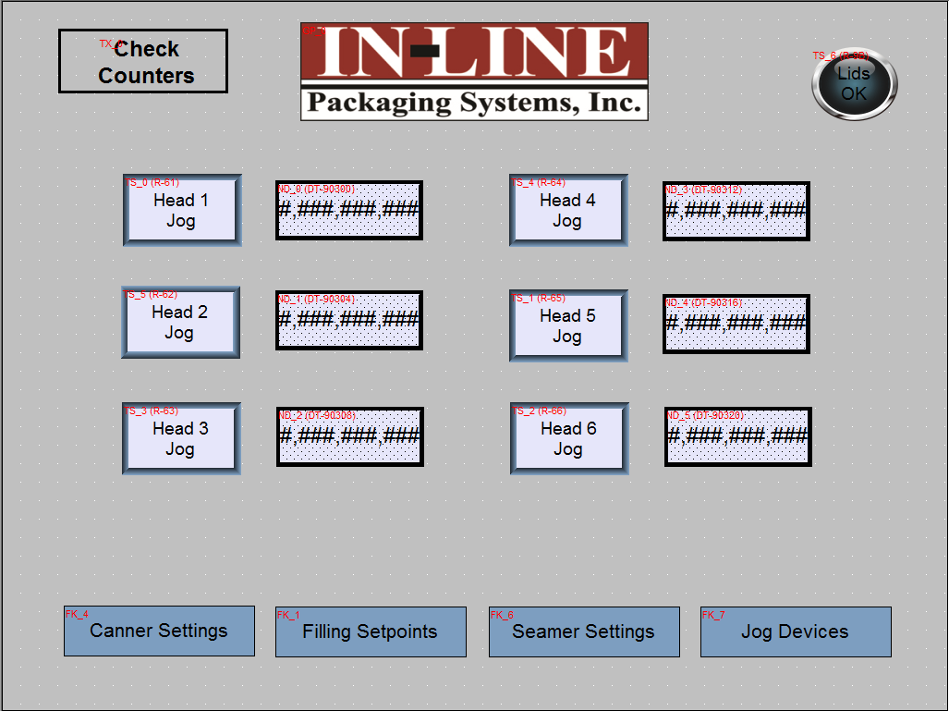

This screen allows you to check the counter functions to ensure they are working properly. You can jog each head individually and see the counter moving. Or during operation you can see the values change as each cycle occurs. A counter not counting up either has a connection issue or has failed.
Each of the lower buttons takes you to a different screen.

6.3.4 Seamer /servo setup

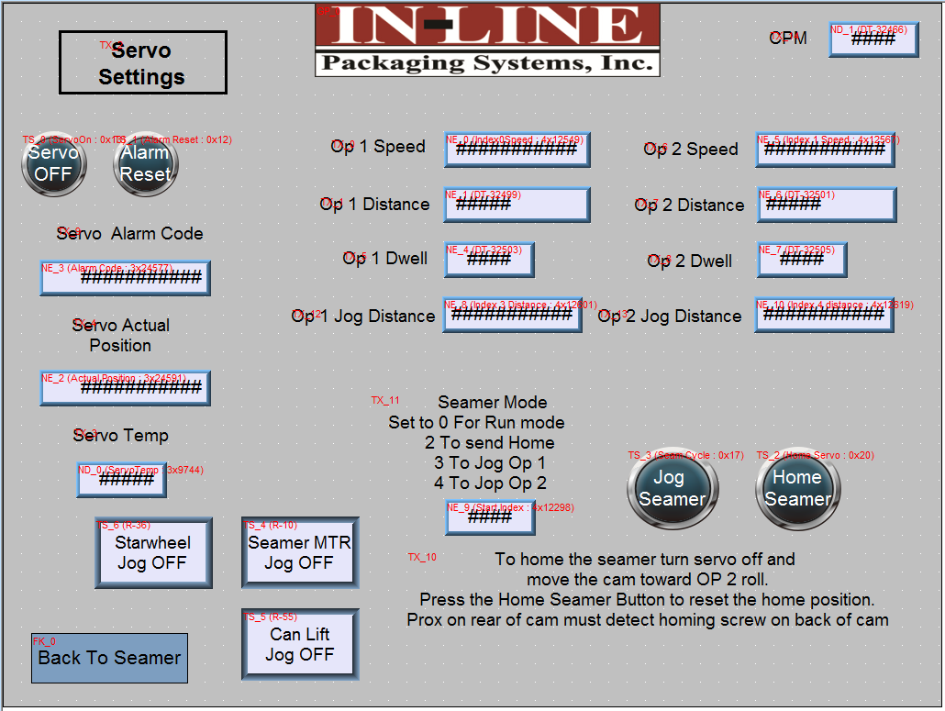
The Seamer is servo controlled. The op1 and op2 speeds are the speed that the cam moves to those positions.
The op 1 and 2 distances are in 10ths of a degree.
The Op1 and 2 dwell is the length of time that the servo holds the rolls against the chuck during the seam cycle.
The op 1 and 2 jog distances are for setup purposes and are not used during the run cycle. Once these numbers are judged to be correct they should be transferred to the op 1 and 2 distances .
The servo actual position simply allows the user to visually see the servo drive commanding and executing a move to the op 1 and op 2 positions. This is a display only field.
SEAMER MODE!!!! IMPORTANT!!!!!
Seamer mode is the index profile that the servo will run the number entered into this field will determine which profile runs. 0 is normal run mode, 2 send the servo to the stored home position (servo position 0), 3 moves the servo to the OP 1 jog position, (this number can be changed and rejogged to fine tune the position without moving to home), 4 moves to he Op 2 jog position (this number can be changed and rejogged to fine tune the position without moving to home).
ALWAYS SET THE SEAMER MODE TO 0 BEFORE RUNNING THE MACHINE .
The homing routine is described on screen , but with the servo disabled move the seamer op 2 location manually, then turn the servo on and press the home seamer button. This will cause the cam to move to the middle position and pass the prox sensor on the back. This sets the servo position to 0.

SECTION 7 – CLEANING CYCLE

- Lower heads onto cans
- Connect sanitizer
- Open beer valves

References

Zahm & Nagel. "Volumes of CO2 Gas Dissolved in Water." Www.zahmnagel.com. N.p., Apr.
2016. Web. 4 Jan. 2017.

WIRING BLOCK DIAGRAMS available upon request.

