  - POSITIVE DISPLACEMENT FILLER
  - – Operation Manual

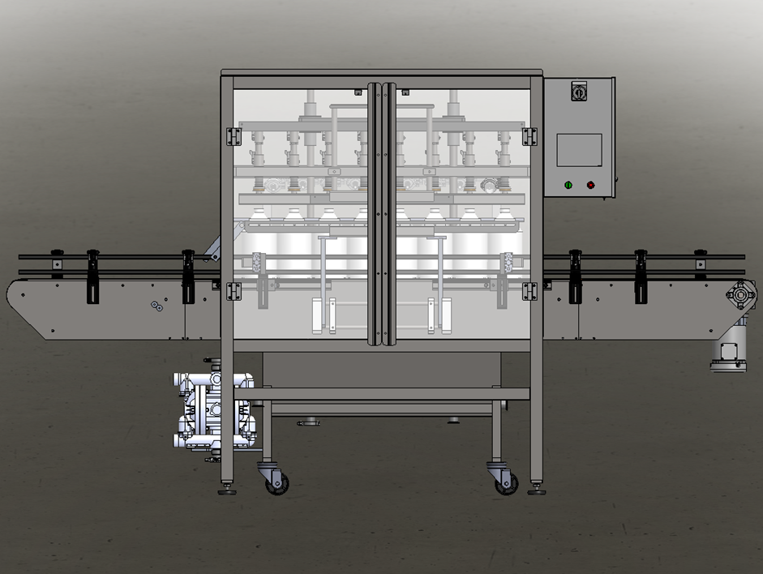

For helpful how-to videos visit our
YouTube channel - Inlinelabeling1

Follow us on:
Instagram @inlinepackaging
Facebook @inlinepack

CAUTION!

Persons operating this machinery are reminded to observe their own company safety policies. In addition, the following safety rules should be observed:

- DO NOT REACH INTO THE MACHINE WHILE IT IS IN OPERATION.
- USE ONLY THE CORRECT TOOL FOR THE JOB BEING DONE.
- STAY ALERT, REMEMBER LOCATION OF CONTROL SWITCHES.

MAINTENANCE
The main electric switch supplying power to the machinery should be locked out or disconnected when repairs are performed on this equipment.

Machine should be cleaned and inspected regularly. All safety switches must be operable, attachments secure and machine free of broken glass and paper.

Do not hand lubricate when the machine is in operation.
Work area should be kept clean and as dry as is practical.

The repair or adjustment of this equipment should be performed only by persons qualified through technical training and ability, as assigned by your company.

OPERATION
All guards should be securely in place before operating the machine. Close all doors when operating machine.

Company rules on eye protection should be followed.

Loose clothing or jewelry such as neckties, rolled sleeves, over blouses, bracelets, watches and rings should not be worn when operating the machine.

Report all malfunctions, unusual operation, and defects immediately.

Please exercise caution with any moving parts, including the conveyor and any pinch or drive rolls.

Stop the machine before placing hand or arms near or into any area where moving parts are located.

TABLE OF CONTENTS

SECTION ONE – GENERAL INFORMATION

 | Terminology of Machine | pg. 4
 | Specifications and Requirements | pg. 5
 | Functional Description of Machine | pg. 6

SECTION TWO – UNCRATING AND INSTALLATION

 | Electrical | pg. 16
 | Communication Cables | pg. 16
 | Pneumatic | pg. 17
 | Installing in Production Line | pg. 18
 | Leveling Base of Machine | pg. 18

SECTION THREE – PERIODIC MAINTENANCE, CLEANING, AND LUBRICATION

 | Maintenance | pg. 20
 | Cleaning the Machine | pg. 20
 | Lubrication | pg. 20

SECTION FOUR – TROUBLESHOOTING

 | Nothing Works at All | pg. 21
 | Screens | pg. 21

SECTION FIVE – SCREENS

 | Main Screen |  | pg. 22

SECTION SIX – CLEANING CYCLE
REFERENCES
WIRING BLOCK DIAGRAMS

SECTION ONE – GENERAL INFORMATION

TERMINOLOGY OF MACHINE

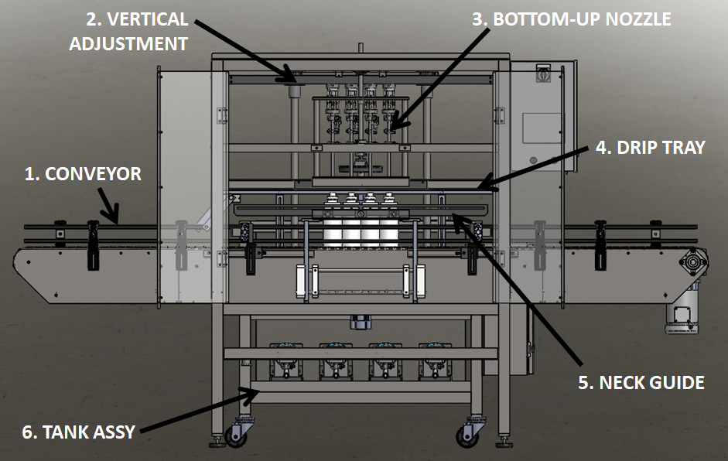
Positive Displacement Filler
Item No. | Assembly Name | Description
1 | Conveyor | Moves bottles through system
2 | Vertical Adjustment | Moves up and down for different bottle heights
3 | Bottom-Up Nozzle | Fill tubes
4 | Drip Tray | Prevents liquid from dropping on top of bottles
5 | Neck Guide(if equpiied) | Straightens bottles under nozzles
6 | Tank Assembly | Product storage

SPECIFICATIONS – STANDARD MACHINE

ITEM | SPECIFICATION
CONVEYOR WIDTH | 4.5 INCHES STANDARD
MACHINE SPEED | VARIABLE with number of heads ( max speeds BPM)
OVERALL DIMENSIONS | h: 71 1/2”; L: 126” (varies); w: 61”
ELECTRIC REQUIREMENTS | 120VAC 10 AMPS/230VAC 5 AMPS
AIR REQUIREMENTS | 90 PSI @ 5 CFM

FUNCTIONAL DESCRIPTION OF MACHINE

The In-line Servo Piston Filler is a fully automatic in-line piston filling machine that can fill various bottle sizes.
The machine can be configured as a 2- 8-head machine.
The machine indexes the set target of bottles into position under the fill tubes. The straightener/neck guide (where equipped) closes on the bottles, further aligning them to the fill tubes, and the filling manifold lowers down onto the bottles. The fill cycle consists of the following: indexing bottles, dispensing product into the bottles. When filling target is met the unit lifts the heads fully, extends the drip tray and opens the exit gate to allow bottles to exit down the line. The next group then indexes in and the cycle is repeated.

Conveyor

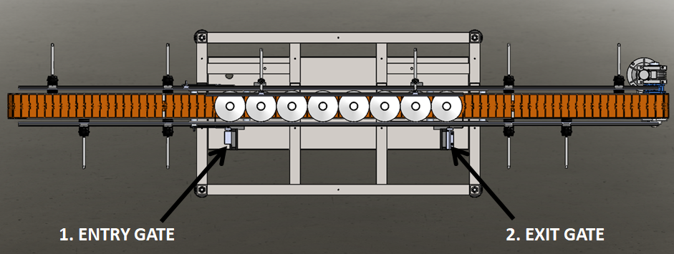
The Conveyor for the Filler controls the indexing of bottles for filling and the positioning of the bottles under the fill tubes.
- Entry Gate – creates spacing between cycles
- Exit Gate – positions bottles under fill tubes

Adjustments
Place multiple bottles on the conveyor in different locations and adjust all railing accordingly.
Center bottles on conveyor and adjust entry gate and exit gate accordingly.

Vertical Adjustment

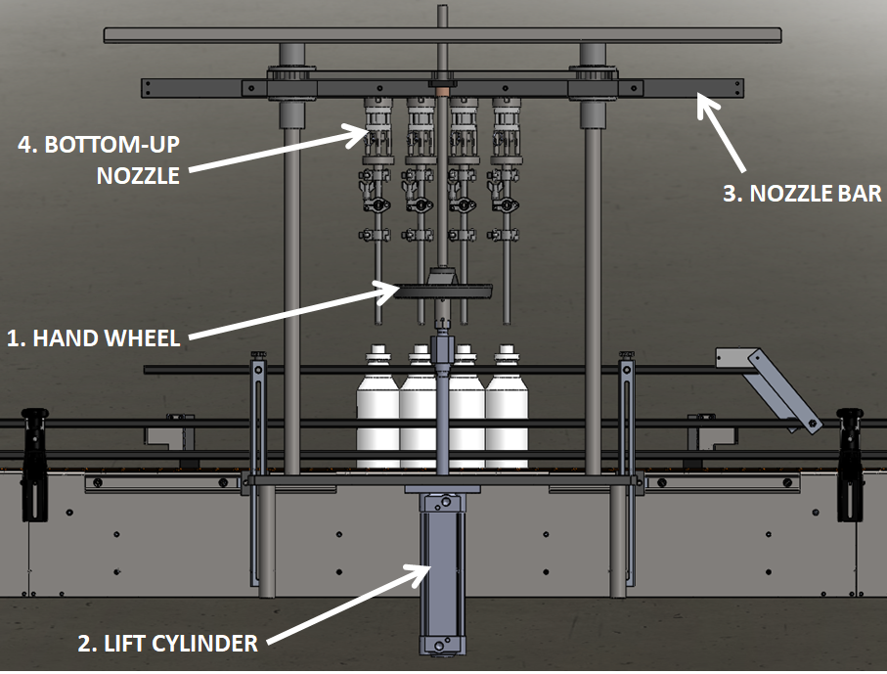 | The Vertical Adjustment controls the height of the Bottom-Up Nozzles and is what is used to raise and lower the nozzles during filling.  - Hand Wheel - moves Nozzle Bar up and down for different bottle heights  - Lift Cylinder – moves Bottom-Up Nozzles up and down during filling  - Nozzle Bar – Bottom-Up Nozzles are attached here; allows for adjustment for different diameter bottle sizes  - Bottom-Up Nozzle – various sizes available; product flows through these into the bottles

Adjustments

Use the Hand Wheel to adjust from one bottle height to another. Adjust the Bottom-Up Nozzles side to side on the Nozzle Bar for different bottle diameters using a 9/16 wrench.

The filling levels Are adjusted by changing the setpoints in the touch screen. There are three positions. The charge position (this is the highest number) is the number that the servo rotates the acme screw pulling the pistons back fully and pilling the piston cavity with product. The second position is the top off position where the servo slows down to reduce the velocity of the product fill to complete the piston discharge. The third position is the dispense position and that number should always be set to 0 to fully empty the piston stroke.

Bottom-Up Nozzle

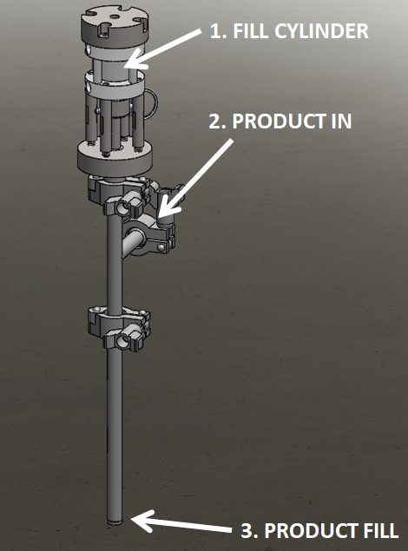 | The Bottom-Up Nozzle is what is used to fill the bottles with product.  - Fill Cylinder – starts and stops product flow  - Product In – product flows from the Tank Assembly into the nozzle through this connection point  - Product Fill – where product flow out of the tube into the bottle

Drip Tray

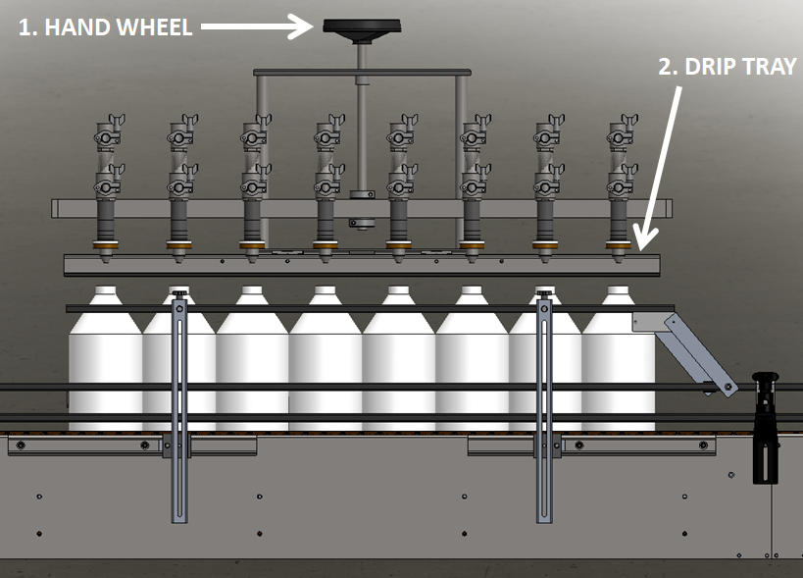 | The Drip Tray is used to prevent any excess product from getting onto the sides of the bottles as they index out/in.  - Hand Wheel – moves the Drip Tray up and down for different height bottles  - Drip Tray – extends out, under the nozzles in-between fill cycles

Adjustments

Raise or lower as needed when changing bottle sizes.

Neck Guide

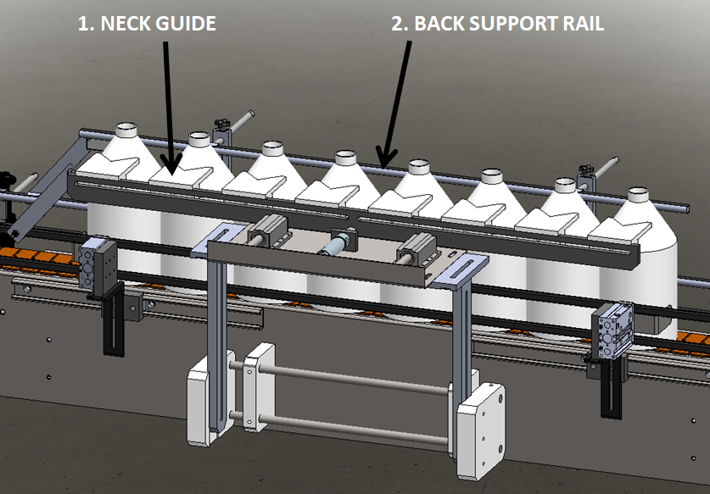
This is the part of the filler that aligns the bottles under the Nozzles.
- Neck Guide – centers bottles under Nozzles
- Back Support Rail – provides necessary support to the back of the bottles
- Neck Guides are often customized so installed components may vary slightly.

Adjustments

Both the Neck Guide and the Back Support Rail are adjustable vertically and in and out to compensate for different bottle heights and diameters.

Tank Assembly

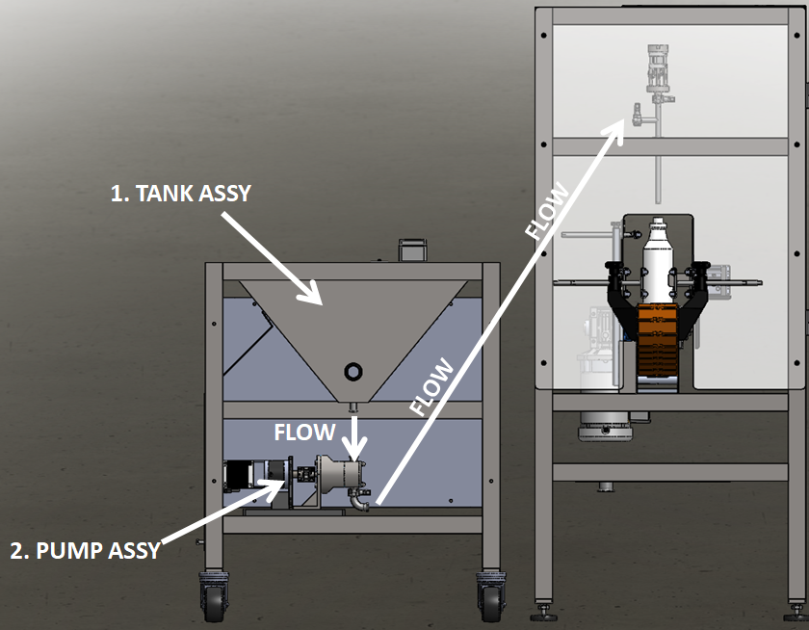
Customer moves product from their tank to this tank to fill. This Tank Assembly comes with a float switch to automatically bring more product in when it gets low.
- Tank Assembly – product storage tank
- Pump Assembly – servo driven piston/pump used to fill bottles with product
- The rotary valve- is mounted below the conical hopper this valve opens and closes with the bottom-up nozzles. When the piston is charging the product path of the valve is from tank to piston cavity. When filling the valve path is from piston cavity flowing to the nozzles.

SECTION TWO – UNCRATING AND INSTALLATION

2.1 ELECTRICAL

A grounded electrical male plug is provided with the machine, and is connected to the main electrical enclosure on the rear side of the machine. Plug this into any grounded receptacle. The main power switch can be found on the right side of the Electrical Enclosure.

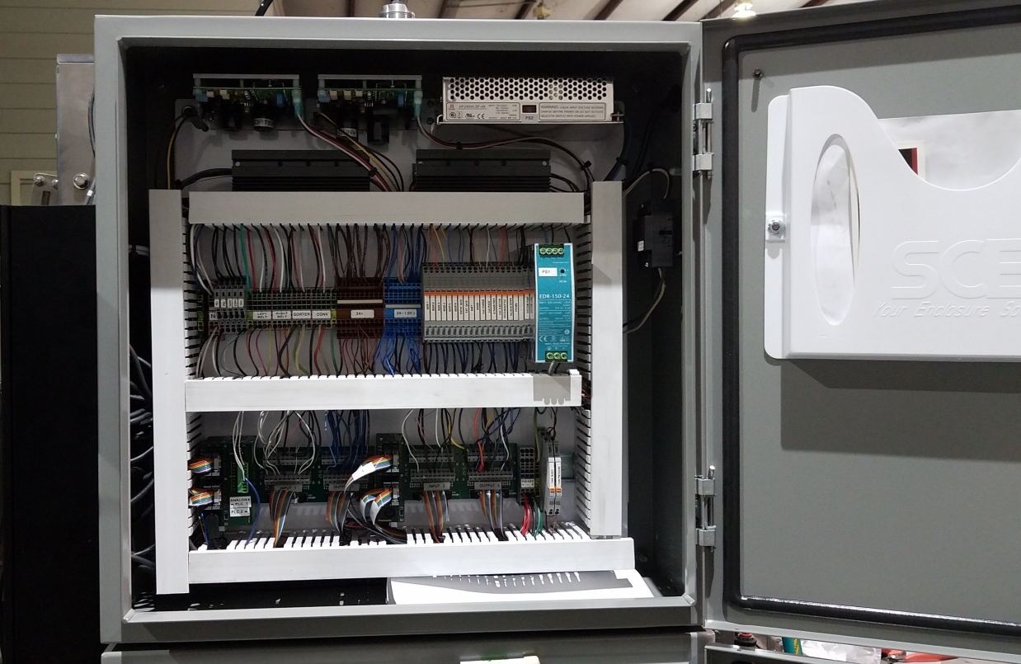

2.2 COMMUNICATION CABLES
If installed with servos, they may be I/O cables between the pump cart and the main panel, this may be multiple cables or a single ETHERNET style cable depending on the specific machine configuration.

2.3 PNEUMATIC (illustration only)
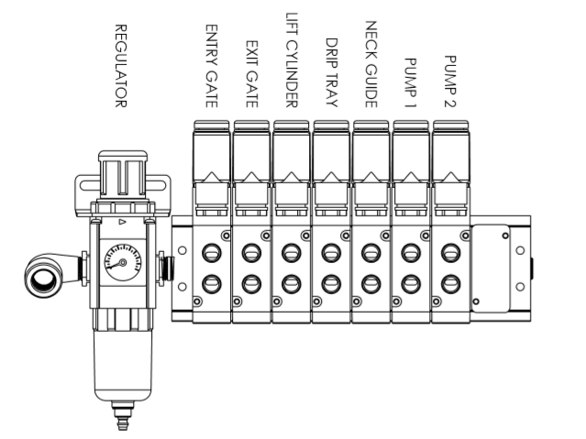
This pneumatic assembly can be found on the back side of the electrical enclosure. The regulator has a 1/4” male quick disconnect attached. You can supply compressed air to the machine by either a mating quick disconnect on the end of an air hose, or you can permanently pipe air to the machine using standard pipe and connecting directly into the air filter using threaded pipe connections. If you permanently pipe into the system we recommend a cut-off valve be mounted at the machine. Some changeover adjustments are easier if the operator is able to temporarily turn off the air pressure.

2.4 INSTALLING IN PRODUCTION LINE
Move the machine into its permanent location. Adjust the conveyor height of the machine to match the heights of the adjoining machines as required. Leveling casters are provided with the Micro Filler that allow you some vertical adjustment. Position the conveyor ends as close to each other as possible and then use conveyor rails to guide the containers across narrow dead plates onto the conveyor.

2.5 LEVELING THE BASE MACHINE
Once the machine is installed, level the main conveyor through the machine by using a bubble level. Place the bubble level along the length of the machine. Leveling the machine is important to the flow of the line as it allows for more seamless transitions between machines. The squaring and straightness of the base machine will ensure the machine operates correctly.
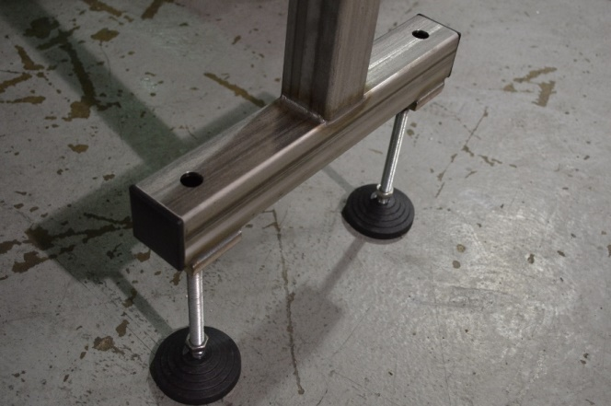

SECTION THREE – PERIODIC MAINTENANCE, CLEANING, AND LUBRICATION

3.1 MAINTENANCE
Ensure that you perform a monthly visual inspection for wear on the Filling Manifold seals, conveyor chain, Side Belts, and Crowning Head.

3.2 CLEANING THE MACHINE
The Micro Filler comes in stainless and aluminum construction. Cleaning the machine regularly is recommended.
Hook up at the Customer Connection point and run the Cleaning cycle on the Systems Settings page.
- Load bottles under the filling head, jog straightener in, lower filling heads onto bottle.
- Prepare cleaning solutions, (HOT CAUSTIC RECOMMEND 160 DEGREES 170 MAX.)
- From the system menu select the cleaning time per stage (speed, snift, vacuum paths).
- Connect cleaning solution product supply manifold.
- Select Cleaning ON. Switch to the monitoring menu to observe progress.
- When the vacuum valve opens remove the tube from the vacuum pump to the tank to fill the tanks with cleaning solution, then drain the tank.
- Repeat hot water through the machine, same process with sanitizer prior to fill
  - Pressure not to exceed 25psi

Wash down conveyors and components with hot water.

3.3 LUBRICATION
The only lubrication points on the machine are:
- The conveyor idler sprockets inside the frame of the machine need grease quarterly. The conveyor idler sprockets are located under the conveyor chain.
- Any threaded rod for linear motion should have light oil (food safe) applied to it periodically to keep the mechanism moving freely.
- Flange mount bearings; these have grease fittings and should be lubricated quarterly

SECTION FOUR - TROUBLESHOOTING

The list below represents a few scenarios in which troubleshooting may need to occur.

4.1 NOTHING WORKS AT ALL/POWER IS ON BUT NOTHING WORKS
- Check main power. Is machine plugged in? Is main power switch turned on?
- Check fuses inside control panel.
- Are conveyor speed controls turned up above zero (in the Touchscreen)?

4.2 OPERATIONAL INCONSISTENCIES (NOTHING IS BEING FILLED)
- Confirm that filling is on and that the counting eye is changing states between bottles.
- Confirm that air supply is on.
- Confirm bottles per cycle is not set to zero.
- Confirm CO₂ pressure is set 5-10psi above tank head pressure.

SECTION FIVE – SCREENS

5.1 Main Screen
The Main Screen is the landing page for accessing most functions. The menus for each function are listed on this screen. Each button that takes you to specific screens. The boot up screen below requires a press on the logo to access the main settings screen
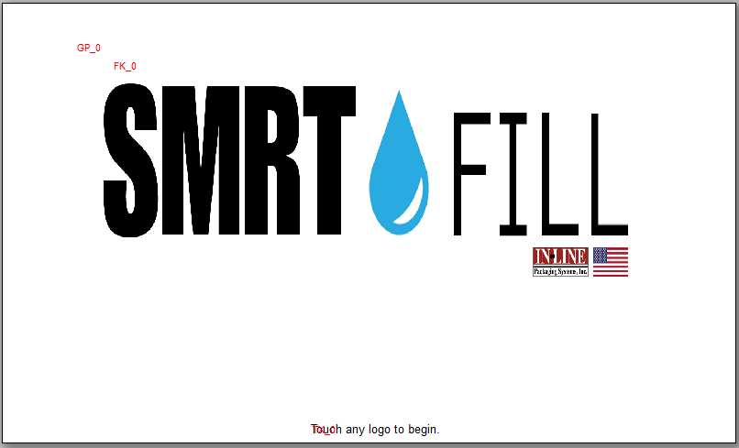

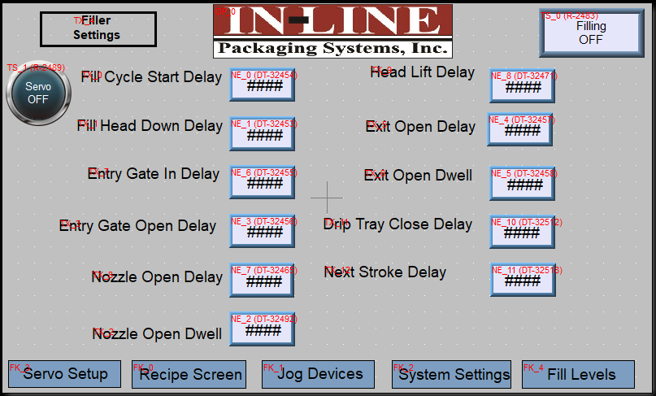

Fill Cycle Start Delay: The time after the count of bottles is complete before beginning the filling cycle.
Fill Bar Down Delay: The time after the cycle begins before the heads lower.
Nozzle Open Delay: after the heads lower the time before the nozzles open.
Nozzle Close Delay: The time that the nozzles remain open after filling is complete.
Fill Bar Up Delay: for bottom up filling this delay begins to raise the heads during the fill. This allows the nozzle to be kept below or right at the fill line to limit foam or reduce spillage.
Gate Delays: manage the opening and closing of the indexing gates.
Drip Tray delays: these are the times for the extending/retracting of the drip tray.
Neck Guide Delay: manages the time after the fill cycle begins for when the neck guides close onto the bottles.
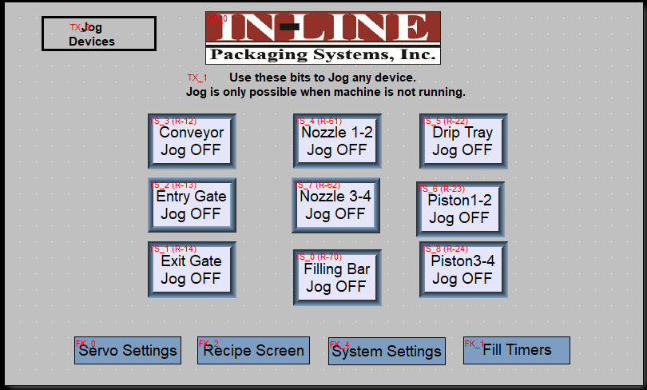

The jog Functions allow the operator to manual activate pneumatic devices. These are only active when the machine is not in run mode.

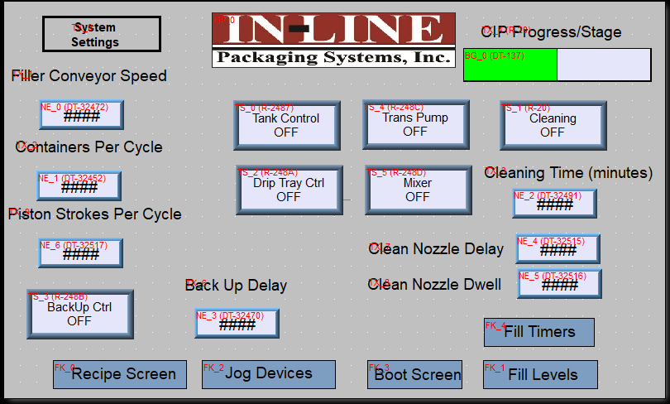
These are the settings for core functions to be enabled for run mode.
Filling On/Off turns the filling function of the machine off, if off gates can be jogged open and the machine is a pass through conveyor.
Drip Tray Ctrl, enable the automated movement of the drip tray.
Tank Control manages the level of the product in the supply tank by using a float ball mounted in the tank. When the tank is low the product valve opens to allow more product to flow into the tank.
The Trans Pump button enables a pneumatic pump to be activated for use in conjunction with the tank control valve.
Backup Control manages the exit gates when the discharge conveyor has no room for bottles to exit, when the eye opens the gates opens to allow bottles to leave the filling area.
The piston strokes per cycle defines how many strokes of the piston are required to fill the bottle.
Containers per cycle should be set to match the number of nozzles installed on the machine.

The cleaning cycle will move the pistons back and forth pulling cleaning product from the tank and pushing it through the nozzles.
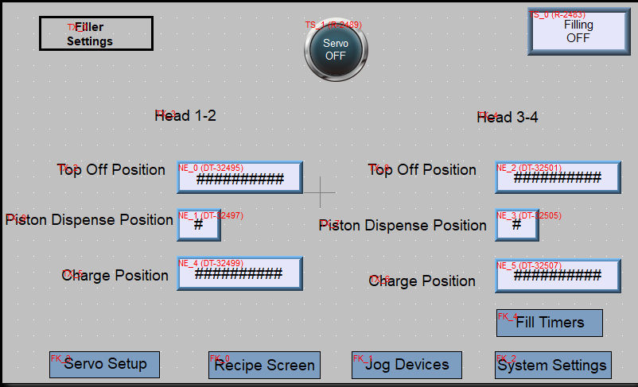

The piston charge positions, dispense positions and top off positions are set here.

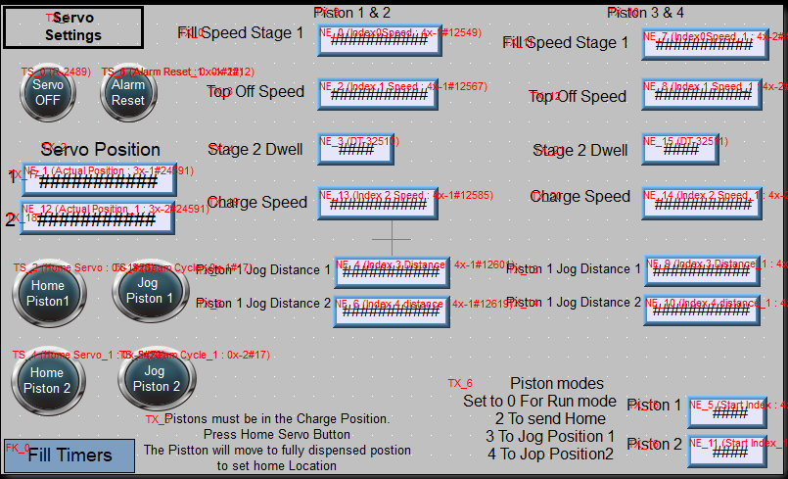

The fill speed stage one is the speed that the product is dispensed from the piston. The top off speed is the speed at which the last amount of product is dispensed. The Charge speed is the speed that the piston recharges with product.
You can also jog the pistons to complete a cycle to push air from the pistons in preparation to fill.
Upon power up the pistons will automatically home themselves then move to the charge position to prepare for filling. However you can home them after the initial homing anytime by pressing the home button.
Homing is done when the linear bearing reaches the home prox sensor pictured below.
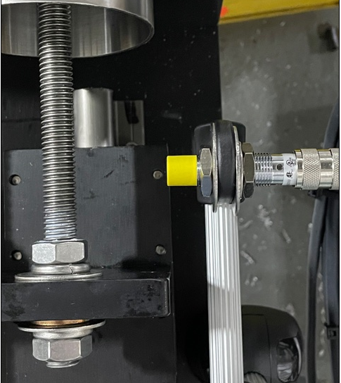

SECTION SIX – CLEANING CYCLE

- After filling is complete do one cycle with hot water only as a rinse.
- Repeat with cleaning solution/detergent of choice caustic not to exceed 1% dilution.

The system will do two cycles, the first is simply cycling product into the pistons and back into the filling tank, the second stage simulates filling cycles opening and closing the nozzles and valves.

