OPERATION MANUAL

TABLE-TOP FILLER/CAPPER

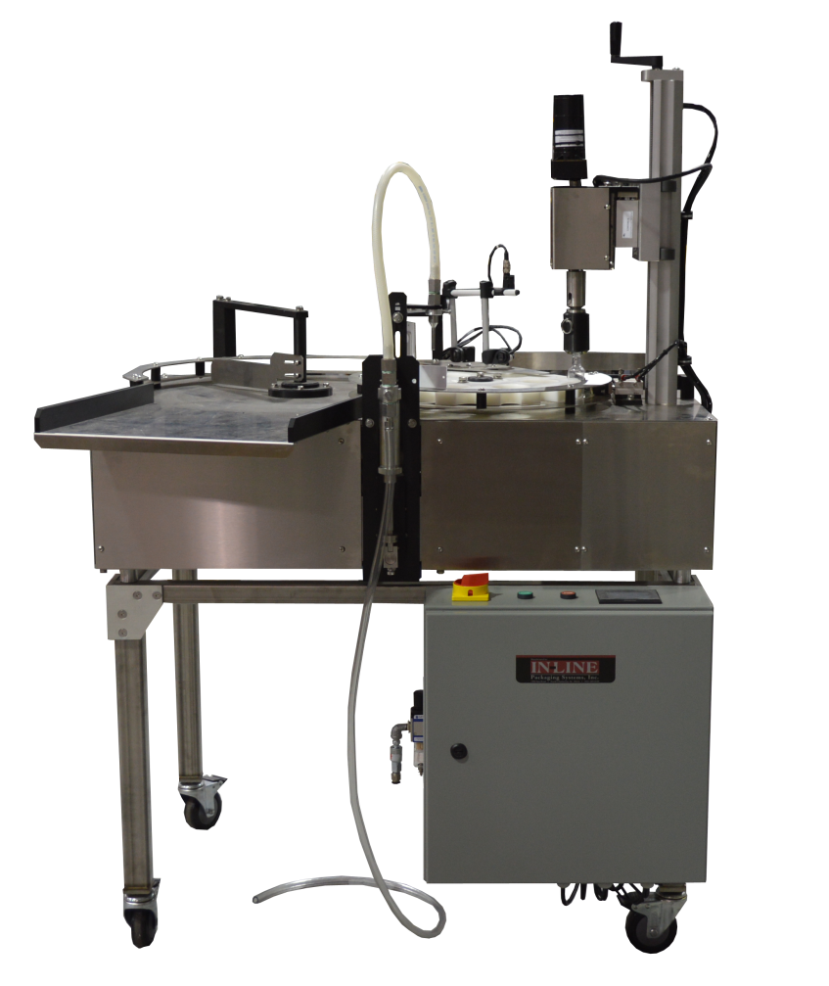

7282 SPA ROAD | NORTH CHARLESTON, SC 29418
PHONE: 843-569-2530 | FAX: 843-576-0798
WWW.INLINEPACK.COM

CAUTION!

Persons operating this machinery are reminded to observe their own company safety policies. In addition, the following safety rules should be observed:

DO NOT REACH INTO THE MACHINE WHILE IT IS IN OPERATION.

USE ONLY THE CORRECT TOOL FOR THE JOB BEING DONE.

STAY ALERT, REMEMBER LOCATION OF CONTROL SWITCHES.

PROPER VENTILATION IS REQUIRED WHERE FILLING MACHINES ARE IN USE.

MAINTENANCE
The main electric switch supplying power to the machinery should be locked out or disconnected when repairs are performed on this equipment.

Machine should be cleaned and inspected regularly. All safety switches must be operable, attachments secure and machine free of broken glass and paper.

Do not hand lubricate when the machine is in operation.
Work area should be kept clean and as dry as is practical.

The repair or adjustment of this equipment should be performed only by persons qualified through technical training and ability, as assigned by your company.

OPERATION
All guards should be securely in place before operating the machine.

Company rules on eye protection should be followed.

Loose clothing or jewelry such as neckties, rolled sleeves, over blouses, bracelets, watches and rings should not be worn when operating the machine.

Report all malfunctions, unusual operation and defects immediately.

Please exercise caution with any moving parts, including the conveyor and any pinch or drive rolls.

Stop the machine before placing hand or arms near or into any area where moving parts are located.

TABLE OF CONTENTS

OPERATIONAL AND MAINTENANCE SAFETY RECOMMENDATIONS
SECTION ONE – GENERAL INFORMATION
1.1 Terminology of Machine
1.2 Specifications and Requirements
1.3 Functional Description of Machine
1.4 Basic Machine Controls and Screen Settings

SECTION TWO – UNCRATING AND INSTALLATION
2.1 Power and Air Connections
2.2 Installing in Production Line
2.3 Leveling Base of Machine
2.4 Adjusting Components of Machine

SECTION THREE – PREPARING FOR OPERATION
3.1 Set Conveyor Rails
3.2 Adjust Machine Settings
3.3 Adjust Sensors

SECTION FOUR – OPERATIONAL ADJUSTMENTS

SECTION FIVE – PERIODIC MAINTENANCE, CLEANING, AND LUBRICATION
5.1 Maintenance
5.2 Cleaning the Machine
5.3 Lubrications

SECTION SIX – TROUBLESHOOTING
6.1 Nothing Works at All
6.2 Operational Inconsistencies

SECTION SEVEN – OPTIONS AND/OR SPECIAL COMPONENTS SUPPLIED WITH MACHINE

SECTION EIGHT – PARTS LIST AND DIAGRAMS

SECTION ONE – GENERAL INFORMATION

1.1 TERMINOLOGY OF MACHINE
3
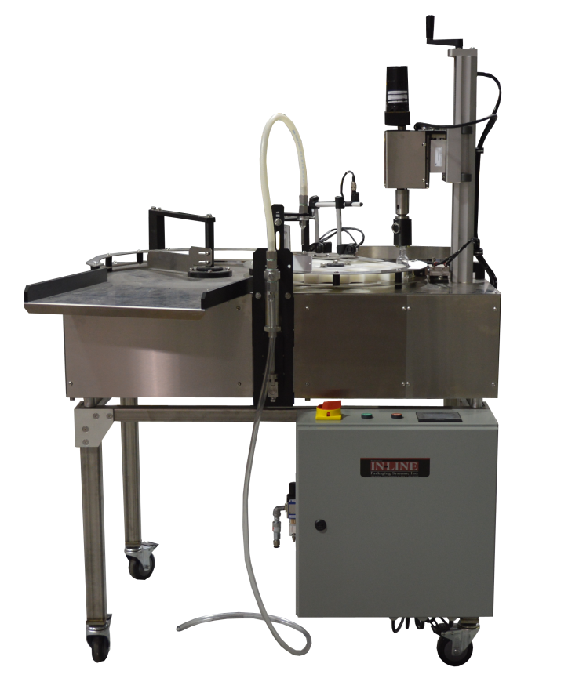

2

1
4

5

Table Top Filler/Capper

1. Feed Table 4. Indexing Star Wheel
2. Pump, Hose, Nozzle 5. Liquid Pick Up Line
3. Cap Tightener Height Adjustment

1.2 SPECIFICATIONS – STANDARD MACHINE

ITEM | SPECIFICATION
CONVEYOR WIDTH | 4.5 INCHES STANDARD
MACHINE SPEED | VARIABLE UP TO 24 BPM
MACHINE WEIGHT | 250 LBS
OVERALL DIMENSIONS | 48x60 INCHES STANDARD
ELECTRIC REQUIREMENTS | 110VAC 6 AMPS
AIR REQUIREMENTS | 90 PSI @ 4-6 CFM

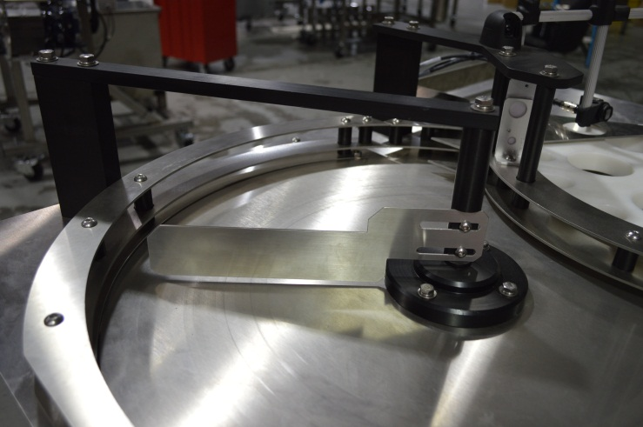
1

- Feed Table Sweep Arm
- Filling Piston Nozzle
- Filling piston Unit.

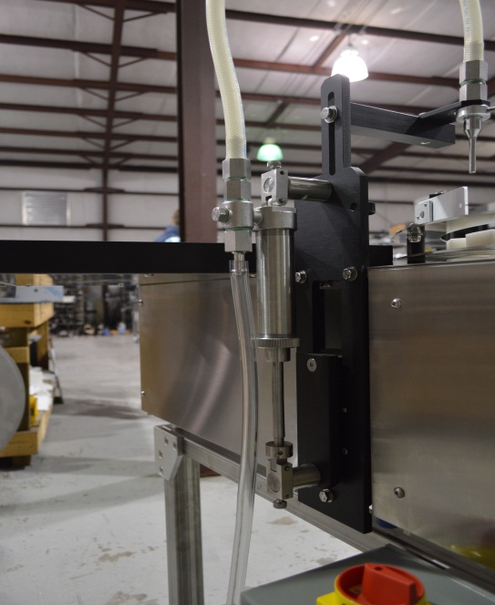
3
2

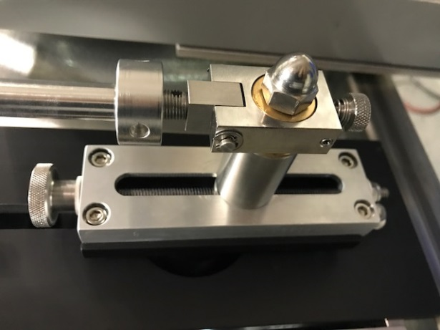
1

- Fill Volume Adjustment
- Cap Torqueing Head
- Indexing Star Wheel

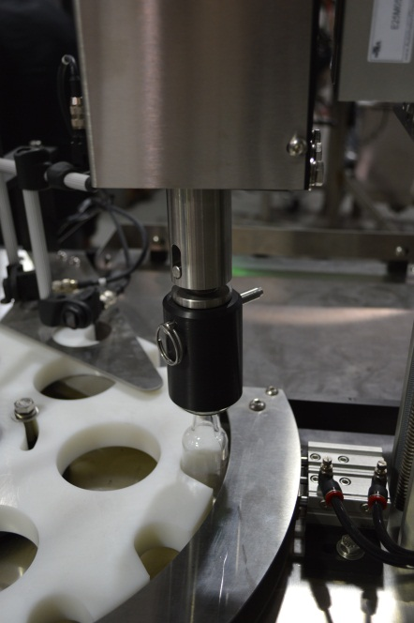
3

2

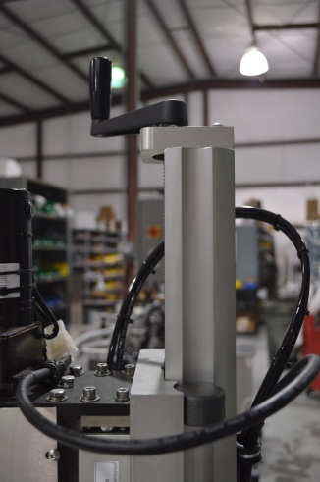
1

- Cap Torqueing height Adjustment
- Infeed Bottle detection Eye
- Filling Bottle detection eye, must be blocked by bottle when the indexing star pause for fill to occur.

2

3

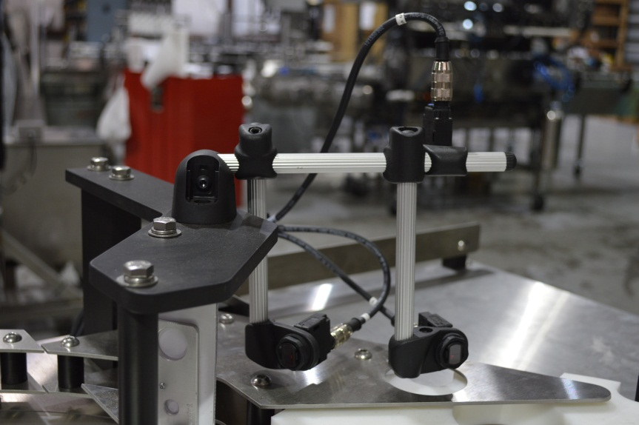

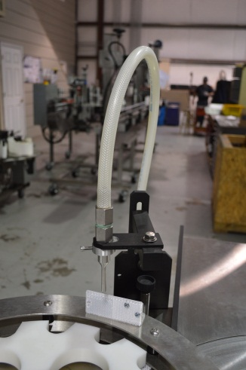
1

- Fill Nozzle
- Fill Position Bottle Sensor Reflector

2

1.3 FUNCTIONAL DESCRIPTION OF MACHINE

The Inline Table-Top Filler is a Semi-automatic inline filling machine that can fill various sizes of containers with medium to low viscosity.

The filler indexes bottles into position using a photoeye and reflector by detecting the star pockets, and stopping the star under the filling head and cap tightener positions . The piston pump is started and the fill nozzle dispenses for filling. Once the filling cycle is complete the star wheel indexes to the next position. A new set of bottles is indexed into position and the cycle continues until the batch target is met (if batch function is enabled). The star wheel only indexes when a bottle supply is detected at the infeed lane on the star wheel.

Features:
- 304-stainless steel frame construction
- Aluminum and plastic parts throughout the mechanism
- Stainless steel filling nozzles
- Positive container indexing and centering
- Hand crank adjustment for different height containers

1.4 BASIC MACHINE CONTROLS

- Main Power Switch
- Start Push Button
- Stop Push Button

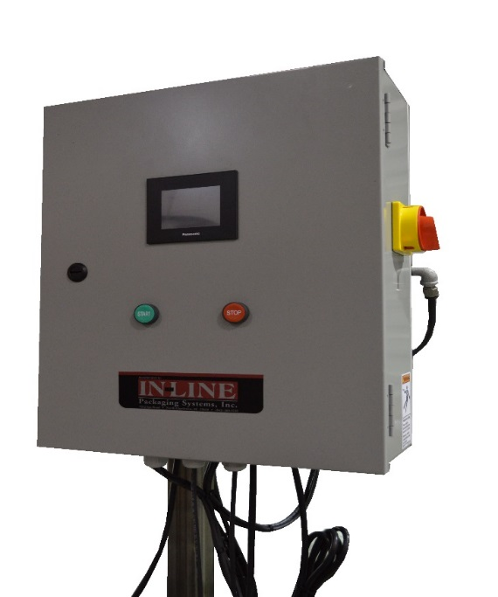
1

2
3

SCREEN SETTINGS

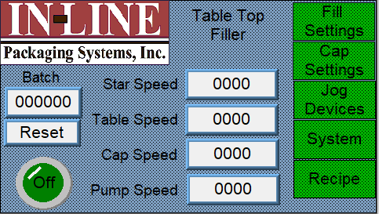 | Main Screen  Device Speeds: Enter speed of star as a percentage  Batch Count: displays current batch count  Batch Reset: Press to reset count to 0  Fill Settings: access screen for Filling  Cap Settings: access screen for cap control  Jog Device : Manually Jog devices  Recipe Functions: save/recall previous settings  System Settings: change settings/devices
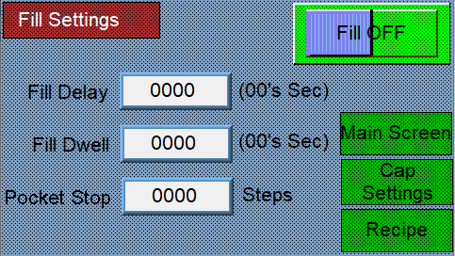 | Filler Settings Screen  Fill On/Off: Push to Toggle On or Off  Fill Delay: Push Number to enter new delay. This number affects the timing in which the filling cycle star index is complete.  Fill dwell : Push Number to change the stop position of the pump..  Pocket Stop: This is the number of the star travel distance per cycle.
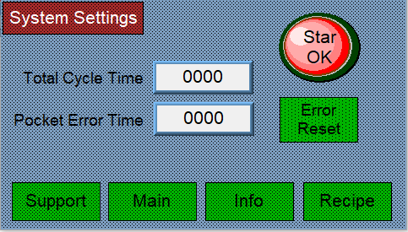 | System Settings Screen:  Cycle Time: This is the total length of the machine cycle, all filling and capping functions must be set within the length of this cycle.  Pocket Error: If the star wheel moves this many steps without seeing a star pocket the machine will stop and error( check that the pocket eye and reflector are working if this occurs)
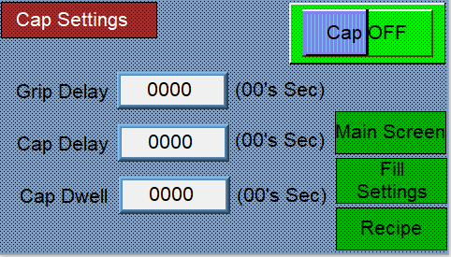 | Cap Settings:  Gripper Delay: Push Number to enter new delay. This number affects the timing in which the gripper extends to capture the bottle for capping.  Capper Delay: This number affects the time after the gripper closes before the cap head lowers.  Capper Dwell: This is the length of time the capping head stays down for torqueing.
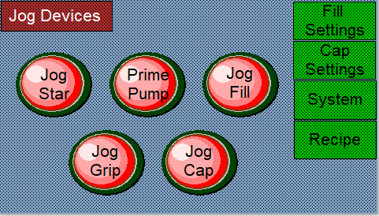 | Device Jog Settings Screen:  Starwheel, the pump and devices can be manually jogged from this screen.  The prime Pump feature cycles the pump continually to charge the piston and purge air. This can be used for prefill charging and cleaning the piston.  Press Jog Filler after turning off priming to “home” the piston.

SECTION TWO – UNCRATING AND INSTALLATION

2.1 POWER AND AIR CONNECTIONS

A grounded electrical male plug is provided with the machine, and is connected to the main electrical enclosure on the rear side of the machine. Plug this into any grounded receptacle. For compressed air, behind the electrical enclosure is an air filter/reservoir with a 1/4” male quick disconnect attached. You can supply compressed air to the machine by either a mating quick disconnect on the end of an air hose, or you can permanently pipe air to the machine using standard pipe and connecting directly into the air filter using threaded pipe connections. If you permanently pipe into the system we recommend a cut-off valve be mounted at the machine. Some changeover adjustments are easier if the operator is able to temporarily turn off the air pressure.

2.2 INSTALLING IN PRODUCTION LINE

Move the machine into its permanent location. Adjust the conveyor height of the machine to match the heights of the adjoining machines as required. Leveling pads are provided with the Econo-Filler that allow you some vertical adjustment. If necessary, make spacing blocks to raise the height. Additional lineal space is provided on each end of the machine to allow a crossover from or to the next machine. Position the conveyor ends as close to each other as possible and then use conveyor rails to guide the containers across narrow dead plates onto the conveyor.

2.3 LEVELING THE BASE MACHINE

Once the machine is installed, level the main conveyor through the machine by using a bubble level. Place the bubble level along the length of the machine. Leveling the machine is important to the flow of the line as it allows for more seamless transitions between machines. The squaring and straightness of the base machine will ensure the machine operates correctly.

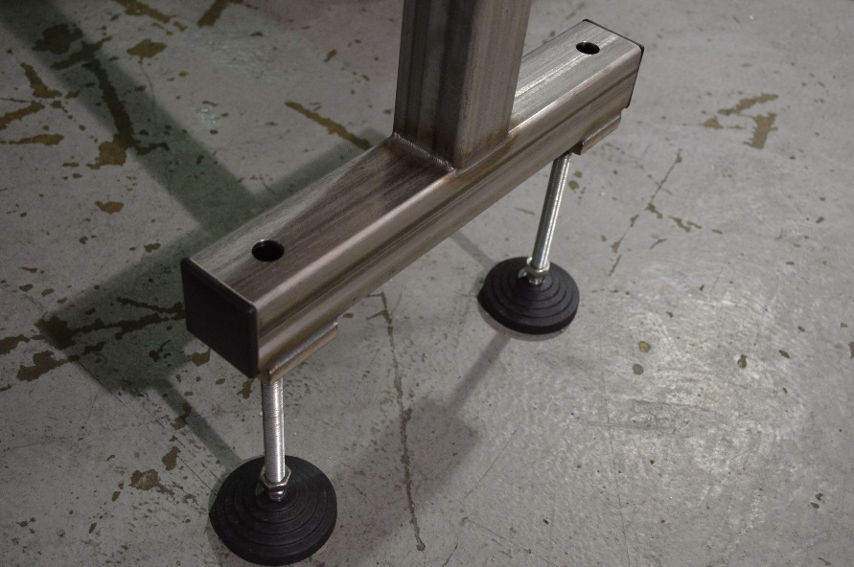

SECTION THREE – PREPARING TO FILL

3.1 LOADING PRODUCT INTO THE TANK
Fill the supply tank 2/3 full of product (Customer Provided). Visually monitor tank level throughout bottling run and refill when desired

3.2 SET TABLE
The feed table speed is adjusted using a potentiometer inside the electrical cabinet. The sweep arm can be adjusted for optimal feed. Note the table should not be completely filled

3.3 ADJUST HEIGHT AND SPACING OF NOZZLES

The height of the nozzle is adjusted using SAE wrenches, the centering over the bottle is also adjustable. The fill level is adjusted by limiting the stroke of the piston drive air cylinder using the plastic knob near the indexing star. Use supplies angle wrench for loosening the jam nut.

3.4 ADJUST capping height.

The capping head is vertically adjustable using the hand crank, the speed of the spindle rotation is adjusted using the speed potentiometer inside the electrical cabinet.

SECTION FOUR – OPERATIONAL ADJUSTMENTS

4.1 ADJUSTING FILL LEVELS

As stated above the fill volume is adjusted using the plastic knob and piston travel limit screw.

SECTION FIVE – PERIODIC MAINTENANCE, CLEANING, AND LUBRICATION

MAINTENANCE

Ensure that you perform a monthly visual inspection for wear on the fill heads, conveyor chain, and pump leaks.

CLEANING THE MACHINE

The Table-Top Filler comes in stainless and aluminum construction. Cleaning the machine regularly is recommended using soap and water, but not by spraying the machine down.

LUBRICATION

The only lubrication points on the machine are:

- Any threaded rod for linear motion should have light oil applied to it periodically to prevent rust and to keep the mechanism moving freely.

SECTION SIX - TROUBLESHOOTING

The list below represents a few scenarios in which troubleshooting may need to occur.

6.1 NOTHING WORKS AT ALL/POWER IS ON BUT NOTHING WORKS

- Check main power. Is machine plugged in? Is main power switch turned on?
- Check fuses inside control panel.
- Are speed controls turned up above zero?

6.2 OPERATIONAL INCONSISTENCIES (NOTHING IS BEING FILLED)

- Confirm that filling is on and that the bottle eye is changing states between bottles.
- Confirm that air supply is on.

